

Investigating the maths inside:

Prawns for profit

*Activity 2*

*Farming prawns*

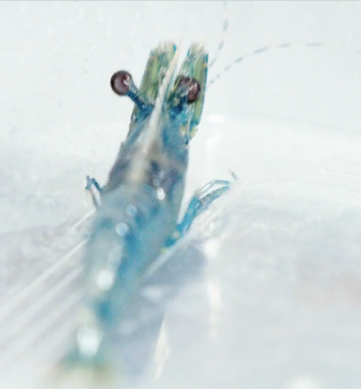

How do you farm a prawn?

# Introduction

Prawn farming is a high-risk industry requiring finance, expertise and the right site with good water quality. A typical prawn farm requires about ten ponds that are each approximately one hectare in size.

It is more difficult to be successful in prawn farming than in the more familiar farming of livestock or horticulture.

# How big is a hectare?

Find the size of a hectare in square metres. Then compare a hectare to the acre as an area of measurement. The acre was the area of measurement used before the hectare and many blocks of land were originally measured as an exact number of acres.

For example, traditionally Australians aspired to own a 3- or 4-bedroom house on a quarter of an [acre](https://en.wikipedia.org/wiki/Acre) block of land. A **quarter acre** was a term for a suburban block of land.

What is the area of a **quarter acre** in square metres? How does this compare with a hectare? How does this compare with the size of blocks of land currently being sold?

The following is a Google Earth view of a prawn farm with ten of the ponds numbered.

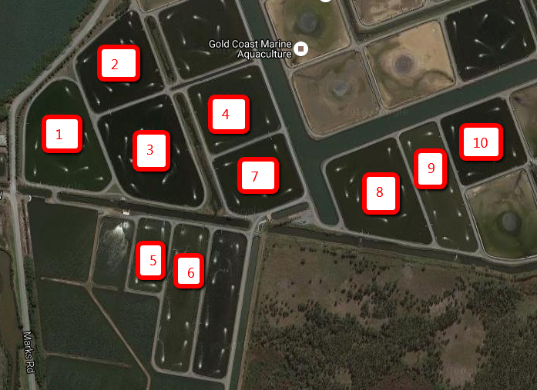

DaftLogic [www.daftlogic.com](http://www.daftlogic.com) enables you to find the area of shapes that you nominate using a pointer on each of the vertices.

Go to the DaftLogic website and select the ‘Google Maps Area Calculator Tool’ and then search for Gold Coast Marine Aquaculture, Marks Road, Woongoolba, QLD.

Look at the image above and estimate which of the three ponds are the largest.

Now use DaftLogic to measure the area of each pond. Were your estimates correct?

Search for your own school site and find its area using the DaftLogic software. Approximately how many ponds for growing prawns would fit on your school site?

# Stocking the pond

Use a stocking rate of 40 prawns for each square metre to investigate the number of prawns in a pond.

Select one of the ten ponds. How many prawns can be grown in this pond?

Growth rates and the number of prawns are monitored via weekly sampling of the prawns. Farmers are then able to manage the amount of feed required to minimise feed wastage.

To check the number of prawns in a pond and to monitor their size, a net is used. The net covers an average area of 1.44 square metres.

Ten casts around the edge of the pond produced the following results.

|  |  |  |  |  |  |  |  |  |  |  |
| --- | --- | --- | --- | --- | --- | --- | --- | --- | --- | --- |
| 50 | 52 | 54 | 52 | 53 | 54 | 49 | 50 | 54 | 55 |  |
|  |  |  |  |  |  |  |  |  |  |  |

What do you notice about the data? Calculate the mean number of prawns for a cast around the edge of the pond?

How many prawns are estimated to be in each square metre? Using the result of the ten casts around the edge, estimate the number of prawns in the pond you selected?

Ten casts towards the centre of the pond produced the following results.

|  |  |  |  |  |  |  |  |  |  |
| --- | --- | --- | --- | --- | --- | --- | --- | --- | --- |
| 55 | 54 | 54 | 52 | 54 | 56 | 54 | 51 | 52 | 49 |

What is the mean number of prawns for a cast in the middle area of the pond?

How many prawns are estimated to be in each square metre? Using the result of the ten casts in the centre, estimate the number of prawns in the pond you selected?

To cast the net in the centre of the pond is more difficult than around the edge.

Would casting only at the edge give a sufficiently accurate measure to determine the number of prawns in the pond? Why do you think this?

# Baby prawns

1.2 m

4.3 m

1.8 m



(NOT DRAWN TO SCALE)

The tank holds the baby prawns (larvae). Each tank contains about a million prawn larvae.

Find the capacity of the tank in litres.

To check the numbers in the tank, a ten-litre bucket is used to take water out of the tank and the number of prawn larvae is counted. Approximately how many prawn larvae should be in the bucket if there are 1 000 000 prawn larvae in the tank?

The following numbers are the result of this procedure repeated 10 times.

831 793 852 845 792 776 838 780 852 827

How many larvae do you think are in the tank? How big are the prawn larvae? Do you think the prawn farmer would actually count the prawn larvae? What other methods could be used to estimate the number of prawn larvae?

To fill the pond that you chose earlier with the required number, how many ten-litre buckets taken from the tank need to be emptied into your pond?

This is not a very practical method of stocking the pond with prawn larvae. Discuss some ways that you think the prawn farmer would do this so that each pond is stocked with approximately the right number of prawns.

# Feeding

The success of a farm is very dependent on the amount of feed that is used. This is a major cost.

The effectiveness of a feeding program is measured using a Food Conversion Ratio (FCR). For this farm, they aim to keep the FCR close to 1.5:1 (1.5 kg of food for every 1 kg of prawns).

If the prawns are approximately 35 g in weight when they are harvested and sold, what is the total weight of the feed that can be fed to the prawns in the pond you selected?

Your teacher will provide you with a table or spreadsheet of data of a suggested feeding program for prawns. Use this table to develop a spreadsheet showing the weekly feeding program for your pond.

Calculate the total amount of feed used in the 24 weeks and determine the FCR for your pond.

Total weight of feed = Number of prawns $×$ Mass of prawn $×$ FCR (answer is in grams)

Graph the mass of the prawns against the time in weeks over the 24-week period and discuss how the prawns grow over this period.

Why would prawn farmers harvest their prawns when they have reached an average mass of approximately 35–38 g? Check the retail price of Tiger prawns and calculate what the harvest from your pond would be worth if the prawns were sold at the retail price.

# Further Research

* The effect of temperature on the growth of the prawns
* Maintenance of water quality
* Avoiding diseases
* Possible locations – what features are essential?
* Marketing – what is the price at which the prawns are sold to make a profit?
* Breeding better prawns
* Survival rates
* Rate of evaporation