

Investigating the maths inside:

Big data, better hospitals

Activity 1

Errors and the power of percentages



What are some situations in which an estimate or approximation can be used?

How accurate do estimates and approximations need to be?

# Introduction

There are many situations in which estimates and approximations are used. These values are sometimes used for making important decisions. How accurate do they need to be?

*The data used in this activity have been provided by Queensland Health’s Healthcare Improvement Unit and are used with their approval.*

# Estimating and measuring

|  |
| --- |
| Your teacher will show you a doll. Estimate its height (in centimetres, correct to the nearest centimetre).  Estimate the height of your teacher (in centimetres, correct to the nearest centimetre).  Record your results in the table below and calculate the absolute error for each, using + for an over-estimate and – for an under-estimate. |

|  |  |  |
| --- | --- | --- |
|  | **Doll** | **Teacher** |
| Estimated height |  |  |
| Measured height |  |  |
| Absolute error |  |  |

Share your results with the class and complete the table below.

|  |  |  |
| --- | --- | --- |
|  | **Doll** | **Teacher** |
| Number of students who over-estimated |  |  |
| Number of students who estimated correctly |  |  |
| Number of students who under-estimated |  |  |
| **Total:** |  |  |

## Discussion questions

What strategies did you use to make your estimates?

Which of your two estimates do you think is more accurate? Why?

Suppose a student over-estimated both heights by 3 centimetres. Which estimate is better? Explain.

Assume nobody in your class estimated both heights correctly. How could we choose the ‘best estimator’ from your class?

# How accurate?

The Patient Admission Prediction Tool is used to forecast the number of patients who will turn up to a hospital on any given day of the year.

For example, on 28 June

* The forecast was 206 people
* The actual number was 221

The forecast was 15 *below* the actual. This error could be written as .

The calculation below shows the error as a percentage.

|  |
| --- |
| **28 June**  Forecast: 206 Actual: 221  Error: -15  Percentage error: |

You will be allocated a day (or days). Calculate the error and percentage error, then write the percentage error for ‘your’ day(s) on a sticky-note.

|  |  |  |  |  |
| --- | --- | --- | --- | --- |
| **Date** | **Forecast** | **Actual** | **Error** | **Percentage error**  **(to one decimal place)** |
| 1 July | 163 | 178 | $-$ 15 | $-$ 8.4% |
| 2 July | 162 | 160 | 2 | 1.3% |
| 3 July | 158 | 169 |  |  |
| 4 July | 177 | 182 |  |  |
| 5 July | 187 | 186 |  |  |
| 6 July | 184 | 180 |  |  |
| 7 July | 152 | 140 |  |  |
| 8 July | 160 | 160 |  |  |
| 9 July | 159 | 122 |  |  |
| 10 July | 158 | 159 |  |  |
| 11 July | 172 | 163 |  |  |
| 12 July | 181 | 189 |  |  |
| 13 July | 178 | 191 |  |  |
| 14 July | 143 | 168 |  |  |
| 15 July | 142 | 145 |  |  |
| 16 July | 150 | 184 |  |  |
| 17 July | 146 | 166 |  |  |
| 18 July | 156 | 178 |  |  |
| 19 July | 166 | 166 |  |  |
| 20 July | 163 | 178 |  |  |

Arrange the sticky-notes in order on a wall of your classroom.

Complete the following:

|  |  |
| --- | --- |
| Number of days for which the forecast was an under-estimate. |  |
| Number of days for which the forecast was correct. |  |
| Number of days for which the forecast was an over-estimate. |  |

|  |  |
| --- | --- |
| Number of days for which the forecast was less than 5% above or below or actual. |  |
| Number of days for which the forecast was less than 10% above or below or actual. |  |

## Discussion questions

Do you think that the PAPT generally makes accurate predictions?

For what purposes might the hospital administrators use these predictions?

What working conditions might the staff in the hospital experience on the days in which:

* The forecast estimate was much lower than the actual?
* The forecast estimate was much higher than the actual?

# Five years of data

The provided spreadsheet shows the forecast and actual numbers of patients every day for 5 years.

A snapshot:

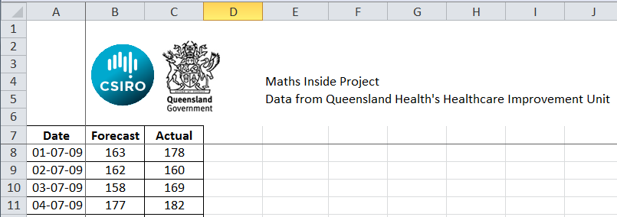

Use the spreadsheet to evaluate the accuracy of the forecasts.

Create a one-page ‘media release’ or a one-minute video ‘infomercial’ to inform the public about the accuracy of the Patient Admission Prediction Tool.

Include information about the percentage of days in which the forecast was very accurate.