

Investigating the maths inside:

Bees with backpacks

Activity 1

Making beehives

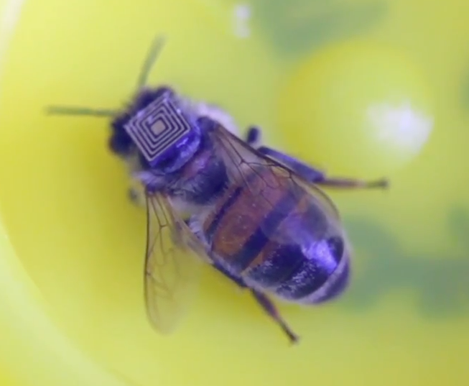

What do bees need to consider when making a ‘good’ beehive?

Why do bees make their hives from hexagons?

# Introduction

Beehives are bee houses.

What do bees need to consider when making a ‘good’ beehive? Share your ideas.

Why do bees make their hives from hexagons? What other regular shapes could they use?

# Beehive building

## With equilateral triangles

Working in pairs, fold a sheet of A4 cardboard into three equal parts. The fold needs to be about 100mm from the end.

Use sticky tape to join the two ends.

This will form an equilateral triangular prism.

## With squares

Next, fold a sheet of A4 cardboard into four equal parts. The fold needs to be about 100mm from the end. Always fold in the same direction so that the ends come together.

Use sticky tape to join the two ends.

This will form a square prism.

## With hexagons

Next, fold a sheet of A4 cardboard into six equal parts. First fold into thirds (as for a triangle), then fold each third into half. Always fold in the same direction so that the ends come together.

Use sticky tape to join the two ends.

This will form a hexagonal prism.

# Making the hives

Join all the triangular prisms together. Make at least two layers.

Do the same for the square prisms and the hexagonal prisms.

What do you notice about each of the hives?

Which do you think is the strongest? Which do you think is the most stable?

How could you test this?

Which type of beehive would you choose? Why? Explain your choice.

# How much honey?

How much honey could fit into each cell of each type of hive?

How could you find out?

# The best beehive

Which is the ‘best’ beehive? Explain.

Are there any other shapes that bees could use to construct their hives?

Why do you think that bees build their hives with hexagonal prisms?