

Investigating the maths inside:

Stargazing with the SKA

Activity 3A

Playing around with parabolas

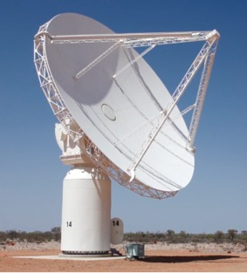

What shape is a parabola?

# Folding a parabola

You can fold creases into a piece of paper to form a curve.

1. Place a sheet of A4 paper in landscape in front of you and fold the paper from left to right so that when you crease the paper you have a centre line. Draw a dot on the piece of paper on the centre line about 5 cm up from the bottom edge.



1. Fold the bottom edge of the paper up so that the edge touches the point. Press firmly to make a sharp crease and open the paper again.



1. Fold again so that the bottom edge touches the point you drew.



1. Repeat folding at many different spots along the edge. Continue making a sharp crease and open the paper each time you fold.



1. Continue the folds on both ‘sides’ of the paper until you have about ten on both sides.



The many creases will form a parabola like this:

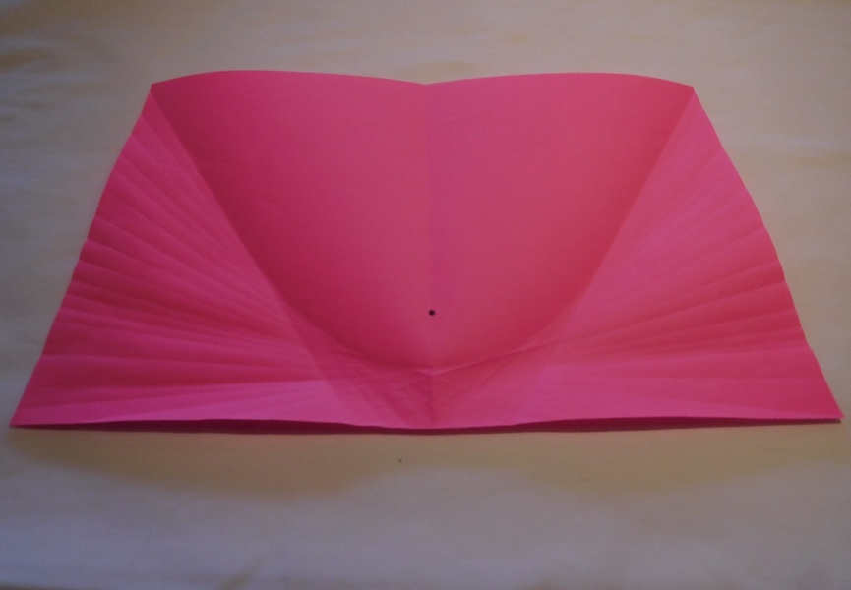

1. Mark a point which is more towards the centre of another A4 sheet of paper and do the same as before.

The point is called the **focus** of the parabola and the bottom edge of the paper is a line called the **directrix.**

Although the two curves have different shapes, they are actually the same with one curve an enlargement of the other. Which parabola looks like an enlargement of part of the other?

Try experimenting with the position of the focus point by placing it at different heights on the page.

How will the parabola look if the focus is place above the centre of the page?

How does it compare when the focus is placed above the centre of the page?

# What is the equation of the Sydney Harbour Bridge?

The bottom edge of the arch of the Sydney Harbour closely resembles a parabola.

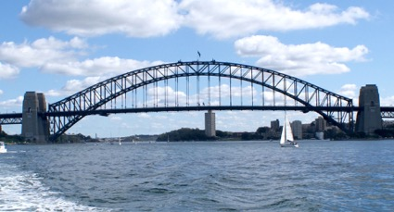

The arch spans a distance of 503 metres and is 118 metres high in the middle.

Use the coordinates of points *A*, *B* and *C* to find the equation of the arch in the form *y* = *ax*2.

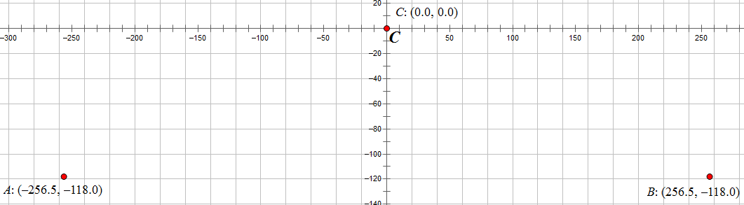

# Challenge 1

Explain why the creased lines must pass through a point on the parabola if a parabola is defined as all of the points that are equidistant from the focus and the directrix.

# Challenge 2

Show that the equation of the curve is $y=\frac{x^{2}}{4a}$ where the x-axis is parallel to the bottom edge of the page, the turning point of the parabola (the vertex) is the point (0, 0) and *a* is the distance between (0, 0) and the focus.