Jan’s train
http://topdrawer.aamt.edu.au/Reasoning/Good-teaching/Reasoning-for-all-students/Challenging-all-students

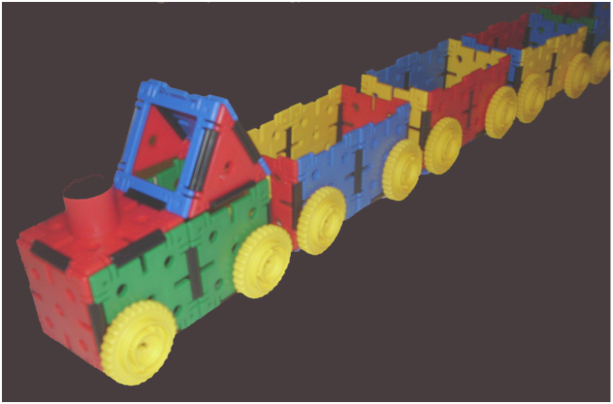

This is Jan’s train. It has one engine and nine carriages. The engine and carriages are each 15 cm long.
How long is the train?

Solve the problem in at least three different ways.
Share your thinking with someone sitting nearby.
How was their thinking the same as yours, and how was it different?
Together, work out some other lengths that the train could be if some of its carriages were removed. Draw at least three trains and write their lengths.

