Turn up the volume Year level: 8–10
Unit of work contributed by Ed Cuthbertson, Lanyon High School, ACT
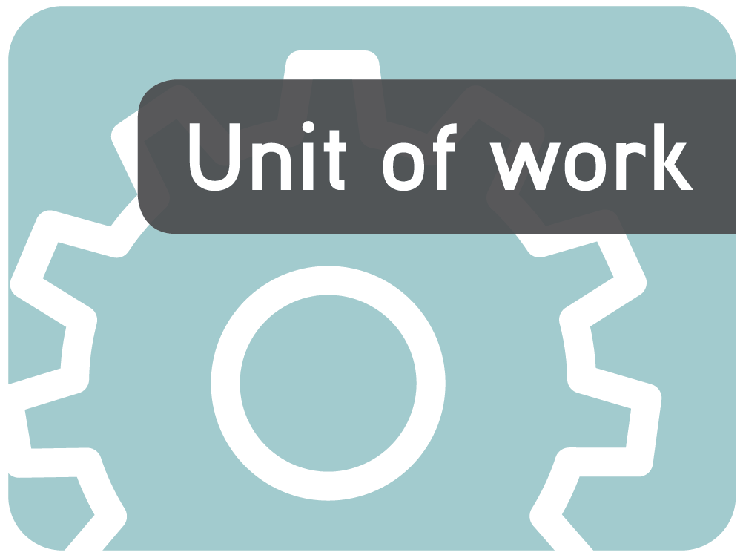
About the unit
Unit description
In this unit of work students explore and explain the connections between the surface area and volume of different shapes and how each attribute is measured.
Knowledge, understandings, skills, values
- Students will understand the concepts of surface area and volume and explore the differences between the two
- Students explore how surface area and volume are measured and how to apply this to their world
- Students will understand and use the different units of measurement for calculating volume and surface area of 2D and 3D objects
- Students will learn how to represent 3D objects on paper
- Students will explore the language associated with 3D objects
- Students estimate the volume of objects and explain their mathematical thinking
Focus questions
- What are the features of common plane (2D) and solid (3D) shapes?
- How are 3D shapes constructed?
- How does an object’s shape, dimensions and surface area affect its volume?
- How can an object’s volume be calculated using a common formula?
Resources
The Le@rning Federation digital curriculum resources
L3530 Geoboard: isometric [Windows version]
L3542 Platonic solids
Internet sites
- Paper models of polyhedra: http://www.korthalsaltes.com
- SEN teacher: http://www.senteacher.org/ (search for worksheet nets)
Software
- MS Word (or equivalent)
Other resources
- Digital or mobile phone cameras
- MAB (Multibase Arithmetic Blocks)
- Models of 3D shapes
- Grid paper
- Containers
Attached printable resources

The following teacher-created learning resources referred to in the Unit of work are available for you to modify, print and use in your own teaching and learning context:
- Scavenger hunt
- Features of shapes
- Predict the net
- Vertices, faces and edges
- Find the volume
- Estimation of volume
- Surface area
- Defining volume
- Sculpture assignment
- Student reflection: Sculpture assignment
- Surface area and volume: Sculpture assignment CQ rubric
Teaching the unit
Setting the scene
Resources
- L3530 Geoboard: isometric
- Scavenger hunt (page 10)
- Features of shapes (page 11)
- Digital camera (or mobile phone cameras)
- Hoops or rope circles to construct a Venn diagram
- Grid paper
- A variety of solid shapes
- MAB (Multibase Arithmetic Blocks)
Teaching and learning activities
Scavenger hunt
Students find examples in their environment of the shapes and solids listed on the Scavenger hunt worksheet (page 10) and photograph these using mobile phones or a digital camera.
~
Have students upload their photos into a Word document and use the ‘Insert shapes’ function to highlight the specific shape they are identifying.
As a class, discuss why each shape was used in the particular construction. Some reasons could be structural design, strength, economy, safety or aesthetics. Consider offering extra credit for shapes, not already on the worksheet, that are found and identified.
Features of shapes
Using the shapes from their scavenger hunt, students complete the Features of shapes worksheet (page 11), identifying the number of sides, corners and their measurement in degrees, particular features and, where possible, a formula for determining the surface area of each shape.
Have students look for patterns and relationships between the number of sides, corners and degrees.
Is there a formula that can be used to connect these?
~
Determine whether the shapes:
- are regular or irregular
- have lines of symmetry
- tessellate
- have parallel or converging lines
- change when they are reflected or rotated.
Include this information in the ‘Features’ column of the worksheet.
Prisms, pyramids and polyhedra
Construct a three-circle Venn diagram using three hoops. The labels for the hoops are ‘Prisms’, ‘Pyramids’ and ‘Regular polyhedra’. Discuss the definition of each term. Unveil a 3D shape and have students select the appropriate hoop and justify their choice.
Repeat for a variety of shapes.
~
Have students write a definition for each term (prism, pyramid, polyhedra) based on their observations, and ask them to provide diagrams of each to demonstrate their understanding.
Drawing 3D shapes
Use L3530 Geoboard: isometric to demonstrate how to draw 3D shapes and prisms. Using the virtual rubber band board demonstrate how you draw the base shape and extend out at the same angle.
~
Provide students with grid paper that has the same pattern as the pin board and instruct them to draw four different prisms, reminding them of the definition of a prism. Draw hidden edges using a dotted line.
A different perspective
Seat students in a circle and in the centre of the circle create a composite 3D shape using the MAB blocks. Have students divide a page into four sections and draw the side view of the shape you have created, from the position from which they are sitting.
Students compare their drawings with those next to them and make corrections.
Students then rotate the shape by 90° and draw their new view of the shape. Repeat until the 3D shape has been drawn four times.
How else could we view this shape and draw it?
~
Have students visualise and draw the shape from a different perspective and then compare the visualisation with the actual shape.
In what type of employment would this spatial skill be important?
~
Give students a 3D drawing to build using the MAB blocks.
Give students a 3D drawing and have them draw it from different angles.
Investigating
Resources
- L3542 Platonic solids
- Paper models of polyhedra: http://www.korthalsaltes.com
- SEN teacher: http://www.senteacher.org (search for worksheet nets)
- Predict the net (page 13)
- Vertices, faces and edges (page 12)
- Find the volume (page 17)
- Estimation of volume (page 16)
- Surface area (page 14)
- Defining volume (page 15)
Teaching and learning activities
Vertices, faces and edges
Use L3542 Platonic solids to highlight the faces/edges/vertices of different polygons. Investigate the relationships between the number of faces, vertices and edges.
What is Euler’s formula?
How can it be written as a mathematical formula for a ready reference tool?
~
Have students use the Vertices, faces and edges worksheet (page 12) to investigate and summarise information about the faces, vertices and edges of a variety of 3D objects.
~
Investigate the difference between Platonic solids and Archimedean solids.
The shapes of shapes
Using models of 3D shapes have students complete the Predict the net worksheet (page 13) for the nets of basic shapes.
Students identify the shape then predict what the net will look like.
They check their predictions by comparing their nets with those available from sites such as:
- Paper models of polyhedra: http://www.korthalsaltes.com
- SEN teacher: http://www.senteacher.org (search for ‘worksheet nets’)
Students make corrections in the ‘Actual net’ column of their worksheet.
On the surface
Create a cardboard box with a different colour to differentiate each face.
In pairs, have students record the steps they would take to find the surface area of the box. Have them justify each step. For example, they should say that the formula for finding the area of a rectangle is length times width.
Students sit in a circle. Have one volunteer to sit in the middle with the multi-coloured box. Choose a student at random to describe their steps aloud. The student in the middle follows the exact steps. If a mistake is made then a new student begins to give instructions. Students can update and review their steps as the activity proceeds to make sure their instructions are correct.
Vary this activity by having students pair up and sit back to back. One reads the instructions and the other follows them.
~
Complete the Surface area worksheet (page 14). Students draw each prism, its net and then explain how they would find the surface area of a triangular prism, rectangular prism and a cube, and also a cylinder.
Discuss the real-world applications for being able to calculate the surface area of a solid shape.
Defining volume
Using the Defining volume worksheet (page 15), have students write their own definition of volume, then interview seven of their peers.
At each interview the students read their definition to each other and then, using whole numbers, rank the quality of their definitions out of seven. For example, Ben’s might be 2, and Ed’s 5 because it is more comprehensive.
By the end of the process, students should have seven scores with a possible total of 49. Have them add their scores and grade themselves.
What made the top definitions better than others?
Students rewrite their original definition.
Surface area or volume?
What is the difference between surface area and volume?
Use a Venn diagram to summarise a class discussion about the similarities and differences between surface area and volume.
Estimating volume
Have students sit in a circle and in the centre place a variety of different sized containers such as cardboard boxes, eskies, lunch boxes and small objects such as cricket balls, pencils and erasers.
Provide each student with a copy of the Estimation of volume table (page 16).
Spin a bottle to determine the order of play. The first student has to devise a question using an object and a container. For example, ‘How many cricket balls would fit inside this esky?’ All students make an estimate and record this on their worksheet.
Spin the bottle again and ask the next student for their estimation and how it was made. Test their estimate. Students may also put boundaries on their estimate such as, ‘Between 1 and 5 cricket balls would fit in that shoe box’.
How could you make your estimate more accurate?
How would you answer if you needed to be exact?
What equipment would be required?
Students complete the Find the volume worksheet (page 17), recording how they would find the volume of a variety of prisms. Model one example for the class.
Bringing it all together
Resources
- Sculpture assignment (page 18)
- Student reflection: Sculpture assignment (page 22)
- Surface area and volume: Sculpture assignment CQ rubric (page 21)
Teaching and learning activities
The final frontier
Students are given grid paper of various colours.
Using their knowledge of different prisms they are to draw and build:
- a cube
- a rectangular prism
- a triangular prism
All three prisms should have a volume of 36 cubic centimetres (or another volume specified by the teacher).
~
Students record the dimensions of each shape and measure the surface area.
What was the relationship between the surface area and the volume for each shape?
Why do you think this is the case?
Displacement
Using 3D plastic shapes, have students find and record the volume of each prism in a data set.
Then fill each plastic shape with water and measure the amount of water in millilitres. Students record on their data set.
Weigh the water contained in each shape.
Record the results.
From the data gathered what assumptions can we make about the relationship between millilitres, grams and cubic centimetres?

Investigate the displacement of water when measuring the volume of different objects, for example, rocks or an eraser. How many millilitres are displaced when each item is placed in the beaker.
How could we measure the volume of a person?
Assessment
Sculpture assignment
Students investigate and calculate the surface area and volume of three different prisms while creating a sculpture. They then complete the Sculpture assignment worksheet (page 18).
Have students fill in the attached Student reflection sheet on completion of this unit.
Writer: Ed Cuthbertson
The material in this Unit of work may contain links to internet sites maintained by entities not connected to Education Services Australia Ltd and which it does not control (‘Sites’).
Education Services Australia Ltd:
- provides the links for ease of reference only and it does not sponsor, sanction or approve of any material contained on the Sites; and
- does not make any warranties or representations as to, and will not be liable for, the accuracy or any other aspect of the material on the Sites or any other matter connected to the use of the Sites.



While the material in this Unit of work is not remunerable under Part VB of the Copyright Act 1968, material on the Sites may be remunerable under Part VB of the Copyright Act 1968. It is your responsibility to read and comply with any copyright information, notices or conditions of use which apply to a Site.

Scavenger hunt

Name |  | Class |  | Date

  - Find and photograph examples of the following shapes, and upload them to a MSWord document:
Plane (2D) shapes

Square
Rectangle
Parallelogram
Triangle
Circle
Rhombus
Trapezium
Pentagon

Solid (3D) shapes

Cube
Rectangular prism
Triangular prism
Cylinder
Pyramid
Rectangular prism
Tetrahedron
Octahedron

  - Use the drawing tools within MSWord to highlight the particular shape, as shown in the examples.
Pentagon Rectangle
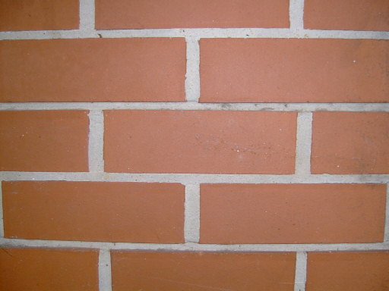
Lanyon High School, ACT.
Lanyon High School, ACT.

  - Suggest the reason the shape was chosen for this purpose (for example, structural design, strength, economics, safety, aesthetics).

Features of shapes

Name |  | Class |  | Date
- Identify the number of sides, number of corners, and degrees (use a protractor) of shapes
- In the features column determine whether:

- all angles in the shape are right angles
- all sides in the shape are the same
- all angles in the shape are the same
- two sides of the shape are the same length.

- Develop a formula for determining the area of the shape. Draw a diagram to explain your calculations.
Shape | Sides | Corners | Name | Features | Formula

Vertices, faces and edges

Name |  | Class |  | Date
Investigate and record the number of faces, vertices and edges of a variety of polyhedra.
3D shape | Faces | Edges | Vertices

Predict the net

Name |  | Class |  | Date
- Examine models of 3D shapes. Draw them in the first column.
- Make a prediction of what the net will look like for each shape. Draw your prediction in column two.
- Compare your predicted nets with those available from sites such as:
- Paper models of polyhedra http://www.korthalsaltes.com
- SEN teacher http://www.senteacher.org/ (search for worksheet nets)
- Draw the actual net in column three.
3D shape | Predicted net | Actual net

Surface area
Name |  | Class |  | Date

Prism | Draw the net of this prism | Calculate the area of each face | Add all areas together to work out the surface area
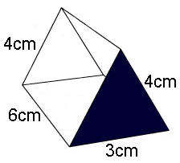
Triangular prism
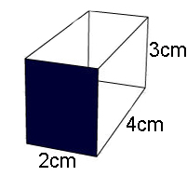
Rectangular prism
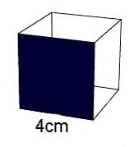
Cube
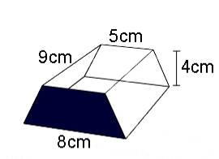
Trapezoidal prism

Defining volume
Name |  | Class |  | Date

Write your own definition of volume below, have a good think about what you write as it will be compared to others’ definitions.

Write some good words used by other students for their definitions in the box below.

Write the best definition for volume determined by the whole class in the box below.
Read each others’ definitions and give each a score that totals 7. i.e. Your Score + Partner’s Score = 7

1. Name: |  | Your score: | + | Partner’s score: | = | 7
2. Name: |  | Your score: | + | Partner’s score: | = | 7
3. Name: |  | Your score: | + | Partner’s score: | = | 7
4. Name: |  | Your score: | + | Partner’s score: | = | 7
5. Name: |  | Your score: | + | Partner’s score: | = | 7
6. Name: |  | Your score: | + | Partner’s score: | = | 7
7. Name: |  | Your score: | + | Partner’s score: | = | 7
Add your scores and write your total here

Estimation of volume
Name |  | Class |  | Date
Estimate how many objects will fit in each container. For example, ‘How many cricket balls would fit inside this esky?’ Make an estimate and record it in the table.
How many … | Fit into … | Estimation
eg Milk cartons | A milk crate | 16

Find the volume
Name |  | Class |  | Date
How would you find the volume of a prism? Explain each step in calculating the volume of the prism. You must use sentences and include any formula or working out.
Prism | How would you find the volume?
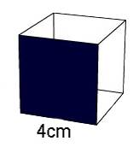
Cube
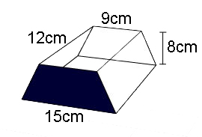
Trapezoidal prism
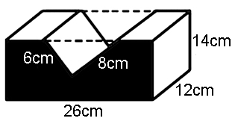
Composite prism
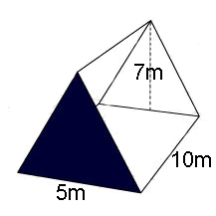
Triangular prism

Sculpture assignment
Name |  |  | Class |  | Date
Team members

Surface area and volume: creating three prisms from an A3 sheet
Equipment:
- A3 paper
- Ruler
- Pencil
- Calculator
- Glue
- Scissors
- Colour pencils
Organisation
- Form groups of two or three
- Collect an A3 sheet of paper from your teacher
- Make sure you have the appropriate equipment
Self assessment
Lesson date:
What did you achieve in this lesson?

The Task
  - You have one A3 sheet of paper on which you have to draw the net of three different prisms. You can choose from:
- Rectangular prism
- Triangular prism
- Quadrilateral prism
- Cube
- Square prism
- Rhomboid
2. The object of the task is to create the 3 prism/nets with the least amount of waste as possible.
3. Create your prisms using foam board.
4. Join with another group and create a sculpture by sticking all your prisms together.
5. Take a photo of your geometric prism sculpture.
Task Summary | Sign when completed
Draw nets of three prisms on a sheet of A3 paper with the least waste.
Measure the amount of waste from your A3 sheet.
Measure the surface area of your three prisms.
Measure the volume of your three prisms.
Measure the surface area of your sculpture.
Measure the volume of your sculpture.
Draw a 3D picture of your sculpture.
Reflect on what you did well and what you could improve.
Task 1
Explain how your group designed the three prisms to fit into the A3 sheet.
You can write it step by step or explain as a story or cartoon.
Task 2
Explain mathematically how you worked out how much paper was being wasted with your design.
Estimate before you make your calculations:__________________
Task 3
Explain mathematically (using formulas and diagrams where appropriate) how you found the surface area of each of your prisms.
Estimate before you make your calculations:_________________
Task 4
Explain mathematically (using formulas and diagrams where appropriate) how you found the volume of each of your prisms.
Estimate before you make your calculations:_________________
Task 5
Draw your sculpture from the following perspectives. Use a ruler and be neat.
- Bird’s-eye view (top)
- Worm’s-eye view (bottom)
- Front
- Side

Bird’s-eye view | Worm’s-eye view
Front | Top
Task 6
Explain mathematically (using formulas and diagrams where appropriate) how you found the surface area of your sculpture.
Estimate before you make your calculations:__________________
Task 7
Explain mathematically (using formulas and diagrams where appropriate) how you found the volume of your sculpture.
Estimate before you make your calculations:_________________

Surface area and volume: Sculpture assignment CQ rubric

Expectations |  | Selected feedback
Criteria | Quality | Achievement | Evidence of suggestions
Solving mathematical problems | Uses appropriate formulas to find surface area of common prisms  Uses appropriate formulas to find volume of common prisms  Makes appropriate estimates of surface area and volume of common prisms  Uses appropriate units of measurement  Processes calculations correctly | Proficient  Working towards  Requires attention
Drawing and construction 2D and 3D representations | Draws by hand 2D and 3D representations of common prisms from different perspectives  Draws nets and constructs common prisms | Proficient  Working towards  Requires attention
Communicating mathematical understanding | Explains solution strategies and reasons for answers | Proficient  Working towards  Requires attention

Additional Criteria:

- Submitted on time
- Work is neat and tidy
- Student name clearly marked
- All sections complete

Student reflection: sculpture assignment
Name |  | Class |  | Date

Step 1:  What was I expected to do? | Reflect upon what you have done. How was it useful?
Step 2:  What are the pluses, minuses, and what do I find interesting? | Positive | Negative | Interesting
Step 3:
What did I do well?
Step 4:
What would I do differently?
Step 5:  What were the important skills (key competencies) demonstrated by this task or activity? (Identify one or two) | By doing this task or activity, I have demonstrated these skills:

