Fraction action Year level: 7–8
Unit of work contributed by Terry Jacka, St Hilda's School, Qld
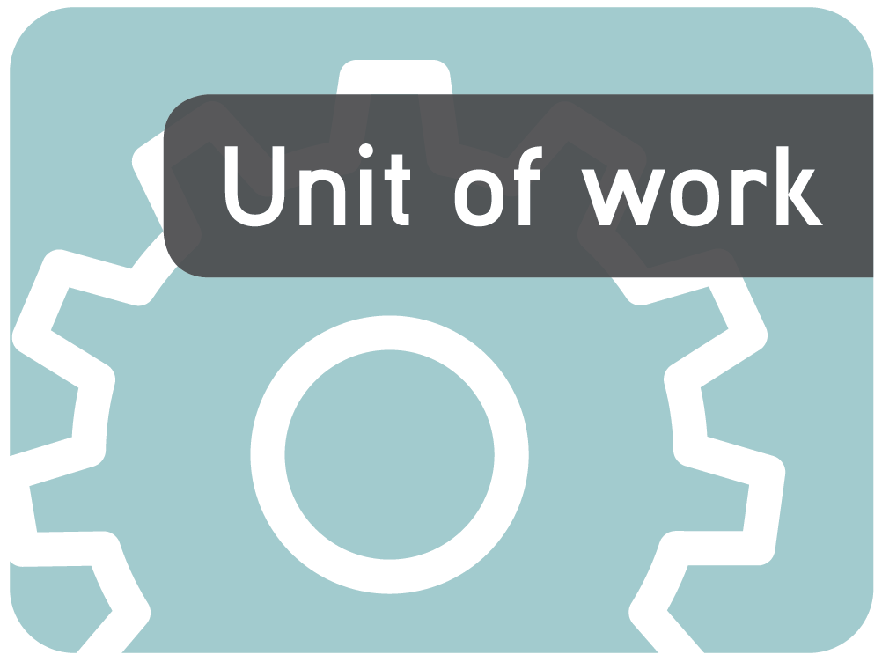
About the unit
Unit description
In this unit of work students move from working with tenths, hundredths and thousandths to relating common and decimal fractions and percentages.
Knowledge, understandings, skills, values
- Use fractions, decimals and percentages to understand the relationship between them
- Understand the relationship between common and decimal fractions
- Understand and use decimal fractions
- Plan and undertake efficient mathematical investigations to explore particular problems and generate an effective solution
- Transfer what students already know to new situations to enrich and enhance understanding
- Value how decimal and common fractions and percentages are used (interchangeably) in real-world situations
Focus questions
- What is the relationship between common and decimal fractions and percentages?
- How can common and decimal fractions and percentages be used (interchangeably) in real-world situations?
Resources
Digital curriculum resources
Wishball series: L869 hundredths, L495 thousandths, L873 challenge: hundredths, L874 challenge: thousandths, L875 challenge: ultimate
Swamp survival series: L7901 hundredths counting, L7902 hundredths patterns, L7903 hundredths challenge, L7904 thousandths counting, L7905 thousandths patterns, L7906 thousandths challenge
L3521 Fractions: comparing
L6542 Exploring fractions
L133 Playground percentages
L6545 Exploring combined percentages
Design series: L127 Design a school, L122 Design a neighbourhood, L123 Design a city, L124 Design a farm
Other resources
- Metre rulers
- 30-cm rulers to use as number lines
- Cardboard for making games
- Pattern blocks
- 1-m lengths of string
- Coins, one per couple
Printable worksheets

The following teacher-created learning resources referred to in the unit of work are available for you to modify, print and use in your own teaching and learning context:
- Blank 10 x 10 grid (page 16)
- Coin toss record sheet (page 11)
- Comparing decimals (pages 9))
- Ordering decimals (page 10)
- Fraction snap cards (page 17)
- Design a mural – assessment task (page 12)
Teaching the unit
Setting the scene
Resources
- 1-m lengths of string
- Blank 10 x 10 grid (page 16)
- Fraction snap cards (page 17)
- Wishball series: L869 hundredths, L495 thousandths, L873 challenge: hundredths, L874 challenge: thousandths, L875 challenge: ultimate
- Comparing decimals activity sheet (pages 9)
- Ordering decimals activity sheet (page 10)
- Swamp survival series: L7901 hundredths counting, L7902 hundredths patterns, L7903 hundredths challenge, L7904 thousandths counting, L7905 thousandths patterns, L7906 thousandths challenge
Teaching and learning activities
How long is a piece of string?
In front of students fold a metre of string in half to emphasise a fraction as part of a whole.
What fraction of the metre is folded?
Consolidate the language of fractions and the meaning of the symbol ‘½’ (ie one part of two).
How could you represent this fraction as a decimal?
Measure the folded string to consolidate the concept of decimals as being parts of 100 – in this case 100 cm.
After folding the string in four and then eight, measure it again, each time emphasising that the fraction is part of the whole. Represent the part in both fraction and decimal formats.
Give groups their own metre of string to fold and have them construct a table of common and decimal fractions of a metre such as ½, ¼, ⅛, ⅔ and ⅓.
Challenge them to convert the fractions to percentages and add this information to the table.
Have the groups share their observations and then summarise them. Explore these issues while encouraging the use of mathematical language:
How can we order fractions and decimals?
Given two decimals, what would you look for to decide which is largest?
Given two fractions, how can you tell which is largest?
Fractions and decimals
Have students undertake the following activities to develop their understanding of fractions and decimals.
- Locate decimal fractions (tenths and hundredths) on a number line (or a ruler) and then use this information to order the fractions.
- Practise ordering decimal numbers by sorting the non-fiction resources in the library so they are ready for shelving.
- Project a 10 x 10 grid onto a screen so students can highlight different fraction and decimal values. Have fraction and decimal values written on cards for students to select and shade.
- Write decimal fractions (tenths, hundredths and thousandths) in words as well as numerals.
- Have students write decimal fractions in words and as numerals on pairs of cards.
Use the cards to play matching games, concentration and snap.
- Use cards created in the previous activity to order decimals and fractions in numeral and word form.
- Use the Wishball series of learning objects to practise making decimal numbers using tenths, hundredths and thousandths.
- Use the < and > symbols to compare decimal fractions (tenths and hundredths).
Complete the Comparing decimals activity sheet (page 9).
- Order decimal fractions (tenths and hundredths).
Complete the Ordering decimals activity sheet (page 10).
- Use the Swamp survival series of learning objects to practise patterning and ordering of decimal fractions.
Assessment
Have students begin a print or digital learning journal to record their new understandings and reflections as they complete each section. This will show them that they are making progress.
Investigating
Resources
- Coins, one per couple
- Coin toss record sheet (page 11)
- Fraction snap cards (page 17)
- Blank 10 x 10 grid (page 16)
- L3521 Fractions: comparing
- L6542 Exploring fractions
- L133 Playground percentages
- L6545 Exploring combined percentages
- Design series: L127 Design a school, L122 Design a neighbourhood, L123 Design a city, L124 Design a farm
Teaching and learning activities
Coin toss
If we tossed a coin 100 times, how could we represent what part of the hundred throws were heads using per cent, decimals and fractions?
If we tossed the coin 50 times, could we still write what part of the throws were heads using per cent, decimals and fractions? If so, how?
What about if the coin were tossed 20 times?
~
Have students work in pairs to investigate what percentage of times heads will occur when a coin is tossed 10, 20, 50 and 100 times. Remind students that the number of times the coin is tossed is the ‘whole’ and is represented by the denominator. The number of times heads occurs is the part and is represented by the numerator. So 50/100 is 50 per cent, as is 10/20.
Have students record their responses on the Coin toss record sheet (page 11). They should complete only the first two columns initially to collect the data, and then add extra columns to complete activity.
~
Discuss the relationships between fractions, decimals and per cents in pairs, and then have them share with the class. Summarise their observations.
What does per cent mean?
How does the meaning help us understand the relationship between per cents and fractions?
How can we change fractions to decimals to per cents and back?
Equivalence
Create a chart that becomes a ready reference for equivalent common fractions. Remind students of the activity they did with folding string.
Create various sized grids for students to colour to model equivalent fractions.
~
Use learning objects L3521 Fractions: comparing and L6542 Exploring fractions to help students consolidate their understanding.
Relationships
Use the blank 10 x 10 grid (page 16) to relate common and decimal fractions involving hundredths and to shade decimal, fraction and per cents.
Express common fractions such as ¾ as decimal fractions (hundredths).
~
Use learning objects L133 Playground percentages and L6545 Exploring combined percentages to help students consolidate their understanding.
Use the 10 x 10 grid (page 16) to relate percentage to common and decimal fractions.
Use the fraction snap cards (page 17) to play bingo or fraction, per cent or decimal snap.
Explore learning object L127 Design a school and then have students select from L122 Design a neighbourhood, L123 Design a city or L124 Design a farm to help them consolidate their understanding.
Bringing it all together
Resources
- Design a mural assessment task (page 12)
Assessment
Have students complete the Design a mural assessment task which involves 15-minutes group work, 30-minutes individual work and a homework activity.
Share designs for the mural on a noticeboard display.
Drawing conclusions
Teaching and learning activities
Discuss real-life occasions where students are likely to use fractions, decimals and per cents. Find and display real-life examples. Have each student construct a real-life problem for others to solve such as:
How much would an MP3 player be if it were 20 per cent off its price of $268.00?
Your recipe requires 250 g of sugar. What percentage of a 1 kg bag is that?
You are building a skate ramp and your instructions require four 90-cm lengths of wood. Will cutting a 3.6-m length in quarters give you want you want?
You decide to save for a bike and your gran gives you $200 towards it, which you put in a bank account that gets 5.5 per cent interest. If you leave it for one year and do not add to it, how much extra will you have for your bike?
You are allowed to repaint your room, and the best balance of colours is 60 per cent in the main colour, 40 per cent in a contrast colour and 10 per cent in an accent colour. It will take 16.5 L of paint altogether, so how many litres of each colour do you need?
Communicating
Teaching and learning activities
Class discussions following and during each activity will be used to clarify and consolidate concepts. Vocalisation of understanding is essential to embedding concepts.
Reflections that students write following completion of learning objects and initial activities will support understanding.
Writer: Terry Jacka
The material in this unit of work may contain links to internet sites maintained by entities not connected to Education Services Australia Ltd and which it does not control (‘Sites’).
Education Services Australia Ltd:
- provides the links for ease of reference only and it does not sponsor, sanction or approve of any material contained on the Sites; and
- does not make any warranties or representations as to, and will not be liable for, the accuracy or any other aspect of the material on the Sites or any other matter connected to the use of the Sites.



While the material in this unit of work is not remunerable under Part VB of the Copyright Act 1968, material on the Sites may be remunerable under Part VB of the Copyright Act 1968. It is your responsibility to read and comply with any copyright information, notices or conditions of use which apply to a Site.

Comparing decimals

Name |  | Class |  | Date

Which is bigger?
- Compare the decimals and complete the sentences.
8.6 | 8.67 | 9.6 | 8.5
- 8.6 is than 8.5.
- 8.6 is than 8.67.
- Write two more true statements about the set of decimals.
- Complete the sentence with the correct symbol < (less than) or > (greater than).
- 3.45 is 3.4.
- 3.25 is 3.8.
- Arrange the following numbers in order from smallest to largest using the less than < symbol.
12.7 | 12.56 | 12.57 | 12.4

- Complete the following statements about the number 12.4 using the < and > symbols.
- 12.4 is 12.48.
- 12.4 is 12.56.
- 12.4 is 12.37.
- 12.4 is 12.74.
- 12.4 is 12.28.

- Use the following set of decimals to write as many statements as you can using the greater than > symbol.
5.78 | 3.45 | 2.46 | 7.8
12.57 | 1.45 | 10.56 | 7.86

Ordering decimals

Name |  | Class |  | Date

- Arrange the decimals in ascending order, which means from smallest to largest.
- 8.73 8.7 8.07 8.3
- 4.26 4.02 4.2 4.06
- Arrange the decimals in descending order, which means from largest to smallest.
- 19.29 19.2 19.02 19.9
- 2.36 2.02 2.3 2.6
- Arrange these numbers in ascending order.

7.35 | 1.11 | 7.08 | 2.07
7 | 1.1 | 7.03 | 0.11
2.17 | 1.01 | 7.8 | 2.87

Coin toss record sheet

Name |  | Class |  | Date

Number of tosses | Number of heads | Fraction | Decimal | Per cent
100
50
20
10
1

Design a mural

Name |  | Class |  | Date

Instructions
Mrs Sanburg wants her school’s Maths teachers to make a tile mural on the Reeves Stage wall to celebrate Maths Week. The space measures 1 sq m.
Mrs Sanburg needs to decide how many of each coloured tile to purchase.
Each tile is 10 cm x 10 cm.
Mr McNamee wants red, blue and gold tiles in the mural because they are the school colours. He wants twice as many red as blue and three times as many blue as gold.
Ms Ham wants green in the mural.
Mrs Churchill wants orange in the mural.
Mrs Baker wants pink in the mural.
Mr Greening wants black in the mural.
Each teacher must have at least one tile in the mural and tiles cannot be cut into fractions.

Part 1 – Planning (group work 15–20 min)
Make a suitable plan for the mural. (Note: Mrs Sanburg needs to know how many of each colour to purchase, not where they go.)
Be sure you meet all the requirements.
Below are some grids for rough working (to assist you in your planning).
Submit this sheet with your investigation.

Part 2 – Individual work (20–30 min)
Part A
Using your group’s colour plan, make a table showing the fraction, decimal and percentage of each colour in the mural.

Colour | Fraction( /100) | Decimal | Percentage

Part B
Mrs Sanburg says that all the tiles will be used. Design a mural with the largest possible area covered in blue tiles that still fits all the teachers’ requirements.
Show calculations to justify that your plan has the largest possible area of blue. Place your mural plan on the attached grid.
(Note: You only need to determine quantity of colours. Placement of tiles comes later.)
Explain how your colour plan satisfies each Maths teacher.
Mrs Sanburg decides that she wants the mural’s size to be doubled to 2 m x 2 m. One student, Mia, says she will need twice as many tiles, but Olivia, another student, is not sure and says she might need four times as many tiles. Who is correct? Show your solution using diagrams and calculations.

Part 3 – Homework
Show your design for the mural that satisfies all of the requirements.
Make it a mathematical design and then explain why your design is mathematical.
Use some of these words in your explanation:
symmetrical | Geometrical | equilateral | triangular
Square | Rectangular | shape | reflection
numerical | Diagonal | parallel | perpendicular
Design

Explanation

10 x 10 grid

Name |  | Class |  | Date

Fraction snap cards

1/2 |  | ¼ |  | 3/4 |  | 1/8
0.5 |  | 0.25 |  | 0.75 |  | 0.125
1/5 |  | 1/3 |  | 4/5 |  | 2/3
0.2 |  | 0.33 |  | 0.8 |  | 0.66
1/10 |  | 2/5 |  | 3/5 |  | 10%
0.1 |  | 0.4 |  | 0.6 |  | 20%
25% |  | 33% |  | 40% |  | 50%
60% |  | 66% |  | 75% |  | 80%

