Telling the time Year level: 4–10
Unit of work contributed by Michael Macrae, Duncraig Senior High School Education Support Centre, WA
L7789 School day: analogue. Copyright Education Services Australia Ltd
About the unit
Unit description
This unit introduces the formal measurement of time using the terms ‘o’clock’, ‘half past’, ‘quarter past’ and ‘quarter to’ and their representation on an analogue clock. It is specifically for students with autism spectrum disorders (ASD), so the learning experiences offered are structured, methodical and sequential and require one-to-one instruction.
Knowledge, understandings, skills, values
Students will learn to:
- recognise the time on an analogue clock using ‘o’clock’, ‘half past’, ‘quarter past’ and ‘quarter to’.
Focus questions
- How do we know when we are supposed to do things?
- Why do we use a clock?
- What do the hands on the clock mean?
- What do the numbers on the clock mean?
Resources
The Le@rning Federation digital curriculum resources
L9653 Time tools: 12-hour to the half hour: time match
L7789 School day: analogue
L7795 After school: analogue
Internet sites
- Division TEACHH (Treatment and Education of Autistic and related Communication-handicapped Children): http://www.teacch.com/
Other resources
- Clock
- Cards with clock faces and times (use Making time worksheet)
- Cards of regular daily activities, at home and school
- One-minute eggtimer
Attached printable resources

The following teacher-created learning resources referred to in the Unit of work are available for you to modify, print and use in your own teaching and learning context
- Making time activity cards (page 7)
- Telling time activity tracking sheet (page 11)
- A journey through my day (page 12)
Teaching the unit
Setting the scene
Resources
- Clock
- One-minute eggtimer
- Small picture cards of regular daily activities
Teaching and learning activities
Tracking time
Many ASD students need to have a predictable and regular routine. Build on this by explaining that clocks help us to keep track of time so we do things when we need to. Discuss the student’s daily routine from the time they wake up to the time they go to bed. Identify the things they do every day and make a chart of these using individual moveable pictures with captions.
If appropriate, help develop the language of time and sequence by asking questions such as:
What do you do after ... ?
What do you do before ... ?
Did you do ... before or after ... ?
Could you do ... before you did ... ? Why?
Provide the student with a clock and, together, explore how it works. If it is battery-operated, take the battery out so the student can manipulate the hands manually. Introduce the terminology of hands, hours, minutes and so forth. Then insert the battery and set the eggtimer going so the student can see the second and minute hands moving and how far they move in one minute.
Explain that from now until the student is ... (insert appropriate activity an hour later), the minute hand will have moved all the way around the clock face back to where it is now, and the hour hand will have moved on to the next number. Set the clock nearby so the student can watch the hands’ progress while engaged in other activities.
Assessment
Record what the student already knows about time and its passage. Then choose a sequence of learning activities that will best meet their needs and are realistic, achievable and measurable.
Investigating
Resources
- Making time activity cards (cut out and laminate)
- Clock
- Telling time activity tracking sheet
- L9653 Time tools: 12-hour to the half hour: time match
Teaching and learning activities
Making time
Ask the student how they know when it is time to eat breakfast, catch the bus, go to lunch, and so forth. Explore the concept of ‘o’clock’ and what it looks like on the clock. Let the student manipulate the hands to make the various times.
Have the student draw the times of different daily activities onto the laminated clock faces (from the Making time activity cards) using a whiteboard marker. Then attach the correct version to the routine chart. Record the time in the formats 11.00 and 11 o’clock.
Have the student articulate what their chart tells them: ’At 11 o’clock I ... ’
Matching time
Make a time on the clock face and ask the student to show you the matching time card from a selection of three choices.
As they become more adept, provide the student with the Making time activity card clock faces with ‘o’clock’ times marked on them, as well as cards with times in written format. This activity could be done using cards, a cut-and-paste worksheet, or an interactive whiteboard. Have students match the clock face to the correct time.
Give the student the time in written format and have them draw it on a clock face. Start with one example and gradually increase this. For each example, prompt the student for activities they would undertake at this time. For example, ‘What would you normally be doing at 11.00 am?’
Extending time
As the student gets more proficient, repeat the sequence of activities to introduce the concepts of half past, quarter past and quarter to. When half past is understood, have them play L9653 Time tools: 12-hour to the half hour: time match.
Assessment
If the student offers no response to an instruction, repeat it and record this prompt by placing VP (verbal prompt) in the Response column of the Telling time activity tracking sheet. If there is still no response, touch the correct clock and enter PP (physical prompt) in the Response column. If the student still does not select the correct card, remove one or both of the incorrect clocks and repeat the instruction. Record this as VP, PP. If there is still no response, place your hand on the student’s and show them what is required. Record this as HOH (hand on hand). When the student achieves the task independently, record this as AI.
Once a task has been generalised it should be integrated into the student’s independent workload so it is consolidated and applied.
Bringing it all together
Resources
- L7789 School day: analogue
- L7795 After school: analogue
- A journey through my day
Teaching and learning activities
The school day
Use the two learning objects to consolidate both the concept of o’clock and ordering time. Compare Neo’s day to the student’s.
What things do you do that are the same as Neo?
What things do you do at the same time as Neo?
Each day, have the student select the appropriate time cards to construct their daily timetable. At the end of the day, discuss the things they have done and in what order.
A day in the life
Ask the student to complete the A journey through my day worksheet by drawing the relevant activity in each segment. Activities done after 6.00 pm are drawn on the back.
Writer: Michael Macrae
The material in this Unit of work may contain links to internet sites maintained by entities not connected to Education Services Australia Ltd and which it does not control (‘Sites’).
Education Services Australia Ltd:
- provides the links for ease of reference only and it does not sponsor, sanction or approve of any material contained on the Sites; and
- does not make any warranties or representations as to, and will not be liable for, the accuracy or any other aspect of the material on the Sites or any other matter connected to the use of the Sites.
While the material in this Unit of work is not remunerable under Part VB of the Copyright Act 1968, material on the Sites may be remunerable under Part VB of the Copyright Act 1968. It is your responsibility to read and comply with any copyright information, notices or conditions of use which apply to a Site.




Making time activity cards
Clock faces
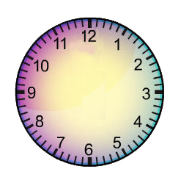
Digital times
1.00 |  | 2.00 |  | 3.00 |  | 4.00
5.00 |  | 6.00 |  | 7.00 |  | 8.00
9.00 |  | 10.00 |  | 11.00 |  | 12.00
1.30 |  | 2.30 |  | 3.30 |  | 4.30

5.30 |  | 6.30 |  | 7.30 |  | 8.30
9.30 |  | 10.30 |  | 11.30 |  | 12.30
1.15 |  | 2.15 |  | 3.15 |  | 4.15
5.15 |  | 6.15 |  | 7.15 |  | 8.15
9.15 |  | 10.15 |  | 11.15 |  | 12.15
1.45 |  | 2.45 |  | 3.45 |  | 4.45
5.45 |  | 6.45 |  | 7.45 |  | 8.45

9.45 |  | 10.45 |  | 11.45 |  | 12.45
Written times

1 o’clock |  | 2 o’clock |  | 3 o’clock |  | 4 o’clock
5 o’clock |  | 6 o’clock |  | 7 o’clock |  | 8 o’clock
9 o’clock |  | 10 o’clock |  | 11 o’clock |  | 12 o’clock
half past 1 |  | half past 2 |  | half past 3 |  | half past 4
half past 5 |  | half past 6 |  | half past 7 |  | half past 8
half past 9 |  | half past 10 |  | half past 11 |  | half past 12

quarter past 1 |  | quarter past 2 |  | quarter past 3 |  | quarter past 4
quarter past 5 |  | quarter past 6 |  | quarter past 7 |  | quarter past 8
quarter past 9 |  | quarter past 10 |  | quarter past 11 |  | quarter past 12
quarter  to 1 |  | quarter  to 2 |  | quarter  to 3 |  | quarter  to 4
quarter  to 5 |  | quarter  to 6 |  | quarter  to 7 |  | quarter  to 8
quarter  to 9 |  | quarter  to 10 |  | quarter  to 11 |  | quarter  to 12

Telling time activity tracking sheet

Name |  | Class

Activity | Response | Comments | Date
Descriptors
AI (achieved independently), HOH (hand on hand), PP (physical prompt), VP (verbal prompt)

A journey through my day
Name |  | Class |  | Date

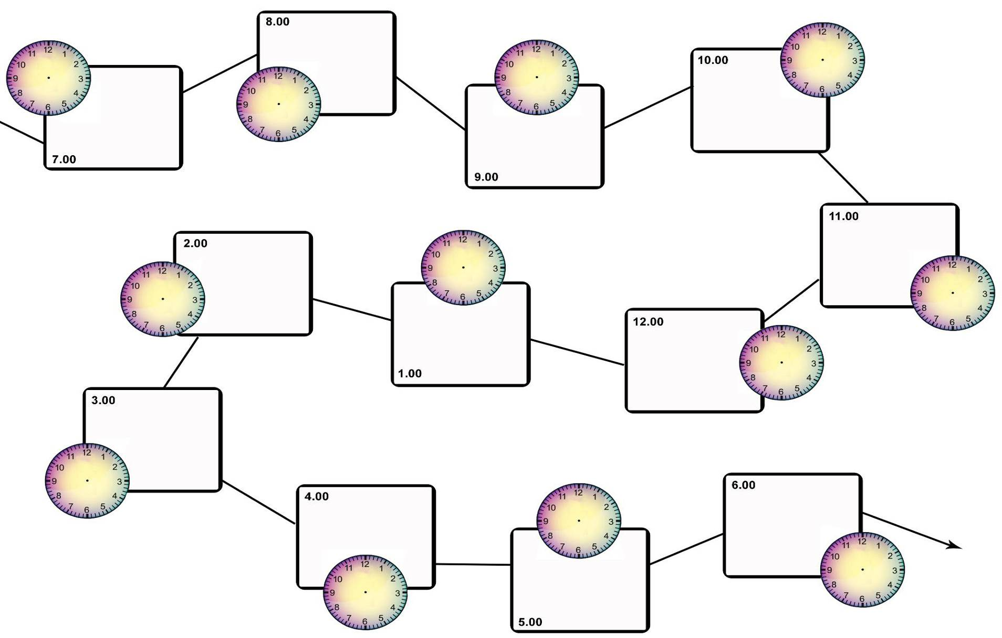
Draw the time on each blank clock face. Then draw a picture of what you do at that time of day in the box.

