Area and perimeter Year level: 3
Unit of work contributed by Wendy Fletcher, Centre for Extended Learning Opportunities, and Roxanne Steenbergen, Claremont Primary School, Tas
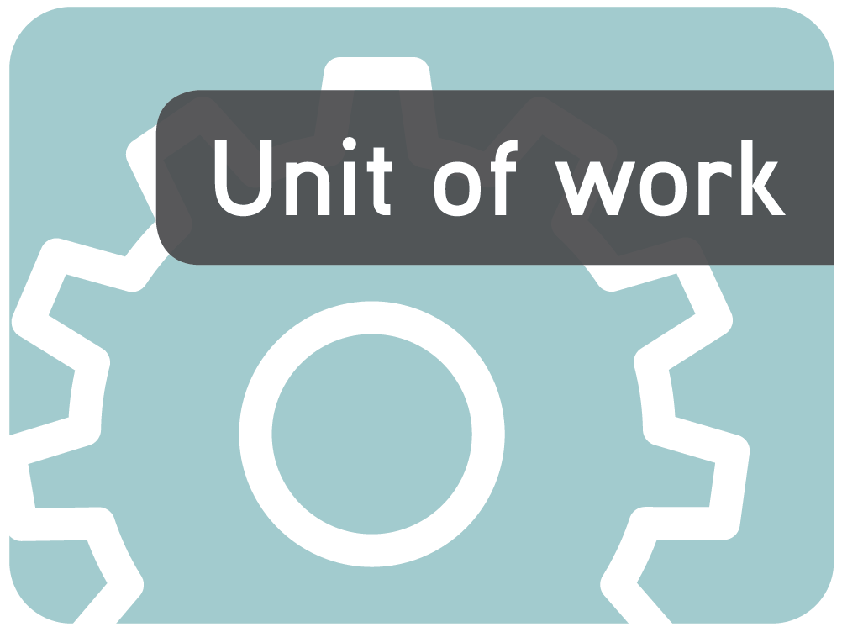
About the unit
Unit description
This unit allows students to explore the beginning concepts of perimeter and area, including the formal units of cm, m, cm sq, and m sq and to learn the differences between these measurements.
Knowledge, understandings, skills, values
Students will be able to:
- measure the perimeter of squares and rectangles, as well as shapes made from combinations of these
- measure perimeter accurately in centimetres and metres
- measure the area of squares and rectangles, as well as shapes made from combinations of these
- understand the notation of cm sq and m sq and measure accurately using these units.
Focus questions
- What is the perimeter of a shape?
- How do we find the perimeter of a shape?
- What is the area of a shape?
- How do we find the area of a shape?
- What is the difference between measuring area and measuring perimeter?
- Which unit of measurement is most suitable for measuring particular things?
Resources
Digital curriculum resources
L3528 Geoboard
L6557 Exploring area and perimeter
L384 Finding the area of rectangles
L139 Area counting with Coco
L383 Finding the area of compound shapes
Other resources
- Toothpicks, paperclips and other objects suitable for informally measuring length
- Centicubes or Unifix blocks
- Rulers, tape measures, metre sticks
- 1-cm-sq grid paper
- Coloured paper cut into 1-cm-sq squares
- Newspaper, cardboard, grid transparencies
- Matchsticks or toothpicks cut to 1-cm lengths (at least 10 per student)
- 5 squares per student for making pentominoes
Teaching the unit
Setting the scene
Resources
- Toothpicks, paperclips and other objects suitable for informally measuring length
- Centicubes or Unifix blocks
- Rulers marked in centimetres
- Card or paper at least 1-m long
- Metre rulers
Teaching and learning activities
Around the edge
Explain and explore the concept of perimeter.
When is it important to know the distance around the edge of an object?
Have students use a number of informal measuring objects such as toothpicks, paperclips or pencils to measure the perimeter of familiar objects in the classroom, eg a pencil case, book, mat, desk. Then create a class chart to compare the lengths found using informal units.
Are these useful units of measure? Why?
Now students should measure the same objects using centicubes.
Were centicubes a more effective unit for measuring? Why or why not?
Were they an efficient unit for measuring all the items? Why or why not?
Would centicubes be effective for measuring something as large as the classroom or the netball court?
What might be more useful than a centicube for measuring longer distances?
If the students are not familiar with measuring in centimetres, introduce the concept and provide them with lots of practice to ensure they measure accurately. They should then practise measuring perimeters using centimetres.
Metre creature
Introduce the concept of a metre by having students make a metre creature. First, they should measure out a 1-m strip of paper, and then decorate it to look like a monster by adding arms, fangs, etc. Each creature should have a pouch or pocket containing a centimetre creature that is 1-cm long.
What sorts of things would the length of the metre creature be useful for measuring?
The students could go outside and use the metre creatures to measure the perimeter of larger spaces, eg a netball court, etc.
What could we do if we ran out of metre creatures before we got all the way around what we want to measure?
~
Model what to do when all the metres are used. For example, students from the back can come to the front to continue the perimeter measurement until it is complete.
Take photos of the students at work.
Assessment
Have students reflect on their learning by creating a display using the photos taken during the activity and writing captions that explain what they are doing and why.
Record anecdotal evidence of students’ understandings, particularly those students whose lack of fine motor skills make it difficult for them to make things meet end to end.
Investigating
Resources
- 1-cm-sq grid paper
- Coloured paper cut into 1-cm-sq squares
- Newspapers
- L3528 Geoboard
- L384 Finding the area of rectangles
- L139 Area counting with Coco
- L383 Finding the area of compound shapes
- L6557 Exploring area and perimeter
Teaching and learning activities
Outside shapes
Challenge students to draw as many different shapes as they can on grid paper that has a perimeter of 35 cm.
Use L3528 Geoboar’ to explore this concept further. Select a particular perimeter length and investigate how many shapes can be made. Students can then transcribe the shapes onto grid paper.
Making mosaics
Give students containers of 1-cm squares of coloured paper. Have them make mosaic pictures and write a brief description of the shape of the area covered by each colour. Introduce the term ‘square centimetre’ and its notation as cm with a superscript 2 cm².
Is there a more efficient way to find a shape’s area than by counting each square?
Model the learning object L139 Area counting with Coco to demonstrate counting by rows rather than squares.
Is there a way we can work out the area of a rectangle without counting squares?
Use the learning object to show how an array can be used to work out area. At this stage, explore the examples using squares and rectangles only. Link the students’ understanding of how to find the area of these shapes to their knowledge of multiplication. Students could explore the learning object themselves, but restrict them to squares and rectangles. In pairs, they could also explore L384 Finding the area of rectangles.
~
Ask students to think about how to find the area of compound shapes. Then they could use L383 Finding the area of compound shapes to explore the solution.
How can we work out the area of shapes that are not rectangles or squares, but are a combination of both?
Discuss measuring big spaces.
When is it important to know the area of a big space?
How could such a space be measured?
For each student, create a square metre out of newspaper. They can then use these collaboratively to create a shape of 3 x 10 and work out that its area is 30 square metres.
~
Play a game in which students are given an area size, for example, 5 square metres, and have to sit, each on their square metre, with the correct number of people to create the area.
Extension activities
Discuss how shapes can have different areas even if they have the same perimeter.
Explore compound shapes further using L6557 Exploring area and perimeter. Provide the students with given areas and challenge them to investigate how many shapes with different perimeter lengths they can make. Have them print out their solutions.
Bringing it all together
Resources
- Matchsticks or toothpicks cut to 1-cm lengths (at least 10 per student)
- Five squares per student or pair of students
- L3528 Geoboard
Teaching and learning activities
Animal farm
Give each student eight sticks. Challenge them to work together, pooling their sticks, to create three different-shaped, fully enclosed pens for farm animals using all the sticks. As they make each enclosure, have them note both its area and its perimeter.
If each animal is allocated an area of 1 cm sq, how many animals can your enclosure hold?
Does one shape allow more animals than another?
How many more sticks would you need to create a pen that holds two more animals?
How many sticks would you need to create a pen that would hold six animals?
How many ways can you design a pen that holds six animals?
How many animals could your pen hold if you had 16 sticks to work with?
Ask students to compare the area and the perimeter they noted for their enclosures.
Is there a relationship between a shape’s area and its perimeter?
Consolidate this learning using L3528 Geoboard.
Pentominoes
Pentominoes are made by joining five squares with one side touching. There are 12 distinct shapes that can be made (excluding rotations and flips), each named after the letter it resembles (F, I, L, N, P, T, U, V, W, X, Y and Z). Provide each student or pair of students with five squares and challenge them to construct all 12 shapes, drawing them on squared paper as they complete them. They should label each one with its letter name. Have them measure both the perimeter and the area of each shape.
Does the perimeter of the area change as the shape changes? Explain why this happens.
If you put two pentominoes together to make a new shape, do the area and length of the perimeter double? Why?
Does the length of the perimeter or the area change with each combination?
How many ways can you make a five-step staircase using three pentominoes?
Does the length of the perimeter or the area change with each combination?
Drawing conclusions
Resources
- 1-cm-sq grid paper
Teaching and learning activities
Robert Robot
Have students design a robot on 1-cm-sq grid paper including at least one compound shape and only right angles. There should be no gaps or overlaps. Each separate shape needs to be marked with its total area and total perimeter. Have each student prepare a short written presentation to share with the class explaining the area and perimeter of different sections of their robot’s body and how they worked it out.
More capable students could direct other students in drawing a robot by providing the area and perimeter of the shapes for them. For example, ‘The head is a rectangle 3 x 3 cm square. The body is a square 9 x 9 cm square. The shapes join. The robot has two legs.’
Assessment
Record the accuracy of the students’ total area and perimeter calculations.
Did the student correctly identify which measurement was area and which was perimeter?
Did the student refer to cm and square cm?
Did the student show evidence of multiplying lengths in their calculations or did they count to work out the area?
Communicating
Teaching and learning activities
Have students show their metre and centimetre creatures at assembly and report their findings. Select some students to present a shape made with their metre square. They should state the area and perimeter and then change the shape and show that although the area remains the same, the perimeter is different.
Set up a Pentominoes Challenge for students.
Have students reflect on their learning in print or digital format.
Writers: Wendy Fletcher and Roxanne Steenbergen
The material in this unit of work may contain links to internet sites maintained by entities not connected to Education Services Australia Ltd and which it does not control (‘Sites’).
Education Services Australia Ltd:
- provides the links for ease of reference only and it does not sponsor, sanction or approve of any material contained on the Sites; and
- does not make any warranties or representations as to, and will not be liable for, the accuracy or any other aspect of the material on the Sites or any other matter connected to the use of the Sites.



While the material in this unit of work is not remunerable under Part VB of the Copyright Act 1968, material on the Sites may be remunerable under Part VB of the Copyright Act 1968. It is your responsibility to read and comply with any copyright information, notices or conditions of use which apply to a Site.

