Periodic functions Year level: 11–12
Unit of work contributed by Bernie O’Sullivan, St Luke's Anglican School, Qld

About the unit
Unit description
This unit focuses on periodic functions and is part of a university preparation course for those aiming to study mathematics and science courses such as engineering.
Knowledge, understandings, skills, values
- Students will understand the difference between degrees and radians and how to measure using radians
- Students will learn how to convert between radians and degrees
- Students will learn the definition of a periodic function, period and amplitude, unit circles and triangles
- Students learn how to graph trigonometric functions.
Focus questions
- How can we model repeating phenomena such as tides or alternating currents?
Resources
The Le@rning Federation digital curriculum resources
L7848 Trig radians: introduction
L7843 Trig degrees
L7847 Trig radians
L10089 EagleCat: trig-G
L9180 Trigonometry: assessment

Attached resources

The following teacher-created learning resources referred to in the Unit of work are available for you to modify, print and use in your own teaching and learning context:
- Radians and degrees
- Period and amplitude
- Unit circle
- Unit triangle
- Tides
- Downloadable Excel spreadsheet ‘Sine function interactive graph’
Teaching the unit
Setting the scene
Teaching and learning activities
Making connections
Connect the purpose of this study to real life by asking students how they would construct mathematical models of repeating phenomena, such as tides or alternating currents.
To understand the processes and find the solution they will need an understanding of trigonometry in the unit circle.
Investigating
Resources
- L7848 Trig radians: introduction
- Radians and degrees (page 6)
- Period and amplitude (page 7)
- Unit circle (page 8)
- Unit triangle (page 9)
- L7843 Trig degrees
- L7847 Trig radians
- Excel spreadsheet ‘Sine function interactive graph’
Teaching and learning activities
About radians
Use L7848 Trig radians: introduction to explore and explain the concept of radians and their use in solving measurement problems in circles. Students learn and apply formulas to use radians to measure angles, identify key angles in their radian form, convert angles in degrees (up to 360) to angles in radians, solve measurement problems using angles in radians and determine arc lengths using radians.
Investigate the relationship between radians and degrees. Summarise this using the Radians and degrees activity (page 6) then have students complete the tasks.
Period and amplitude of sine
Work through the Period and amplitude activity (page 7) to demonstrate how to evaluate period and amplitude of a sine curve.
Trigonometric values for all angles
Use the activity Unit circle (page 8) to explore and explain the exact value of trig ratios for angles between zero and 360 degrees, and between zero and 2π radians.
- Find, without use of a calculator, the exact value of sine, cosine and tangent of angles related to 30°, ie (150°, 210°, 330° and their radian equivalents).
- Repeat this for angles related to 60° and 45°.
- Use L7843 Trig degrees as the focus of the teaching of this concept. Under teacher direction, students use the animation of the unit circle to evaluate the sine, cosine or tangent of any angle between zero and 360°.
- Remind students to use mnemonic ‘All Stations To Central’ to work out which trig ratio returns a positive value in which quadrant.
A = all 3 ratios (sin, cos and tan) are positive in the first quadrant
S = only the sin is positive in the 2nd quadrant
T = only the tan is positive in the 3rd quadrant
C = only the cos is positive in the 4th quadrant
- Remind students to use the distance to the horizontal axis to convert an angle greater than 90 degrees to an equivalent value in the first quadrant.
- Repeat the previous step for radians, zero to 2π, using L7847 Trig Radians.
Unit triangles
Use the ‘Unit triangle’ activity (page 9) to demonstrate fully worked examples on how to evaluate the exact value of angles. For example, being able to show that .
Graphing trig functions
The general shape of trigonometric graphs will have been developed over the delivery of all the previous points.
Transforming trig functions
Use the downloadable spreadsheet file ‘Sine function interactive graph’ for a series of practice questions. Ensure macros are enabled to allow the full functionality of the spreadsheet.
Students have to look at a randomly generated trig graphs and evaluate the constants A, B and K that produced that graph.
Bringing it all together
Resources
- Tides (page 11)
- L10089 EagleCat: trig-G
- L9180 Trigonometry: assessment
Teaching and learning activities
Modelling real life
Consolidate the learning using the learning object L10089 EagleCat: trig-G. Explore the graphs of trigonometric equations in the form:
- y = a sin[n(x – h)] + k
- y = a cos[n(x – h)] + k
- y = a tan[n(x – h)] + k
Use sliders or enter values to dilate, reflect and translate the basic trigonometric equations y = sin(x), y = cos(x) and y = tan(x), and observe the changes in the amplitude, period, shape and position of the graphs as the equation changes.
Complete the Tides activity (page 11) to demonstrate using the cosine curve to model tides.
Assessment
Use L9180 Trigonometry: assessment to assess students’ learning.

Writer: Bernie O’Sullivan
The material in this Unit of work may contain links to internet sites maintained by entities not connected to Education Services Australia Ltd and which it does not control (‘Sites’).
Education Services Australia Ltd:
- provides the links for ease of reference only and it does not sponsor, sanction or approve of any material contained on the Sites; and
- does not make any warranties or representations as to, and will not be liable for, the accuracy or any other aspect of the material on the Sites or any other matter connected to the use of the Sites.
While the material in this Unit of work is not remunerable under Part VB of the Copyright Act 1968, material on the Sites may be remunerable under Part VB of the Copyright Act 1968. It is your responsibility to read and comply with any copyright information, notices or conditions of use which apply to a Site.



Radians and degrees

Name |  | Class |  | Date
Introduction
Investigate the relationship between radians and degrees.
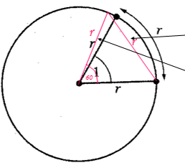  a  b | In the equilateral triangle each angle is 60°.  If chord ‘a’ was pushed onto the circumference radius, ‘b’ would be pulled back onto the other marked radius.
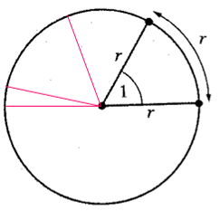 | 1 radian 57º18’  2 radians 114º36’  3 radians 171º54’  π radians = 180º
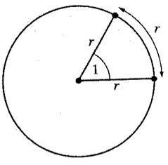 | π radians = 180º  π/2 radians = 90º  π/3 radians = 60º  π/4 radians = 45º
Activities
Complete the following tasks (remember that π = 180º).
- Express the following in degrees:
- 2π/3
- 4π/5
- 13π/6
- Express the following in radians:
- 225 º
- 724 º
- 42 º
Homework
Complete the first half of L7848 Trig radians: introduction in class then complete the rest for homework. Be careful when converting those degrees to radians – the object will tell you that you are wrong if you don't give your answers in lowest terms.
Period and amplitude
Name |  | Class |  | Date

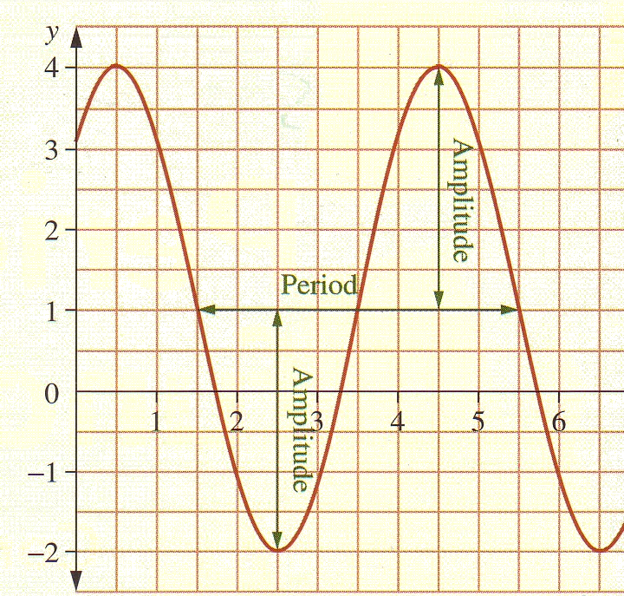
Definition
Consider the function shown here.
A function that repeats values in this way is called a ‘periodic function’.
The minimum time taken for it to repeat is called the ‘period (T)’. This graph has a period of 4.
Half of the theoretical distance between peaks and troughs is called ‘Amplitude (A)’. This graph has an amplitude of 3.

The following graph has a period of 20ms.
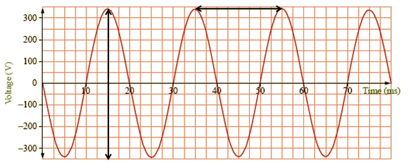
The period for the graph below is 3.
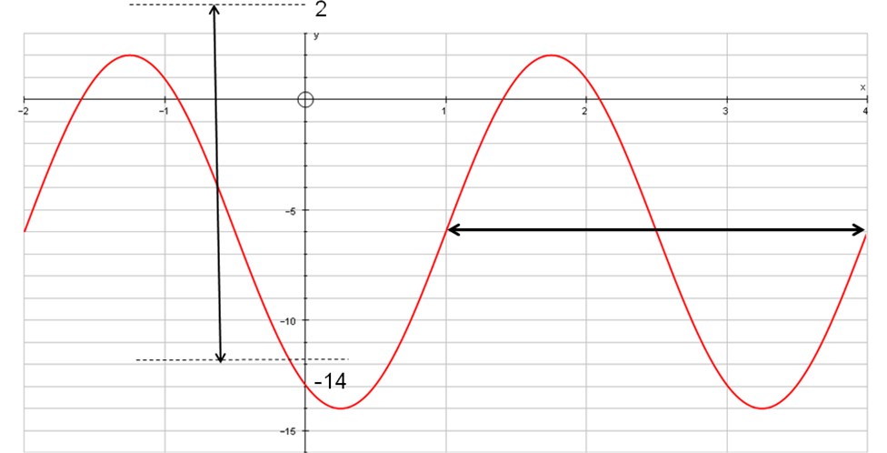

Unit circle

Name |  | Class |  | Date

Use the unit circle tool in L7843 Trig degrees to check out how the values of sine, cosine and tangent behave in different quadrants. You will be asked to work out the sine, cosine and tangent values for angles between 0° and 360°.
Use what was taught in class to pick the patterns and you will be able to predict the answers in different quadrants.
You must complete either the sine or cosine section. You may complete one, or both, of the remaining two sections after that if you wish.
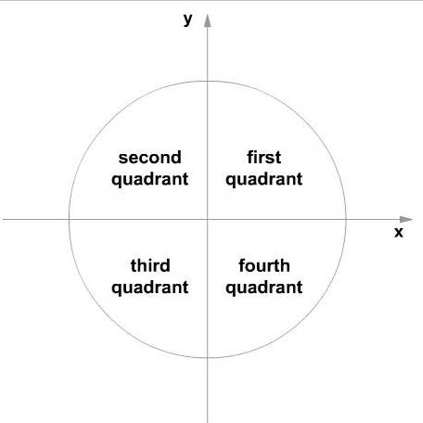
You will need to remember the following:
- All stations to central to work out which trig ratio returns a positive value in which quadrant.
A = all 3 ratios (sin, cos and tan) are positive in the first quadrant
S = only the sin is positive in the 2nd quadrant
T = only the tan is positive in the 3rd quadrant
C = only the cos is positive in the 4th quadrant
- Use the distance to the horizontal axis to convert an angle greater than 90° to an equivalent value in the first quadrant.
Find the value
Find the exact value of:
- cos 225°
- tan 225°
- sin 225°

Unit triangle

Name |  | Class |  | Date

We are now familiar with the unit circle, but to answer these questions we will need to use the unit triangle as well.
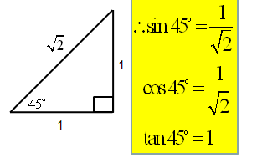 | 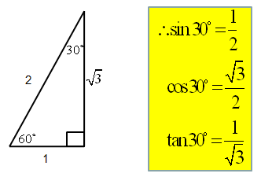
sin 45° =  cos 45° = $\frac{1}{\sqrt{2}}$  tan 45° = 1 | sin 30° =  cos 30° =  tan 30° = | sin 60° = $\frac{\sqrt{3}}{2}$  cos 60° =  tan 60° =
Find the value
Find the exact value of:
- cos 225° | 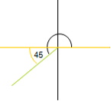 | cos 225°  = cos –45°  = –$\frac{1}{\sqrt{2}}$
- tan 225° |  | tan 225°  = tan 45°  = 1
- sin 300° | 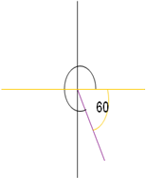 | sin 300°  = sin 60°  = $\frac{\sqrt{3}}{2}$
Now let’s do the same again, using radians
Work through learning object L7847 Trig radians.
This is similar to the Trig degrees object that you have already looked at. Do exactly the same for this object. Remember that you only need to do either the sine or cosine section. If you did sine last time, why not do cosine this time?
Find the value
Find the exact value of:
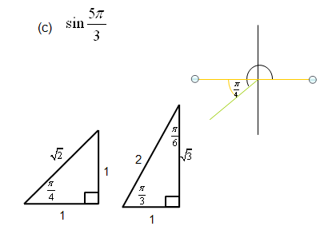
$\frac{5π}{4}$  - cos | 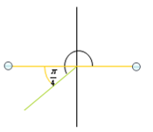 | cos $\frac{5π}{4}$  = – cos $\frac{π}{4}$  = –$\frac{1}{\sqrt{2}}$
$\frac{5π}{4}$  - tan |  | tan $\frac{5π}{4}$  = tan $\frac{π}{4}$  = 1
$\frac{5π}{3}$  - sin | 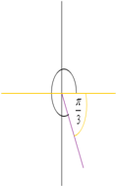 | sin $\frac{5π}{3}$  = sin $\frac{π}{3}$  = –$\frac{\sqrt{3}}{2}$

Homework
For homework, complete L9180 Trigonometry: assessment. Try the 21 questions to see how well you're going. Remember to print out your results at the end and hand it in at the start of the next lesson.

Tides

Name |  | Class |  | Date

Question 1
High tide is 4.5 m at midnight. Low tide is 0.5 m at 6 am.
- Find the height of the tide at 7 pm.
- Between what times will the tide be greater than, or equal to, 3 m?
Use y = A cos B (x + C) + D
- Find A | Tide range = 4.5 – 0.5 = 4 | A = 2  y = 2 cos B (x + C) + D
- Find D | D = 4.5 – 2 = 2.5 | y = 2 cos B (x + C) + 2.5
- Find B | Period = 12 $\begin{aligned}\text{Period}=\frac{2π}{B} \\ B=\frac{2π}{\text{12}}\end{aligned}$ | $$\begin{aligned}B=\frac{π}{6} \\ y=2\text{cos}\left|\frac{π}{6}\left(x+C\right)\right|+2\text{.}5\end{aligned}$$
- Find C | We can see from the graph that no C-value is needed. | $$y=2\text{cos}\frac{πx}{6}+2\text{.}5$$
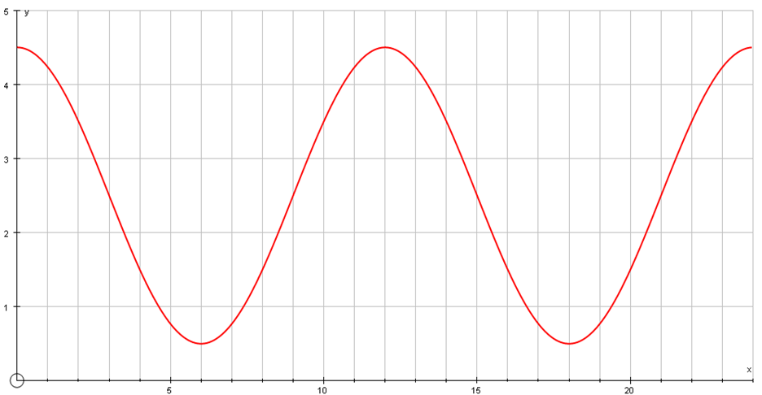
- Use a graphing calculator to work these out. | - What is the tide height at 7 pm?  - Graph using suitable windows  - 2nd → Calc → option 1. Value  - Enter 19  - Answer = 0.77m (2D.P.) | - Tide above 3 m  - Add y = 3 to the graph  - 2nd → Calc → option 5. Intersect  - Follow prompts  - Answer =  - MN – 2:31am  - 9:29am – 2:31pm  - 9:29pm – MN
Question 2
High tide of 4.2 m occurs in a harbor at 4 am Tuesday and the following low tide of 0.8 m occurs 6¼ hours later. If a ship entering the harbor needs a minimum depth of water of 3 m, what times on Tuesday can this vessel enter?
Model
The graph below shows the horizontal displacement of a pendulum from its rest position over time.
- Find the period and amplitude of the movement.
- Predict the displacement at 10 seconds.
- Find all the times up to 20 seconds when the displacement will be 5 cm to the right (shown as positive on the graph).
Model
The graph below shows the horizontal displacement of a pendulum from its rest position over time.
- Find the period and amplitude of the movement.
- Predict the displacement at 10 seconds.
- Find all the times up to 20 seconds when the displacement will be 5 cm to the right (shown as positive on the graph).
Period = 4.5 – 0.5
Period = 4 sec
Model
The graph below shows the horizontal displacement of a pendulum from its rest position over time.
- Find the period and amplitude of the movement.
- Predict the displacement at 10 seconds.
- Find all the times up to 20 seconds when the displacement will be 5 cm to the right (shown as positive on the graph).
Amplitude = 8
Model
The graph below shows the horizontal displacement of a pendulum from its rest position over time.
- Find the period and amplitude of the movement.
- Predict the displacement at 10 seconds.
- Find all the times up to 20 seconds when the displacement will be 5 cm to the right (shown as positive on the graph).
Since the period = 4 sec
Displacement after 10 sec will be the same as displacement after 2 sec
= 5.7 cm to the left
Model
The graph below shows the horizontal displacement of a pendulum from its rest position over time.
- Find the period and amplitude of the movement.
- Predict the displacement at 10 seconds.
- Find all the times up to 20 seconds when the displacement will be 5 cm to the right (shown as positive on the graph).
Displacement = 5 cm
t = 1.1, 5.1, 9.1, 13.1, 17.1
3.9, 7.9, 11.9, 15.9, 19.9

