Take a chance Year level: 6–8
Unit of work contributed by Nicole Heyder, Atwell College, WA
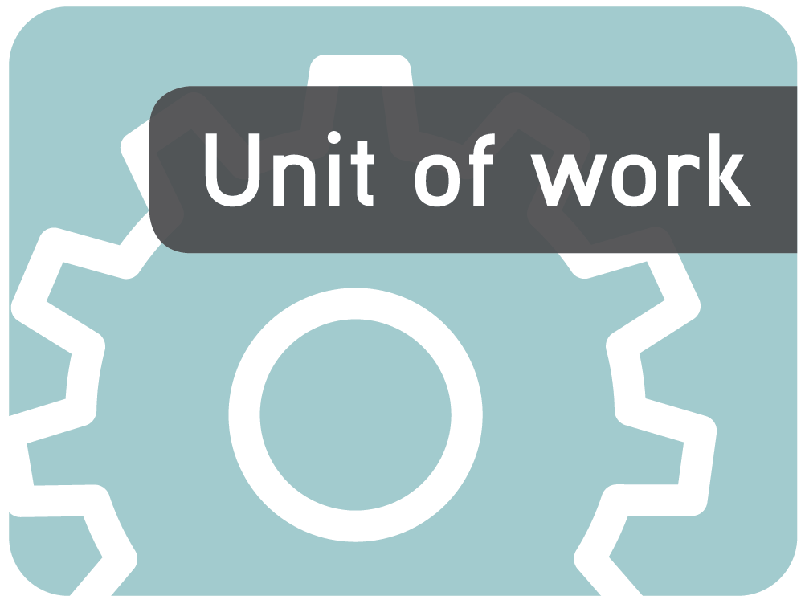
About the unit
Unit description
This unit provides students with a real life context to investigate the language of chance and how events may be manipulated to alter the chance of something happening. It also introduces the use of fractions, decimals and percentages when looking at probability.
Knowledge, understandings, skills, values
Students will be provided with the opportunity to:
- Justify choices of likelihood by referring to past experience of known information.
- Make informal statements about how one might influence the chance of an event happening.
- Compare events within their experience of being more or less likely.
- Design a probability device to produce a specified probability.
- Use data to compare events within their experience.
- Use simple fractions, decimals and percentages to assign probabilities.
Focus questions
- What is the everyday language associated with chance?
- How can the language of chance be related to familiar events?
- How can the likelihood of an event happening be altered?
- What is bias?
- What are some different ways data can be recorded?
- How are decimals, fractions and percentages linked to probability?
Resources
The Le@rning Federation digital curriculum resources
The foul food maker series: L214 best guess, L212 questions 1, L213 questions 2,
L215 go figure
Dice duels series: L3671 load one dice, L3672 load a pair of dice
L5907 Graph investigator: getting to school
L11105 HOTmaths: exploring relative frequency
L10840 HOTmaths: using relative frequency
R11186 HOTmaths: exploring relative frequency: solution sheet
R11187 HOTmaths: using relative frequency: solution sheet
Software
- MS Excel ( or similar)
Other resources
Games students have constructed
- Collection of hoops (or rope circles) 50 cm, 100 cm and 200 cm in diameter
- Heavy and light beanbags suitable for throwing
- Play money
Attached printable resources

The following teacher-created learning resources referred to in the Unit of work are available for you to modify, print and use in your own teaching and learning context:
- Game on – task sheet
- Playing games – summary table
- Record sheets for game owners and players
Teaching the unit
Setting the scene
Resources
- L215 The foul food maker: go figure
Teaching and learning activities
Words, words, words
Look out the window and ask the students how likely it will be that you will need an umbrella if you go outside. Discuss the clues they use to draw their conclusion.
Am I able to change this likelihood?
As discussion progresses collect and define key words, to create a glossary to display around the classroom for the duration of the unit.
~
If it is raining, discuss how you could change the likelihood of your getting wet. If it is fine, discuss how you could change the likelihood of not getting sunburnt. Explore how some things cannot be changed, whilst others can be manipulated to increase or decrease the risk.
Display L215 The foul food maker: go figure to introduce the concept and language of probability and chance. Add new words to your glossary. Consolidate this understanding by undertaking some of the suggested activities.
~
Demonstrate the difference between what logic says should happen (theoretical probability) and what actually does happen (experimental probability). Put 20 red pencils and 20 blue pencils in a container and explain that because there are an equal number of each you are likely to get five of each colour if you remove 10. Undertake the experiment to investigate if this actually happens. Discuss the reasons for the results.
Have students predict how many times they will get a head if they toss a coin in the air 20 times. Have them do this and record the results. Collate each student’s results to determine how often there was a 10–10 split.
What might be the reasons for the differences?
Graph all the results and make statements about the probability of having an 11–9 split or a
19–1 split.
Investigating
Resources
- The foul food maker series: L214 best guess, L212 questions 1, L213 questions 2
- L5907 Graph investigator: getting to school
- L11105 HOTmaths: exploring relative frequency
- L10840 HOTmaths: using relative frequency
- R11186 HOTmaths: exploring relative frequency: solution sheet
- R11187 HOTmaths: using relative frequency: solution sheet
Teaching and learning activities
Learning the language
Use the following learning objects to help students learn and use the language of chance and probability. Use a data projector to demonstrate each learning object before students undertake them.
- L214 The foul food maker: best guess – students use a vending machine that serves random meals such as fly soup, worm pasta or yucky duck. From the menu, students predict which one is likely to be served. Results are described using the language of probability. Students can track their results by selecting ‘Show results’.
- L212 The foul food maker: questions 1 – this is similar to L214 but students have to use the menu to select the probability of receiving a particular meal. Choices are: impossible, likely, equal and certain. By selecting ‘Table/graph’ they are presented with a table that shows the possibilities of receiving each meal expressed as a fraction, percentage and decimal. They can also view the results of hypothetical trials that demonstrate that chance can affect predictions.
- L213 The foul food maker: questions 2 – this is very similar to the previous learning object but students are now required to fill in the likelihood of obtaining a particular meal using fractions, decimals and percentages by filling in the blanks with equivalent values. They study the results of hypothetical experiments and describe the probability of each using numerical values.
On display
Use the following learning objects to help students understand relative frequency and how to display data.
Relative frequency refers to the proportion of times an event occurs and is calculated by dividing the number of times an event occurs by the total number of times an experiment is carried out. So if a coin is tossed 50 times and heads land 30 times, then the relative frequency of a coin toss producing heads is 30/50 or 3/5 or 0.6. Use the data collected in the ‘Coin toss’ activity to determine the relative frequency of heads.
Demonstrate each learning object first so students are familiar with the language, content and instructions.
- L11105 HOTmaths: exploring relative frequency – in this game, students play the familiar laughing clown game to get balls into numbered slots. The aim is to get either the highest or lowest numbers possible. There is a worksheet attached to record the results and calculate the relative frequency. They are encouraged to try to influence the outcome by timing when they select ‘go’, so the results are not random. The worksheet helps them record their results so they can analyse them.
- L10840 HOTmaths: using relative frequency – this is similar to the laughing clown game, except marbles fall from a tube and drop through barriers before landing in numbered slots. It is more suited as an extension activity.
- L5907 Graph investigator – this learning object shows a variety of graphs used in data handling and explains their features, their different uses and their advantages. Graph types include: stem-and-leaf, histogram, box-and-whisker, scatter plot, pie graph, line graph and column graph. Students learn about different graph types, their features and their uses and choose the most appropriate for particular situations.
Discuss which would be the most appropriate format for graphing the results of either the coin tossing experiment or the laughing clown results. Use MS Excel (or similar) to demonstrate how to create these sorts of graphs.
Being biased
Explain the concept of bias where an element that would otherwise have been left to chance, is manipulated so it is more likely to appear than not. Discuss the situations where this might be seen. Use the following learning objects to help students learn about bias. Demonstrate each learning object first so students are familiar with the language, content and instructions.
- L3671 Dice duels: load one dice – this learning object shows the difference in probabilities of fair dice versus loaded or biased dice. Students can ‘load’ a dice and experiment. Results are graphed and students interpret the graph.
- L3672 Dice duels: load a pair of dice – this learning object is similar to the previous one. It explains the concept of even distribution based on chance and how this can be manipulated by weighting the dice or changing the spaces on a spinner. It explains the likelihood of getting a particular number with a pair of fair dice. Students experiment with both fair and weighted dice.
Have students conduct their own experiments with fair dice.
Is 7 the most consistent total?
Have them make a weighted spinner like the one in the learning object. Have them predict the number of times the pointer will land on the larger space. Then spin and graph the results of 10 spins.
Were the results as expected?
Bringing it all together
Resources
- Collection of hoops (or rope circles) 50 cm, 100 cm and 200 cm in diameter
- Heavy and light beanbags suitable for throwing
- Game on task sheet (page 10)
Teaching and learning activities
Game on
Investigate how games that appear to be based on skill or luck can be weighted in favour of the person running the game, rather than the participant.
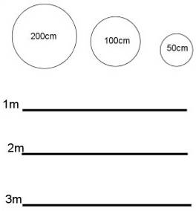
Set up a set of three hoops 50 cm, 100 cm and 200 cm in diameter in a line. For each hoop provide a heavy and a lightweight beanbag. Mark one, two and three metre distances from each set of hoops as per the following diagram.
Students attempt to throw both beanbags into each hoop from each mark. Allow three attempts with each object at each distance at each hoop.
Have them record their results at each hoop using the attached ‘Game on’ task sheet and then analyse these. Discuss.
Were you successful at every hoop?
How did the size of the hoop affect your accuracy?
How did the weight of the beanbag affect your accuracy?
Were you more successful with the heavier or lighter one?
How did the distance from the hoop affect your accuracy?
Were you more successful from the one-metre mark?
Did you get better with practice?
If this were a game at a fete, which combination of hoop, object and distance is most likely to be a winner for the player?
Which is most likely to be a loser?
Which one is most likely to raise the most money for the game owner?
Brainstorm the sorts of easily-made games that could be played at a school fete. Have small groups choose and construct a game and then explore and record ways that they could create a bias to decrease the chances of the participant winning by changing various factors.
Decide how much it will cost to play each game, how many attempts constitute a turn, what will be considered as ‘success’ and the amount students will win if they are successful. Create posters to display these conditions for each game.
Have others test the games and use the record sheet to track the results and calculate the win/loss ratio. Remind students of the language of probability and add to or refine the glossary as their understanding deepens.
Should the player always lose? Why?
Drawing conclusions
Resources
- Games students have constructed in previous activity
- Play money
- Playing games summary table (page 11)
- Record sheets for game owners and players (page 12)
Teaching and learning activities
Playing games
Hold a games session, with students from another class being the players. Give each player the same amount of play money to begin, and each stall holder the same amount for their float. Display the posters of playing conditions.
Give each owner and player the appropriate record sheet so they can track their progress. Stipulate that players can only have one turn at each game.
Have groups analyse their data and make a comparison to their trial data using the attached summary table.
They need to consider if the data from their trials coincides with the actual data they collected from the games session. Each group then presents their findings to the other students from each stall. They should comment on similarities and/or discrepancies of the data, the theoretical and experimental probability involved and whether their choices on creating bias were successful in achieving their aim (which was to reduce the chance of the participants’ success rate). Collate the data from individual games using the summary table to structure the responses and make comparisons easier.
Was there one game that was particularly good for the game owners? Why?
Was there one game that was particularly good for the players? Why?
Which game was most popular? Why?
Is it better to take entry money, have players always lose and then have no players as word spreads?
Discuss how stall-holders in a sideshow alley might use these variables to sway the outcome of a game in their favour.
Communicating
Teaching and learning activities
Have students construct a graph to display the data they have collected, as small groups and as a whole, and write a report of their findings.
Which game is likely to be the most successful at the next school fete? Why?
Writer: Nicole Heyder
The material in this Unit of work may contain links to internet sites maintained by entities not connected to Education Services Australia Ltd and which it does not control (‘Sites’).
Education Services Australia Ltd:
- provides the links for ease of reference only and it does not sponsor, sanction or approve of any material contained on the Sites; and
- does not make any warranties or representations as to, and will not be liable for, the accuracy or any other aspect of the material on the Sites or any other matter connected to the use of the Sites.
While the material in this Unit of work is not remunerable under Part VB of the Copyright Act 1968, material on the Sites may be remunerable under Part VB of the Copyright Act 1968. It is your responsibility to read and comply with any copyright information, notices or conditions of use which apply to a Site.




Game on
Name |  | Class |  | Date

Distance | Hoop diameter
Distance | 50 cm | 100 cm | 200 cm
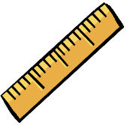  1 metre | Heavy bag | Heavy bag | Heavy bag
 | Light bag | Light bag | Light bag
2 metres | Heavy bag | Heavy bag | Heavy bag
 | Light bag | Light bag | Light bag
3 metres | Heavy bag | Heavy bag | Heavy bag
 | Light bag | Light bag | Light bag

Playing games summary table
Name |  | Class |  | Date
Trial results
Game | Number of trials | Number of wins for player | Number of wins for owner | Relative frequency of wins for players
Competition results
 | Game |  |  | Number of players |  |  | Number of winners |  |  |  | Relative frequency of winners |  | Comparison to trial data
Our game is called:
Of |  |  | players, |  |  | were winners.
This makes the relative frequency of winners:
This is better / worse / the same as the trials predicted:
To change the game so the game owners won more often, we:
Group comparison
Game | Total players | Number of winners | Relative frequency of winners | Comparison to trial data

Record sheet for owners
Name |  | Class |  | Date

Starting amount | Players | Wins | Losses | Total earned

Record sheet for players
Name |  | Class |  | Date

Starting amount | Games | Wins | Losses | Total earned

