Investigating us Year level: 8
Unit of work contributed by Mark Darrell, Hallett Cove School, SA

About the unit
Unit description
This unit is designed to enable students to design and conduct simple surveys, collate the data into appropriate tables, identify the types of graphs that are suited to display the data sets depending on the number and types of variables, select appropriate display formats to represent the data and interpret data from the graphs and tables. It utilises students’ natural interest regarding themselves and where they ‘fit in’ in relation to their peers.
Knowledge, understandings, skills, values
Students engage with data by formulating and answering questions, and collecting, organising and representing data in order to investigate and understand the world around them.
Students use statistical methods to reduce, analyse and interpret data, while critically evaluating the cultural and social inclusivity of the samples used.
Focus questions
- What is the difference between categorical and numerical data?
- What graph types are appropriate for displaying these two types of data?
- What sort of statistical analysis can we perform on the data?
- What sort of information can we obtain from the data?
- How could we best display this information to others?
Resources
Digital curriculum resources
L3150 Home Internet survey
L5903 Graph investigator
L3512 Bar chart
L1428 Graphing: pie graphs and column graphs
L3541 Pie chart
L3513 Box plot / histogram
L5857 Scatter plots
Internet sites
- Australian Bureau of Statistics ‘CensusAtSchool’: http://www.abs.gov.au/ (type 'census at school' in the search field)
- Edublogs: http://edublogs.org/ (or similar)
- Crossword puzzle tool: available on the ReadWriteThink website at http://www.readwritethink.org/materials/crossword/
- Poster Guide: http://writing.colostate.edu/ (type 'images of physical posters' in the search field)
- Instructions for creating box and whisker plots in MS Excel: http://support.microsoft.com and http://peltiertech.com/
- Designing effective poster presentations: http://www.readwritethink.org/ (type 'designing effective poster presentations' in search field)
Software
- MS Excel (or equivalent)
Attached printable resources

The following teacher-created learning resources referred to in the Unit of work are available for you to modify, print and use in your own teaching and learning context:
- Investigating us contract
- Statistical measures worksheet
- Excel worksheet: line graph
- Excel worksheet: scatter graph
- Excel worksheet: histogram
- Downloadable Excel spreadsheet – ‘Box and whisker plots’ (courtesy of the Mathematics Association of Victoria)
Teaching the unit
Setting the scene
Resources
- L3150 Home Internet survey
- MS Excel (or equivalent)
- Access to a blogging application, such as Edublogs: http://edublogs.org/
Teaching and learning activities
Daily data
Discuss how we are exposed to graphical representation of data in everyday life through the media, financial reports, council reports, advertising, political propaganda and so forth, and therefore it is essential to be able to both interpret and validate accompanying statements. To best understand this, we need to know how the graphical representations were determined in the first place.
Investigate the students’ prior knowledge of the processes.
What types of graphs do they already know?
Have they done surveys before?
Do they know the difference between categorical and numerical data? (Explain that categorical data can be grouped but not ordered. Also, because categorical data is neither ordered nor numerical, you cannot calculate a median or a mean, but you can identify a mode.)
In pairs, work through L3150 Home Internet survey to explore how to conduct a survey, sort and analyse data and then interpret this in a report. Demonstrate how to use MS Excel (or equivalent) to construct graphs.
Have them use this as a model to survey the Internet usage of the students in the class. Introduce the concept of a ‘sample population’ and determine whether their usage is representative of all the students of their year level in the school.
Extension activities
If the timing is right (Term 4 registration for participation in the following year) investigate CensusAtSchool, a free project from the Australian Bureau of Statistics.
Assessment
Have students make anecdotal records of their existing knowledge and experience in a personal blog so they can track their learning journey. Have them construct glossaries of the various terms used and encountered.
Investigating
Resources
- Investigating us contract (page 9)
- L3150 Home Internet survey
- Crossword puzzle tool: available on the ReadWriteThink website at: http://www.readwritethink.org/materials/crossword/
Teaching and learning activities
Under contract
Students undertake a series of activities based on information about themselves to learn how to formulate survey questions, make predictions, collect the data and learn appropriate statistical vocabulary.
Some of the vocabulary they may not have encountered include these terms about types of data:
- Categorical: categorical data can be put into groups; it cannot be ordered, or have statistical measures like mean or median calculated, but you can determine a mode. Examples could be hair colour, favourite food or city of birth.
- Ordinal: ordinal data can be put into groups and ordered; it cannot have statistical measures like mean calculated, but the mode and median can be. Examples could be places in a race (first, second etc), football team rankings or Olympic team rankings.
- Numerical: numerical data can have statistical measures such as mean, mode and median calculated and is of two different types:
  - Continuous: continuous data is measured on a scale and can have different levels of precision depending upon what you are measuring with. Examples could be times in a race, lengths of socks, heights of students or the width of an apple.
  - Discrete: discrete data can only take particular values. Numerical discrete data is usually obtained from counting. Examples could be how many people participated in each race, how many socks are owned by students in a class or how many apples are on each tree.
These activities are presented in the attached Investigating us contract and students work in pairs to complete each step, using L3150 Home Internet survey as a model.
Students must access the resources in the right-hand column before undertaking the related task. Discuss and determine the focus of your investigation using at least two categorical and two numerical topics. Consider topics such as:
- eye colour, colour of dog, favourite food, favourite music, favourite subject, birth month, colour or type of family car (categorical)
- height, arm span, foot length, length of index finger, reaction time, distance from belly button to floor (numerical, continuous)
- number of brothers or sisters, number of pets (numerical, discrete)
Using L3150 Home Internet survey as a model, develop the questions you are going to ask and prepare the survey sheets for recording your answers.
Make some predictions first about what sort of results you would expect to get for each of the questions. These are called hypotheses. For example: ‘Most students will have the same eye colour as their father.’
Collect the data (don’t forget to include yourselves) about your class members.
Find definitions for the vocabulary list for this topic: axis, horizontal, vertical, survey, categorical, numerical, compare, pictograph, histogram, pie graph, line graph, frequency, mean, average, median and mode. Be sure that the definition that you use relates to statistics. Add these to your glossary.
Use the Crossword puzzle tool to generate a crossword using the vocabulary list and clues from your definitions. Swap crosswords with another group and see if you can work out each other’s crossword.
Bringing it all together
Resources
- Investigating us contract (page 9)
- MS Excel
- Statistical measures worksheet (page 16)
- Instructions for creating box and whisker plots in MS Excel: http://support.microsoft.com and http://peltiertech.com/
- Excel worksheet: line graph (page 14)
- Excel worksheet: scatter graph (page 11)
- Excel worksheet: histogram (page 13)
- Downloadable Excel spreadsheet – ‘Box and whisker plots’
Teaching and learning activities
Still under contract
Students complete steps 6–12 of the Investigating us contract.
Open the Statistical measures worksheet.
Where appropriate, calculate the mean, median, range and mode of your data. Use your definitions to ensure that you understand the meanings of each of these terms and whether or not you can apply them to the data you have. Display this information next to each graph where appropriate.
Learn about frequency tables using 'Frequency and frequency tables' available on mathsteacher.com at: http://www.mathsteacher.com.au/year8/ch17_stat/03_freq/freq.htm
For each question, complete a good copy of a frequency table displaying the data you have gathered.
Explore these learning objects to understand the different types of graphs and when and how they are used.
- L5903 Graph investigator
- L3512 Bar chart
- L1428 Graphing: pie graphs and column graphs
Use Excel worksheet: line graph to learn how to construct a line graph.
On separate A4 pages, draw by hand one of each of the following types of graphs to display your data – pictograph, line graph, column graph (or bar chart), box and whisker, frequency graph.
For each graph, comment on how your findings fit your predictions.
Was your hypothesis proven?
Explore these learning objects to understand the different types of graphs and when and how they are used.
- L3541 Pie chart
- L3513 Box plot / histogram
- L5857 Scatter plots
Use these worksheets to learn how to construct these graphs using MS Excel:
- Excel worksheet: scatter graph
- Excel worksheet: histogram
As a class, explore the Box and whisker plots Excel spreadsheet using an overhead projector or interactive whiteboard; calling for students to suggest data and observe the effect on the graph.
As box and whisker plots display the median and upper and lower quartiles, a discussion of these concepts is key for students’ understanding of these graphs. This discussion may come before introducing the graphs, or the graphs themselves might be used as an introduction to quartiles.
Construct and print one of each of the following types of graphs to display your data by computer: box and whisker, histogram, pie graph, scatter graph (include a ‘line of best fit’ or ‘trend line’).
For each graph, comment on how your findings fit your predictions.
Work is handed in for assessment and feedback.
Assessment
Each task is assessed separately (different weightings can be given to each task as required for the overall assessment). The unit easily lends itself to allowing for differentiated learning programs. It is also possible to separately assess each task (row) as the groups complete them instead of waiting until step 12. This would also allow for the provision of resubmission of tasks before progressing. Step 12 would then become a final checking point before they produce their work in the form of a poster, that will be publically displayed, and an oral presentation. Ideally, an assessment rubric could be generated for each aspect of the specified outcomes.
Have students reflect on their own learning and progress in their blog after each step.
Communicating
Resources
- Poster guide: http://writing.colostate.edu/guides/speaking/poster/com2i1.cfm (type 'images of physical posters' in search field).
- Designing effective poster presentations: http://www.readwritethink.org/ (type 'designing effective poster presentations' in search field).
- Materials for creating posters.
Teaching and learning activities
Explore the purpose and essential elements of posters. Partners prepare a poster (A3 size) sharing the data they have gathered in graphical form, for display as part of a class presentation. Encourage the use of digital imagery. Graphs may be hand-drawn or computer generated.
Students analyse the data on the posters to write a full page summary of how they, as individuals, compare to the class data to be used as the basis of an oral presentation.
Each student gives a two-minute oral presentation about themselves to the class explaining how their personal data relates to the class data. Encourage students to support their presentation with digital or video resources.
Assessment
Have students reflect on their learning over the course of the unit in a final blog post.
Writer: Mark Darrell
The material in this unit of work may contain links to internet sites maintained by entities not connected to Education Services Australia Ltd and which it does not control (‘Sites’).
Education Services Australia Ltd:
- provides the links for ease of reference only and it does not sponsor, sanction or approve of any material contained on the Sites; and
- does not make any warranties or representations as to, and will not be liable for, the accuracy or any other aspect of the material on the Sites or any other matter connected to the use of the Sites.
While the material in this unit of work is not remunerable under Part VB of the Copyright Act 1968, material on the Sites may be remunerable under Part VB of the Copyright Act 1968. It is your responsibility to read and comply with any copyright information, notices or conditions of use which apply to a Site.




Investigating us contract
Name: |  | Partner’s name: |  | Date:
This unit is designed to help you discover different things about yourself and your class mates while also learning about how data is collected, displayed in tables and graphs and what sense we can make of it. We will do this by performing some surveys about different topics and then comparing your own information to that of the whole group.
You will need to work in pairs and it is important that you stay with the same partner for the whole task (four weeks).
Here is a list of all the work that you will need to complete and hand in to be successful in this topic.
NOTE: Each of the Resource list activities needs to be completed before attempting the associated tasks shown on the right.
 | Resource list activities | Task | Check
1 | L3150 Home Internet survey | Work with your partner to decide what sort of questions (at least five different things) you are going to ask about your class members. You must gather a minimum of two of both categorical and numerical data (see the list of suggestions below).  Prepare the survey sheets where you will record the answers collected.
2 |  | Make some predictions about what sort of results you would expect to get for each of the questions. These predictions are called hypotheses.
3 |  | Collect the data (don’t forget to include yourselves) about your class members.
4 |  | Find definitions for the vocabulary list for this topic: axis, horizontal, vertical, survey, categorical, numerical, compare, pictograph, histogram, pie graph, line graph, frequency, mean, average, median and mode. Be sure that the definition that you use relates to statistics.
5 | Crossword puzzle tool: available on the ReadWriteThink website at: http://www.readwritethink.org/materials/crossword/ | Generate a crossword using the vocabulary list and clues from your definitions. Swap crosswords with another group and see if you can solve each other’s crossword.
6 | Statistical measures worksheet | Where appropriate, calculate the mean, median, range and mode of your data. Use your definitions to ensure that you understand the meanings of each of these terms and whether or not you can apply them to the data you have. Display this information next to each graph, where appropriate.
7 | ‘Frequency and frequency tables’ available on mathsteacher.com at: http://www.mathsteacher.com.au/year8/ch17_stat/03_freq/freq.htm | For each question, complete a good copy of a frequency table displaying the data you have gathered.
8 | L5903 Graph investigator  L3512 Bar chart  L1428 Graphing: pie graphs and column graphs  Excel worksheet: line graph | On separate A4 pages, draw one of each of the following types of graphs to display your data by hand: pictograph, line graph, column graph (or bar chart), box and whisker, frequency graph.
9 |  | For each graph, comment on how your findings fit your predictions.
10 | L3541 Pie chart  L3513 Box plot / histogram  L5857 Scatter plots  Excel worksheet: scatter graph  Excel worksheet: histogram  Box and whisker, using Excel instructions at: http://support.microsoft.com/  and http://peltiertech.com/ | Construct and print one of each of the following types of graphs to display your data by computer: box and whisker, histogram, pie graph, scatter graph (include a ‘line of best fit’ or ‘trend line’)
11 |  | For each graph, comment on how your findings fit your predictions.
12 | Wait for feedback before progressing to the next step. | At this point your work is to be put together in the order indicated above and handed in for assessment.
13 | Writing guides for poster sessions: http://writing.colostate.edu/ (type ‘images of physical posters’ in search field)  Find more information on designing posters at http://www.readwritethink.org/ (type ‘designing effective poster presentations’ in search field) | Prepare a poster (A3 size) with your partner, displaying the data you have gathered in graphical form, to display as part of a class presentation.
14 |  | Write a full page summary of how you compare to the class data. Do this on separate paper. This will be the basis of your oral presentation.
15 |  | Give a two-minute oral presentation about yourself to the class and how your personal data fits in with the class data.
Examples of data you can collect:
Numerical: height, arm span, foot length, length of index finger, reaction time, number of brothers or sisters; house number distance from belly button to floor, etc.
Categorical: eye colour, colour of dog, favourite food, favourite music, favourite subject, birth month, colour or type of family car, etc.

Excel worksheet: scatter graph
Using Excel to draw scatter graphs
To start with, let’s do a ‘made up’ graph for practice. Our practice question is:
Is there is a relationship between the length of a person’s foot and their height?
The following data was collected.
Foot (cm) | 20 | 31 | 28 | 19 | 26 | 28 | 32 | 22 | 25 | 29
Height (cm) | 149 | 178 | 166 | 151 | 160 | 168 | 180 | 154 | 157 | 170
Draw some graphs to show this information.
- Open Excel.
Foot length | Height
20 | 149
31 | 178
28 | 166
19 | 151
26 | 160
28 | 168
32 | 180
22 | 154
25 | 157
29 | 170
- In cell A1, type FOOT LENGTH.
- In cell B1, type HEIGHT.
- In cell A2, type 20. In cell B2 type 149.
- In cell A3, type 31. In cell B3 type 178.
- Repeat the table going down to A11 and B11, filling in all cells in between. Your table should look like the one on the right.
- Highlight all the data, including the labels. You do this by clicking on the top left hand cell (Foot length) and dragging to the bottom number (170). The cells will be shaded.
- Go to INSERT … CHART. The first screen gives you all the different types of graphs you can make. Select a scatter graph, then choose NEXT.
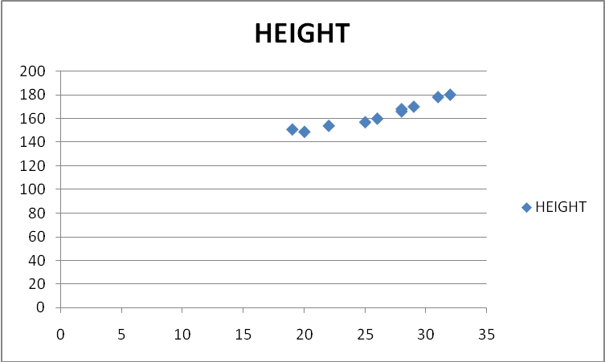
You should have a graph that looks similar to this.
- Click on SERIES. Click on CATEGORY (X) LABELS. Highlight the cells in the first column (from 2 to 20). This will place these numbers on the x-axis.
- Click in NAME. Type in HEIGHT. This is the name of the information on the graph.
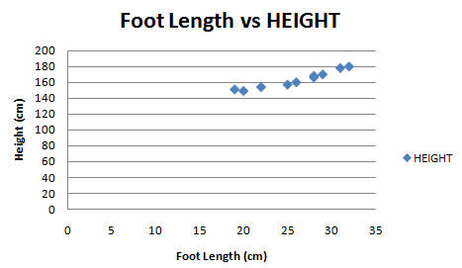
- Select NEXT.
- In CHART TITLE, type in Foot Length v Height.
- In CATEGORY (X) AXIS type in Foot Length (cm).
- In VALUE (Y) AXIS type in Height (cm).
Select NEXT.
- Insert it into the active sheet, so just choose FINISH.

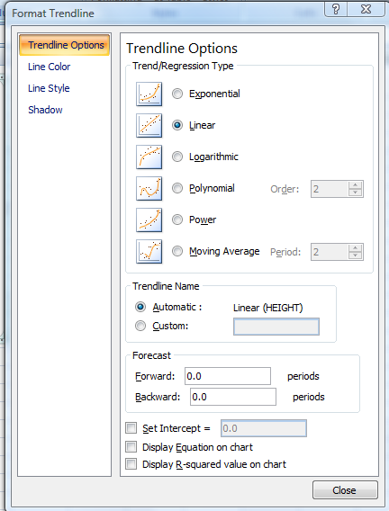
You should now have a graph that looks like this (you’ll have faint lines on your screen):

- Move the cursor so that it is just pointing at one of the data points and right click. The following window appears.

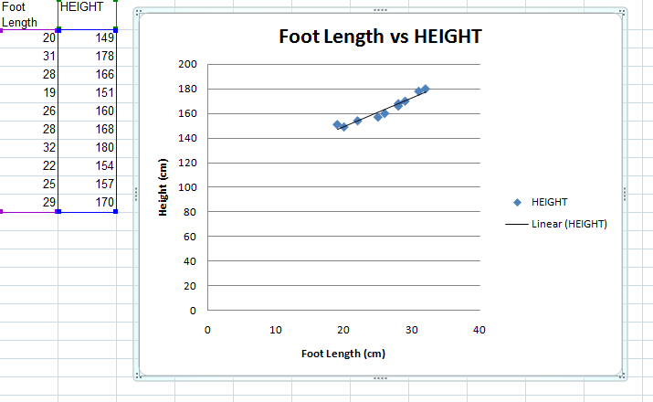

- We finish up with this, indicating that there does appear to be a relationship between Foot Length and Height.

Excel worksheet: histogram
How to draw histograms
To start with, we will all do a ‘made up’ graph for practice. Our practice scenario is:
All of the students in the school were measured to see how tall they are.
The heights, in centimetres, are shown below:
115.5 | 136.8 | 125.8 | 118.4 | 136.8 | 118.4 | 96.1 | 140.6 | 111.0 | 156.0
120.9 | 115.5 | 124.0 | 99.0 | 118.4 | 108.0 | 148.0 | 136.8 | 112.0 | 152.0
148.2 | 99.0 | 102.3 | 136.0 | 99.0 | 122.5 | 117.0 | 140.6 | 90.0 | 96.0
115.2 | 111.6 | 136.5 | 124.0 | 117.8 | 117.8 | 99.2 | 108.0 | 132.0 | 124.0
108.0 | 133.2 | 90.0 | 148.0 | 115.5 | 140.6 | 129.5 | 120.0 | 99.0 | 118.4
140.4 | 144.4 | 112.0 | 132.0 | 144.3 | 96.0 | 148.2 | 122.4 | 117.0 | 140.4
115.6 | 105.0 | 120.9 | 132.0 | 140.6 | 105.0 | 132.6 | 102.4 | 129.2 | 132.6
105.0 | 108.5 | 136.0 | 132.6 | 102.3 | 102.4 | 140.4 | 118.8 | 108.0 | 126.0
Draw graphs to show this information.
- Find the lowest and highest heights.
Height range | Tally | Frequency
90–100 | |||| |||| | 9

- Based on this, decide what would be a good range to use, eg 90–100 cm, to create groups to count in each range.
- Create a table with your height groups, in order from lowest to highest. It will look something like the table shown to the right.
- Working through the data, tally how many fall into each range. Add these up in the frequency column. The first row is done for you.
- On grid paper, draw up your axes. Mark frequencies on the vertical axis, and height along the horizontal axis. On the horizontal axis, mark the minimums of your height range, and position these numbers directly underneath. See how the axis is set up in the example below. (This example is for a different set of heights than that given to you.)
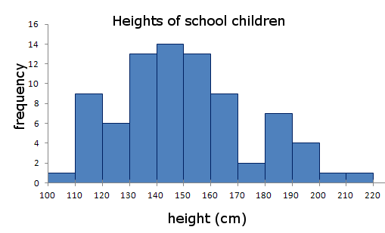

\

- Now work down the table and graph the frequencies.
- Draw a column for each group of heights. The columns in histograms should touch up against one another to represent the frequency spread for your groups of data.
Note: It is possible to create histograms in MS Excel, but the process is quite complex and you need to download a tool pack from Microsoft’s website.

Excel worksheet: line graph
Using Excel to draw line graphs
To start with, let’s do a ‘made up’ graph for practice. Our practice scenario is:
A baby was weighed at the beginning of the month every second month for twenty months.
Her weight, in kilograms, is shown below for each month:
Month | 2 | 4 | 6 | 8 | 10 | 12 | 14 | 16 | 18 | 20
Weight (kg) | 6 | 6.8 | 7.7 | 8.4 | 9 | 10 | 10.4 | 11 | 12 | 12.4
Draw graphs to show this information.
Month | Weight (kg)
2 | 6.0
4 | 6.8
6 | 7.7
8 | 8.4
10 | 9.0
12 | 10.0
14 | 10.4
16 | 11.0
18 | 12.0
20 | 12.4
- Open Excel.
- In cell A1, type MONTH.
- In cell B1, type WEIGHT.
- In cell A2, type 2. In cell B2 type 7.
- In cell A3, type 4. In cell B3 type 7.2.
- Repeat the table going down to A11 and B11, filling in all the cells in between. Your table should look like the one on the right.
- Highlight the numbers in the WEIGHT COLUMN. You do this by clicking on the top number (7) and dragging to the bottom number (18.4). The cells will be shaded.
- Go to INSERT … CHART. The first screen gives you all the different types of graphs you can make. Select line graph and click NEXT.
You should have a graph that looks similar to this.
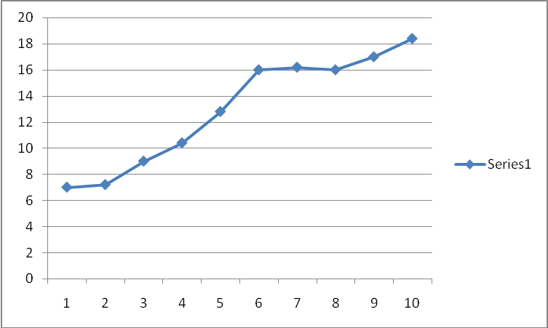
- Click on SERIES. Click on CATEGORY (X) LABELS. Highlight the cells in the first column (from 2 to 20). This will place these numbers on the x-axis.
- Click in NAME. Type in WEIGHT. This is the name of the information on the graph.
- Click on NEXT.
- In CHART TITLE, type in WEIGHT OF A BABY FOR THE FIRST 20 MONTHS.
- In CATEGORY (X) AXIS type in MONTHS.
- In VALUE (Y) AXIS type in WEIGHT (KG).
- Click NEXT.
- Insert it into the active sheet, so just click FINISH.
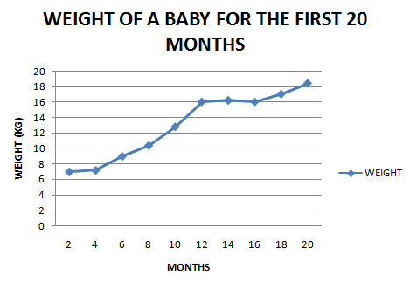
- You should now have a graph that looks like this (you’ll have faint lines on your screen):
- Print a copy of this worksheet to hand in.

Statistical measures worksheet
Calculating statistical measures in Excel
Enter your data into an Excel spreadsheet, as shown.
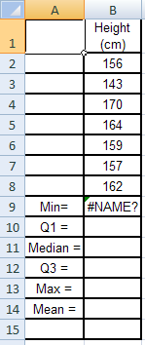
Highlight a cell (eg cell B9) and select Insert … Formula … Statistical … AVERAGE. (This will be slightly different depending upon which version of Excel you are using).
Select the range of data (in this case from cell B2 to cell B8) and press Enter.
The answer will be displayed in cell B9 (not the formula, as I have shown).
Similarly determine the other values.
Mean Average of the data to be plotted, AVERAGE ({data})
Median Median of the data, MEDIAN ({data})
Q1 First quartile, PERCENTILE ({data}, 0.25)
Q3 Third quartile, PERCENTILE ({data}, 0.75)
Minimum Minimum value, MIN ({data})
Maximum Maximum value, MAX ({data})
You should also be able to do these steps in Open Office or MS Works.

