Graphs and data Year level: 5–6
Unit of work contributed by Gayle Cann, Parap Primary School, NT

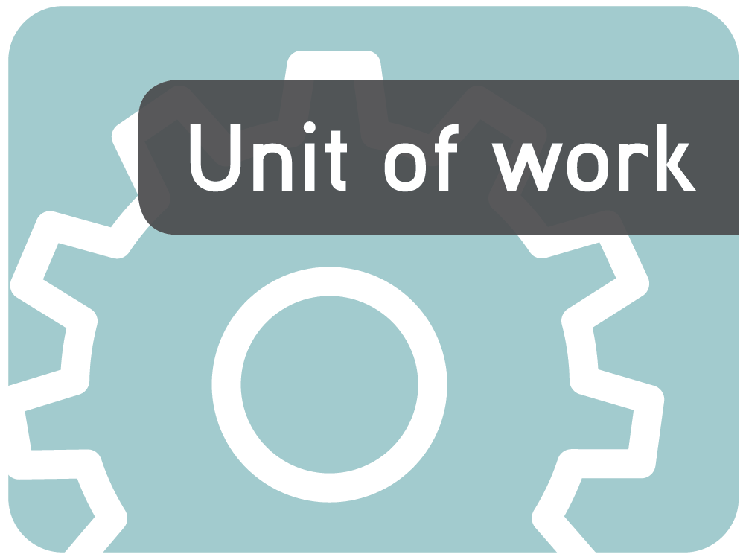

About the unit

Unit description
This unit of work explores why we need data, and how to collate, present and analyse it to extract the information it offers.

Knowledge, understandings, skills, values
- Students collect and organise data in a variety of ways to answer questions posed by themselves and others.
- Students critically interpret data by analysing and extracting information to be able to write a relevant report on the findings.
- Students calculate means, modes and medians for sets of data.

Focus questions
- What types of graphs have you seen? What purpose do they have?
- How can the data be sorted and presented in a meaningful way?
- What information can be gained from interpreting graphs and data?
- How can that information be shared with those who need it?

Resources

The Le@rning Federation digital curriculum resources
L3512 Bar chart
L3541 Pie chart
L6563 Exploring graphs
L5904 Graph investigator: types of graphs
L3154 Leisure survey
Internet sites
- Data Collection: available on TeacherTube at http://teachertube.com/viewVideo.php?video_id=112769&title=data_collection
- Bureau of Meteorology: http://www.bom.gov.au/

Software
- MS Excel (or equivalent)

Other resources
- Butcher’s paper
- Permanent markers
- Class set of newspapers
- Multi pack of small chocolate chip biscuits
- Multi pack of biscuits, sweets or other snacks
- Multi pack of M&M sweets

Attached printable resources

The following teacher-created learning resources referred to in the Unit of work are available for you to modify, print and use in your own teaching and learning context:
- Frequency table

Teaching the unit

Setting the scene

Resources
- Butcher’s paper
- Permanent markers
- Class set of newspapers
- Data Collection: available on TeacherTube at http://teachertube.com/viewVideo.php?video_id=112769&title=data_collection

Teaching and learning activities

Graffiti
In groups of four, students are given two minutes to write or draw what they think of when they hear the words ‘graph’ and ‘data’ on a large sheet of paper. Collate group ideas on paper using a black marker. Date and save to compare with what can be added at the end of the unit.

In the news
Define what data is and then have students look through newspapers to find examples of graphs or data. Have them make a class collage of these with explanations of the information they contain. When discussing this as a class, the following are some important points about data that should be drawn out of the focus questions, and may form a basis for a definition of data. Data:
- is a collection of information about a thing or a set of things
- can be measurements or observations
- is used to raise discussions, make decisions or make a point.
How is the collection and interpretation of data used in our everyday lives?
What sort of data is collected?
Who collects it?
What sort of information are they seeking?
How is it used?
Ask students to revisit their newspapers and see whether there is evidence of data that they may have previously missed.

Extension activities
View Data Collection: available on TeacherTube at http://teachertube.com/viewVideo.php?video_id=112769&title=data_collection
What sort of data is being collected in this video?
Have students keep a diary (electronic or paper) to record all the instances they see or hear of data collection during the course of the unit, particularly instances where the data collection refers (or could refer) directly to them. Explain that this diary will help them with their final activity.

Personal and private
Many websites ask users to fill in particular details about themselves that are then used for targeting them as consumers, or sold to others to use. Use this opportunity to emphasise the need for students to protect their privacy whilst online and how to do this.

Investigating

Resources
- L5904 Graph investigator: types of graphs
- L3512 Bar chart
- Frequency table (page 10)
- Multi pack of small chocolate chip biscuits
- Multi pack of biscuits, sweets or other snacks
- L3541 Pie chart
- L6563 Exploring graphs
- MS Excel

Teaching and learning activities

Types of graphs
Explore and explain L5904 Graph investigator: types of graphs, focusing on histograms (bar graphs), pie graphs, line graphs and column graphs. Construct a class chart that provides a sample of each of these graphs and an explanation of when they would be used.
Have students choose either a stem and leaf plot, box and whisker plot or scatter plot, then write a description of its use and construct an example.

Frequency tables & bar graphs
Use a topic such as ‘transport to school’ or the ‘wearing of school uniform’ to demonstrate the construction of frequency tables for data collection, using tallying to identify each group of five.
Transport | Tally | Frequency
Walk | Illl III | 8
Bike | Illl I | 6
Bus | Illl Illl | 10
Car | Illl | 5

Use the attached Frequency table to record the data.
Convert the data collected to a bar graph (histogram) so that results can be compared. Have students select their own topic and create both a frequency table and bar graph to show their results. Explain the importance of providing a title for the graph and labelling the axes.
~
Work through L3512 Bar chart. Have students use the same information they used to create their own bar chart to complete the task and then compare the two.
Demonstrate how to use software such as MS Excel to do this, including how to give the graph a title and label the axes.

Put it in a pie
Explore and explain L3541 Pie chart. As a class exercise, investigate the favourite ice cream flavours of class members and interpret this information in a pie chart. Give students another set of figures and have them create and interpret individual charts. Print for portfolios.

Exploring graphs
Explore and explain L6563 Exploring graphs. Discuss why some formats are more effective for representing particular types of data.
Have students use MS Excel to create a pie graph with the same data they used for their bar graph. Compare the two.
How are they alike/different?
Which is the most effective for displaying and comparing the data so it easily interpreted?

On the line
Divide the class into groups of eight. Each member of the group will investigate the daily temperatures of a different Australian state capital city (Sydney, Adelaide, Hobart, Canberra, Melbourne, Brisbane, Perth and Darwin).
Use the Bureau of Meteorology site (http://www.bom.gov.au) to collect the minimum and maximum temperatures of these cities over the period of a week to construct a line graph showing the minimum and maximum temperatures for their city. Demonstrate how to do this using MS Excel.
What is the average daily maximum temperature for your city in a week?
Students swap their line graph with another student in their group and write a description of the graph and the week’s temperatures in that capital city.

On average
Investigate the difference between the terms ‘mode’, ‘median’ and ‘mean’.
Give each student (or group) a mini pack of biscuits. Create a scenario in which the students are to act as quality controllers to ensure there are a minimum of 24 chocolate chips per biscuit. Students break apart the biscuit, count the number of chocolate chips in each and record the number on a class chart.
When all the biscuits have been dissected and the number of chocolate chips in each recorded, put the numbers in order. The number that occurred the most is the mode; the number in the middle after the numbers are in order is called the median; the total number of chocolate chips divided by the number of biscuits is the mean. Use the information to write a report to the manufacturer explaining what you discovered about the number of chocolate chips in each biscuit.
This activity could be simplified by having students count the number of items in each mini pack and comparing these. Discuss why such packs are usually marked with their weight not number of items.

Extension activities

More about mean and median
As a class, use L6564 ‘Exploring measures of central tendency’ to examine the mean and median values for a data set recording emergency response times, and explore changes to the mean and median as new results are added.

Bringing it all together

Resources
- Multi pack of M&M sweets
- MS Excel
- L3154 Leisure survey

Teaching and learning activities

M&M maths
Have students investigate the number of M&M sweets in each small packet to examine the frequency of colours. Structure their investigation by following these steps:
- Don’t eat any until you have collected all your data.
- Estimate how many M&Ms you have. Guess which colours may be in your packet.
- Carefully open your packet of M&Ms and count and record how many you have altogether. This is your population.
- Tally the different colours you have in this population.
- Graph your results using a bar graph. Don’t forget to label your axes.
- You now need to get extra data from at least another 5 people. Compare the number, range and frequency of colours to your sample. Discuss the results and create two new bar graphs – the first comparing the total number of sweets in each packet; the second comparing the range and frequency of colours in all the groups’ packets.
- Find the mean, median, range and mode for the number of M&Ms in the combined sample.
- Use the data to construct a pie graph using MS Excel.
- Write an interpretation of your findings.
- Time how long it takes you to dissolve one on your tongue.
- Is it true that they only melt in your mouth not in your hands?

Good sports
Imagine the local council has enough money to install a new sporting facility in your neighbourhood, but they need to know which sport is the most popular and therefore will be the best return on their investment. They need to survey students at the school so they get a clear picture of the needs and interests of as many children as possible.
Make contact with other classes in your school.
Discuss as a class:
- what data needs to be collected
- how it will be collected
- how it will be collated
- the best format for presentation to show the various sports and the number of students interested in each
- how the information can be shared with the council.
Undertake the investigation, keeping a photographic record of the various steps. Use these to construct and publish a report of what was undertaken and achieved. If you have contact with other schools in your local area, this could be widened to include data from other schools if you wish.

Prove it
Conduct an investigation to demonstrate how data can be used to support an argument. Put the proposition that boys are always taller than girls of the same age. Record the number of students who believe this, and the number who don’t. Discuss as a class:
- what data needs to be collected
- whether there needs to be a range of ages tested
- how it will be collected
- how it will be collated
- the best format for presentation
- what percentages will be considered as evidence that the proposition is true.
Undertake the investigation, keeping a photographic record of the various steps. Use these to construct and publish a report of what was undertaken and achieved.

Assessment

Leisure time
Use L3154 Leisure survey to scaffold the culminating task by taking students through the entire process step-by-step. Students complete the report at the end of the scaffolded activity for individual assessment purposes.

From data to delivery
Demonstrate how the collection of data can be used in real life.
Brainstorm and list practical ways that students could initiate changes within the school such as:
- investigating new foods to be sold at the canteen
- suggesting new resources to be acquired by the library
- the need for a new piece of play equipment such as a sandpit or playground markings for games
- the need for timetabling the use of a particular area or piece of equipment
- the need for a school rule to be implemented, changed or abandoned
- the venue for a whole school excursion
- the support for a new sport or recreation activity to be made available.
Have small groups select a project that appeals to collect, prepare, analyse and interpret data to support their proposal.
Use what has been learned to discuss:
- what data needs to be collected
- how it will be collected
- how it will be collated
- the best format for presentation to support their argument
- who the information should be shared with it and it should be shared.
As a class, create a checklist or rubric so students can ensure they complete all the steps to the required standard. Include elements that will demonstrate:
- efficient and effective data collection and collation
- choosing and using a variety of graphs to suit the purpose
- calculating mean, median and mode
- analysis and interpretation of the data
- preparation of a final report.
Assess their completed projects against this rubric.
Have students undertake their project as well as a reflection that examines issues such as:
What have I learned from this?
Did I complete the task successfully?
How have my skills improved?
Which parts did I do really well?
Which parts would I change if I did the activity again?
Which parts do I need support with in the future?
Did I manage my time well?
Writer: Gayle Cann
The material in this Unit of work may contain links to internet sites maintained by entities not connected to Education Services Australia Ltd and which it does not control (‘Sites’).
Education Services Australia Ltd:
- provides the links for ease of reference only and it does not sponsor, sanction or approve of any material contained on the Sites; and
- does not make any warranties or representations as to, and will not be liable for, the accuracy or any other aspect of the material on the Sites or any other matter connected to the use of the Sites.



While the material in this Unit of work is not remunerable under Part VB of the Copyright Act 1968, material on the Sites may be remunerable under Part VB of the Copyright Act 1968. It is your responsibility to read and comply with any copyright information, notices or conditions of use which apply to a Site.

Frequency table

Name |  | Class |  | Date

Topic | Tally | Frequency

