You say data, I say data Year level: 6
Unit of work contributed by Thomas Psomas, All Saints Grammar School, NSW

About the unit
Unit description
This unit introduces the students to a variety of graphs. They will examine examples of various types of graphs and then conduct their own surveys to collect and present the data in a specified form.
Students will understand the practical application of data collection as they learn to:
- pose questions that can be answered using the information from a table or graph
- collect, represent and evaluate a set of data as part of an investigation
- determine what type of graph is the best one to display a set of data
- use a computer database to organise information collected from a survey
- use a spreadsheet program to tabulate and graph collected data
Knowledge, understandings, skills, values
- Draw/construct picture, column, line and divided bar graphs using scales of many-to-one correspondence.
- Read and interpret sector (pie) graphs.
- Conduct surveys, sort and analyse the data, and present the data as graphs.
- Understand the uses, advantages and disadvantages of the different graphs.
Focus questions
- When do we use picture graphs, column graphs, line graphs, divided bar graphs and sector (pie) graphs?
- How do we construct picture, column and line graphs to display the data we collect?
- How do we interpret the information shown on different graphs?
- How do we apply real data to the construction of the respective graphs?
- What is the most appropriate software to use to construct the graphs?
Resources
Digital curriculum resources
L3154 Leisure survey
L3150 Home Internet survey
L3158 Healthy life survey
Software
- MS Excel (or equivalent)
Print
Books
- Mathematics Assessment for Learning: Rich Tasks and Work Samples, A Downton, R Knight, D Clarke and G Lewis, Australian Catholic University and Catholic Education Office, Melbourne, 2006
Attached printable resources

The following teacher-created learning resources referred to in the unit of work are available for you to modify, print and use in your own teaching and learning context:
- Ice cream flavours example
- Picture graph – favourite overseas destinations
- Column graph – weekly spending
- Line graph – bus trip
- Divided bar graph
- Sector (pie) graph
- Name the graph assessment activity
Teaching the unit
Setting the scene
Resources
- Ice cream flavours example (page 11)
Teaching and learning activities
Introduce the word ‘data’ and discuss its meaning. Conclude that ‘data’ is another word for information.
Display the written account about ice cream flavours on page 11 (conceal the graph version) and give the students 2–3 minutes to read, interpret and make conclusions about the information.
Who would like to retell the information?
Why was it difficult to retain the information?
~
Uncover the graph version and give them the same amount of time to read, interpret and make conclusions.
Who would like to retell the information now?
Why was it much easier this time?
~
Conclude that graphs are generally easier to read than text because they present information, particularly numbers, in a visual format.
Ask the students for other ways they could represent the information. Investigate graph formats they already know.
Some of the graphs they may suggest will be covered in this unit:
- Picture graphs use pictures or symbols to represent frequency data. Each symbol may represent more than one, so a key is used in picture graphs. Picture graphs use fractions of symbols to represent quantities as needed. Data for a picture graph could be collected from a survey or from simple observations involving whole numbers (for example populations or numbers of pencils). Questions about picture graphs could be of the type ‘how many?’
- Column graphs use vertical columns to represent frequencies (from a survey, such as 'Ice cream cones') or quantities that have a unit (such as ‘Weekly spending’). Questions about column graphs could be of the type ‘how much?’ or ‘how many?’ depending upon what kind of data is represented.
- Bar graphs are column graphs where the bars are horizontal.
- Line graphs use a series of points connected by short line segments to represent change in a quantity over time. Data for a line graph could be collected from experiments or observations of quantities that change over time. Questions about line graphs would be of the type ‘when was?’ or ‘what was happening at this time?’
- Divided bar graphs use a bar to show a quantity is divided up, usually something that has a well understood ‘whole’ concept, such as ‘a day’ or ‘total budget’ or ‘school population’. Divided bar charts are often grouped for simple comparisons of ratios. Data for a divided bar graph could be collected from a survey or from observations (for example ‘how we spend our weekly pocket money’ or ‘what we do with our day’). Questions about divided bar graphs would be of the type ‘what fraction of?’
- Sector (pie) graphs use sectors of circle to show how a quantity is divided up, usually something that has a well understood ‘whole’ concept, such as ‘a day’ or ‘total budget’ or ‘school population’. Data for a sector graph could be collected from a survey or from observations (for example ‘how we spend our weekly pocket money’ or ‘what we do with our day’. Questions about sector graphs would be of the type ‘what fraction of?’
Investigating
Resources
- Picture graph – favourite overseas destinations (page 12)
- Column graph – weekly spending (page 13)
- Line graph – bus trip (page 14)
- Divided bar graph (page 15)
- Sector (pie) graph (page 16)
- MS excel (or equivalent)
Teaching and learning activities
Picture graphs
Specific knowledge and skills
Determining a suitable scale for data and recording the scale in a key.
Drawing picture graphs using a key.
Interpreting a given picture graph using the key.
Remind the students of the picture graphs they have constructed in earlier years.
When you pasted a picture on these graphs, how many items did each picture represent?
~
Present the picture graph (page 12) about favourite holiday destinations and discuss its features. Pose questions that require students to interpret the information from the graph.
How many people are represented by this graph?
How do you know?
~
Introduce the concept of scale in a graph.
What is the purpose of a scale?
How does it make the information easier to understand?
How is the scale recorded in this graph?
Conduct a class survey on ‘Favourite subjects at school’ and jointly construct a picture graph that shows the results. Use an interactive whiteboard for this if available.
What would be an appropriate picture to use so the purpose of the graph was clear?
What would be an appropriate scale to use?
How do we cope with fractions – for example, if only three people like Maths and our scale is 1:4?
~
Discuss the advantages and disadvantages of this type of graph.
Discuss when this sort of graph would be most effective.
What other surveys could we conduct and then represent the data in a picture graph?
~
Students conduct an in-class survey and construct their own picture graph on any relevant topic.
What would be the most appropriate software to use to publish this sort of graph?
Column graphs
Specific knowledge and skills
Determining a suitable scale for data.
Drawing column graphs using a scale.
Interpreting a given column graph using the scale.
Present the sample column graph, Weekly spending (page 13), and discuss its features.
How is it different to a picture graph?
~
Have students write five things they can learn by examining the graph, and then use think, pair, and share strategies to create a class list of the information.
How is the scale recorded in this graph?
Why is this sort of graph an effective way to compare data?
~
Conduct a class survey on ‘Pocket money spending’ and jointly construct a column graph to show the results. Use an interactive whiteboard for this if available. Demonstrate how to insert the data into a spreadsheet program such as MS Excel (or equivalent) and then use this to construct a column graph.
Discuss the advantages and disadvantages of this type of graph.
Discuss when this sort of graph would be most effective.
What other surveys could we conduct and then represent the data in a column graph?
Students conduct an in-class survey and complete a column graph for the new set of data.
Line graphs
Specific knowledge and skills
Naming and labelling the horizontal and vertical axes.
Drawing a line graph to represent any data that demonstrates a continuous change over time.
Determining a suitable scale for the data and recording the scale on the vertical axis.
Using a scale to determine the placement of each point when drawing a line graph.
Interpreting a given line graph using the scales on the axes.
Present the sample line graph Bus trip (page 14) and discuss its features.
How does it differ from the picture graphs and column graphs that we have investigated?
~
Pose questions that require students to interpret the information from the graph. Introduce the concept of vertical and horizontal axes.
What does the vertical (y) axis describe?
What does the horizontal (x) axis describe?
How is the information in the horizontal axis different from that in picture and column graphs?
What time did they start their journey?
How far had the family travelled after four hours?
How do we know there was no progress between midday and 1.00 pm?
During which part of the journey was the bus moving fastest? When was it travelling slowest? What reasons might there be for this?
How is the scale recorded in this graph?
~
Conduct a class experiment where the students can measure a quantity changing over time. Examples could be measuring how heart rate changes when resting after exercise, or measuring how the temperature of water changes as it is brought to the boil. Jointly construct a line graph to show the results. Use an interactive whiteboard for this if available. Demonstrate how to insert the data into a spreadsheet and then convert it to a line graph using a program such as MS Excel. Demonstrate how to label the axes so the purpose of the graph is obvious.
Discuss the advantages and disadvantages of this type of graph.
When is this sort of graph most effective?
~
What other observations could we conduct and represent the data in a line graph? Reinforce the significance that line graphs are used only when representing continuous information such as:
- maximum (or minimum) temperature of a place over a certain period (noon to midnight)
- petrol prices over a year
- how far a child travels as they swing back and forth on a swing.
Explain and demonstrate that line graphs are also useful in representing two sets of data on the same graph such as ‘Approval rating of 2 candidates’ because you can see the relationship between the two and make inferences. Construct a graph that compares two quantities that change over time, for example the temperature variations of the year in two different cities, or the pulse rate of two students resting after exercise, or similar.
What conclusions can be drawn?
If appropriate, conduct the same investigations during another week and compare the graphs to determine if the conclusions are valid.
Divided bar graphs
Specific knowledge and skills
Naming a divided bar graph.
Naming the category represented by each section.
Interpreting divided bar graphs.
Show students the attached sample Divided bar graph (page 15) and discuss its features.
What is the most obvious feature of this graph?
Pose questions that require students to interpret information from the graph. For example:
Do similar length segments of the bar indicate similar times spent on homework? What then are the bars being used to compare?
What is the scale on this graph?
Is it easy to determine specific information from the graph? Why?
How could it be improved to make it more effective?
~
Conduct a class survey on ‘Hair colour’ and jointly construct a divided bar graph to show the results. Use an interactive whiteboard for this if available. Demonstrate how to insert the data into a spreadsheet program such as MS Excel (or equivalent) and then use this to construct a divided bar graph.
Discuss the advantages and disadvantages of this type of graph. Students could collect data for two other classes in the school and add these bars to the graph.
When would this sort of graph be most effective?
What other surveys could we conduct and then represent the data in a divided bar graph?
Students construct their own divided bar graph after conducting an in-class survey
Sector (pie) graphs
Specific knowledge and skills
Naming a sector (pie) graph.
Naming the category represented by each section.
Interpreting sector (pie) graphs.
Show students the sample Sector (pie) graph (page 16) and discuss its features.
Pose questions that require students to interpret the information from the graph.
How is the scale recorded in this graph?
~
Conduct a class survey on ‘Favourite sport’ and jointly construct a sector graph to show the results. Use an interactive whiteboard for this if available. Demonstrate how to insert the data into a spreadsheet program such as MS Excel (or equivalent) and then use this to construct a sector graph.
Discuss the advantages and disadvantages of this type of graph.
When is this graph easy to interpret? When is it difficult?
When would this sort of graph be most effective?
What other surveys could we conduct and then represent the data in a sector (pie) graph?
~
Students construct their own sector (pie) graph after conducting an in-class survey.
Bringing it all together
Resources
- L3154 Leisure survey
- L3150 Home Internet survey
- L3158 Healthy life survey
- MS Excel (or equivalent)
Teaching and learning activities
Explore L3154 Leisure survey as a class, following these instructions:
- select a topic
- choose questions
- conduct interviews
- sort data
- analyse data
- write article to report findings
Have students complete L3150 Home Internet survey and L3158 Healthy life survey independently. Include their work in their portfolios.
After completing the learning objects:
- brainstorm topics about which the students would like to conduct surveys
- organise class into groups of 4–6 students
- discuss roles of students within their groups
- reinforce the model to be used (select a topic, choose questions, conduct interviews, sort data, analyse data, write article to report findings)
- discuss the best ways to conduct interviews
- conduct interviews and collect the data
- use a program such as MS Excel to construct the most appropriate type of graph to display the data, and write an explanation of the findings
- discuss who would find the information useful and the most effective way to share this
Assessment
Completed surveys with relevant details (topic, questions, interviews, data collection and representation and explanation) form part of the assessment for this Unit of work.
Drawing conclusions
Resources
- Name the graph activity (page 17)
Teaching and learning activities
Students will draw conclusions by working mathematically, eg:
- discussing and interpreting graphs found in the media.
Assessment
The final assessment activity is the attached task Name the graph (based on a similar activity from Mathematics Assessment for Learning).
Students are provided with a line graph but neither the vertical or horizontal axes will be labelled. Students are to make sense of the graph by responding to the following:
- What do you think this graph might represent?
- Label the graph’s axes to show what you mean.
- Write down at least three things you can tell from the graph.
- Make any other relevant conclusions.
Communicating
Teaching and learning activities
Students will share and present their new understandings at various levels:
- at the classroom level when talking about the different graphs
- at the target audience level during assembly when reporting on their findings and drawing conclusions
- at the whole school community level through the newsletter when reporting on their findings and drawing conclusions
Writer: Thomas Psomas
The material in this Unit of work may contain links to internet sites maintained by entities not connected to Education Services Australia Ltd and which it does not control (‘Sites’).
Education Services Australia Ltd:
- provides the links for ease of reference only and it does not sponsor, sanction or approve of any material contained on the Sites; and
- does not make any warranties or representations as to, and will not be liable for, the accuracy or any other aspect of the material on the Sites or any other matter connected to the use of the Sites.



While the material in this Unit of work is not remunerable under Part VB of the Copyright Act 1968, material on the Sites may be remunerable under Part VB of the Copyright Act 1968. It is your responsibility to read and comply with any copyright information, notices or conditions of use which apply to a Site.

Ice-cream flavours

Name |  | Class |  | Date

Information vs data
Information
A group of 30 year 6 students were surveyed and asked about their favourite ice-cream flavour.
The majority of students nominated chocolate as their preferred flavour. In total, 16 students said chocolate was their favourite.
4 out of the 30 students said vanilla was their flavour of choice and the same number indicated they preferred strawberry.
3 students liked caramel flavour the best. Another 2 students selected mint flavoured ice-cream and 1 student said they were addicted to banana flavoured ice-cream and selected that flavour.
Graph
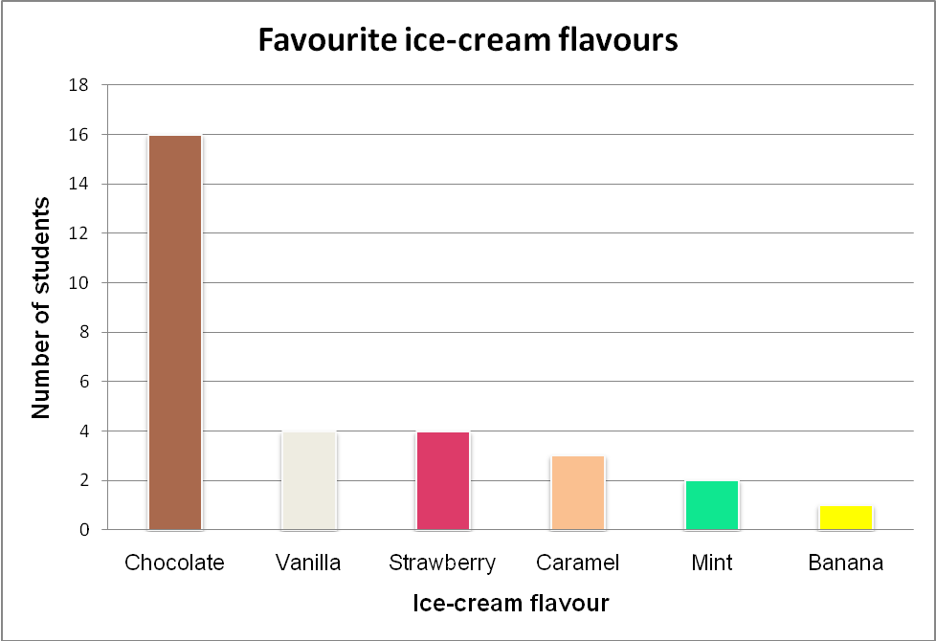

Picture graph

Name |  | Class |  | Date

Favourite overseas destinations

 |  |  | 
Students |  | 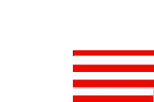 | 
 |  | 
 | 
UK | France | USA | Greece
Countries

Key: 1 flag = 4 people

Column graph

Name |  | Class |  | Date

Weekly spending

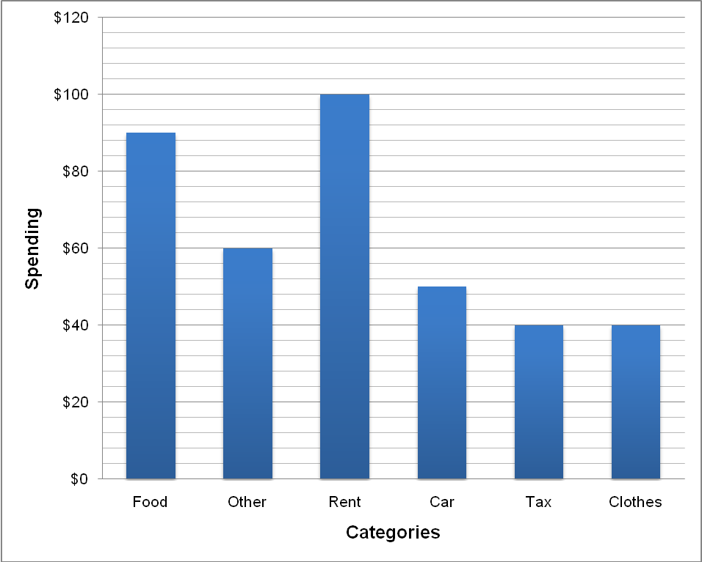

Line graph

Name |  | Class |  | Date

Bus trip

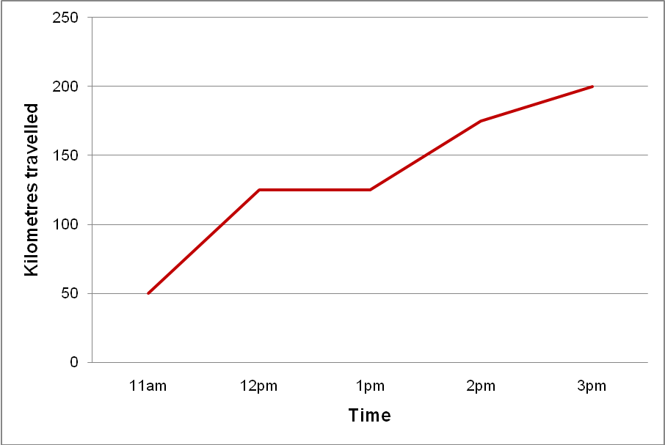

Divided bar graph

Name |  | Class |  | Date

Time spent on homework during the week

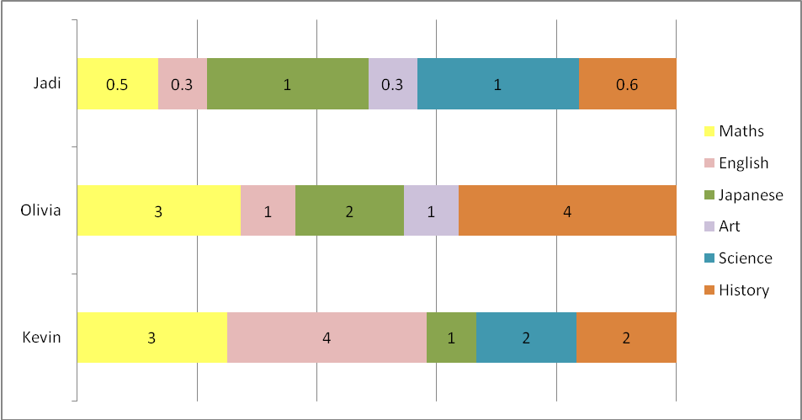

Sector (pie) graph

Name |  | Class |  | Date

Time spent on homework during the week

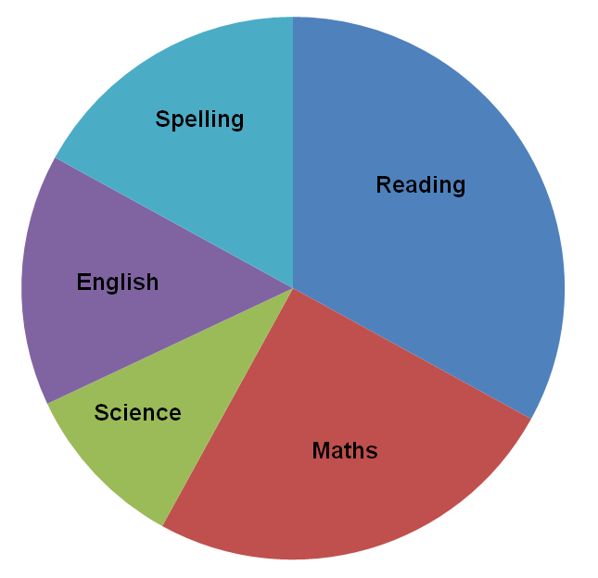

Name the graph

Name |  | Class |  | Date

- Examine this graph.
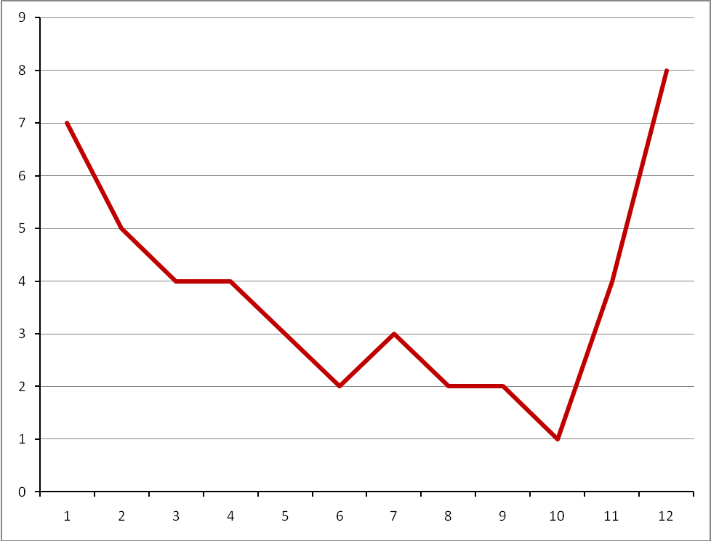

- What do you think it represents?

- Label the graph’s axes to show what you mean.

- Write down at least three things you can tell from the graph.

- Make any other relevant conclusions.

Scoring rubric

5 | Outstanding | Interpretation clearly focused on deep level of analysis of data.
4 | High | Appropriate context, correctly labelled, evidence of well-thought-out interpretation that includes relevant comparisons between data.
3 | Satisfactory | Reasonable context, well labelled, interpretation from graph just presents what is obvious with no particular reflection on any relevant comparisons.
2 | Limited | Context, labelling or interpretation reasonable, but one of these is not of a good quality.
1 | Experiencing difficulty | Inappropriate context or misunderstanding of scale.

Comments

