Places for polygons Year level: 6–7
Unit of work contributed by Anne Pillman, Marryatville Primary School, SA
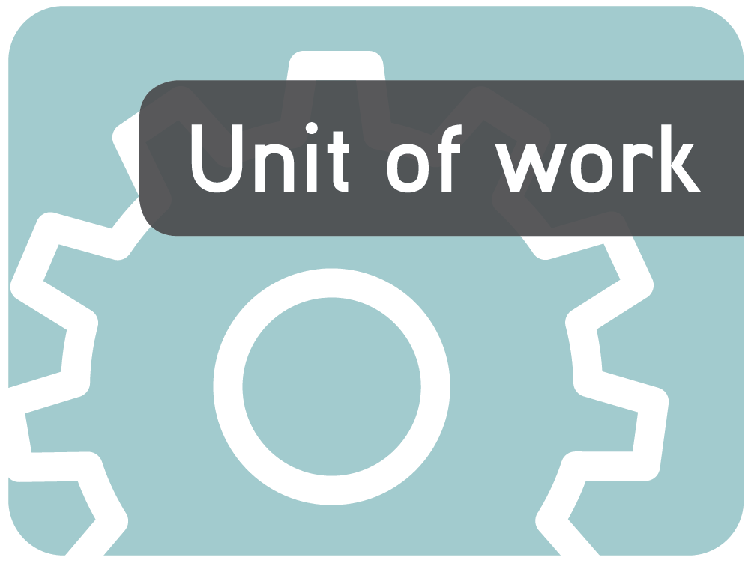
About the unit
Unit description
This unit of work investigates the geometric properties of buildings to develop students’ understanding of polygons.
Knowledge, understandings, skills, values
Students identify the following properties of polygons:
- number and lengths of sides
- number and sizes of angles
- concave/convex polygons
- whether opposite sides are parallel
- whether any sides are of equal length
- number of diagonals and whether they bisect
- symmetrical/non-symmetrical
- lines of symmetry through opposite sides/angles
- rotational symmetry
Students distinguish polygons from non-polygons, recognise, name and construct polygons and describe relationships between properties (eg minimal property lists, if… then … logic).
Focus questions
- What makes a shape a polygon?
- What is the same/different about different polygons?
- What properties are needed to describe these polygons?
- Where do we see polygons in the world around us?
- Why is knowing about the properties of polygons useful?
Resources
The Le@rning Federation digital curriculum resources
L6558 Exploring triangles
L6562 Exploring quadrilaterals
R8055 Prahran and St Kilda arch, Melbourne, 1901
R8060 Wool Arch during the Federation celebrations in Sydney, 1901
R8061 American Arch, 1901
R8337 Colosseum, 1993
R2912 New cyclone-proof houses in Darwin, 1977
R5292 'New home from outer space', 1971
R7487 Antonio Gaudi - To a Dancing God, 1974: Gaudi the perfectionist
R4832 Brick veneer house construction, 2001 - asset 1
R3012 Bullock team and horses at Cobargo, c1900-10
R8332 Parthenon illuminated at dusk
R3577 'Port Arthur during occupation, A.D. 1860'
R2908 Tropical Queensland house, 1955
R3500 St Andrew's College, 1884-1917
R8334 Stonehenge, 2001
R8336 Temple of Concord in Sicily, 2003
R2074 Theatre Royal, Adelaide
R8052 Illuminated towers, Melbourne, 1901
R8529 Monomono (patchwork quilt)
R7990 The 8th Wonder of the World, 1973: The Sydney Opera House sails
Internet sites
- Math cats ‘Tessellation Town’: http://www.mathcats.com/ (type 'tessellation town' in search field)
Software
- Image editing software such as PaintShop Pro or Photoshop
Equipment
- Access to digital cameras for students to take own images
- Polygon templates
- Protractor, compass, ruler for each student
- Construction straws and joiners
Other resources
- Images of familiar sites in the community (eg school)
Attached printable resources

The following teacher-created learning resources referred to in the unit of work are available for you to modify, print and use in your own teaching and learning context:
- Building shapes task sheet
- Guess who cards
- Polygon templates
- Rectangles task sheet
- Polygon, triangle and quadrilateral fact files
- Polygons in their places task sheet
- Polygons test task sheet
- Glossary
Teaching the unit
Setting the scene
Resources
- L6558 Exploring triangles
- Images of buildings and other structures from The Le@rning Federation, as identified in Resources (page 2)
- Images of familiar site, eg school
- Digital cameras for students to take own images
- Building shapes task sheet (page 10)
Teaching and learning activities
Building shapes
Students watch video from L6558 Exploring triangles, about identifying triangles in buildings.
~
Provide students with the Building shapes task sheet (page 10) in electronic form to complete.
Students look at the suggested images from The Le@rning Federation to identify shapes in the buildings.
Students select an image and copy it into the worksheet. They then use the drawing tools to create an outline of the shape. Ask them to name the shape and create a bulleted list of everything they know about it.
Repeat above step with a different image.
~
Introduce the term ‘polygon’. Explain that polygons are made of straight lines that create a closed path. Have them identify the polygons from the shapes they have found so far.
~
Students find shapes in images of their school or other familiar buildings. They find the most interesting shape and photograph it and insert the image into the task sheet. They identify the polygons in the image.
Students select two different shapes from the image, and note what is the same and what is different about them.
Assessment
Assess students’ prior knowledge by looking for evidence of one or more of the following:
- Recognise, name and construct shapes (simple closed curves, polygons, circles, ellipses).
- Identify properties of shapes:
- concave/convex
- symmetrical/non-symmetrical
- number and lengths of sides
- number and sizes of angles
- opposite sides equal/parallel
- diagonals and bisection
- lines of symmetry through opposite sides/ angles
- rotational symmetry
Investigating
Resources
- Polygon templates (page 12)
- Rectangles task sheet (page 13)
- L6562 Exploring quadrilaterals
Teaching and learning activities
Properties of polygons
Give students the Rectangles task sheet (page 13) and, as a class, ask them to list, label and explain everything they can about rectangles using as many of these words as possible:
- side
- parallel
- angle
- equal
- concave/convex
- regular/irregular
- symmetry
- reflection
- rotation
- centre
Add any items the class agrees with.
~
Class discussion – what does each term mean? What mathematical symbols can we use to communicate these ideas? Create a class wall chart with these terms.
~
Students trace a polygon from a template (page 12) and write about it using as many of these key words as they can. Choose polygons for students that are appropriate for their level of understanding.
Students trace a different polygon. Use the keywords to explain how it is similar to the first and how it is different.
Extension activities
Check your students’ understanding of quadrilaterals using L6562 ‘Exploring quadrilaterals’.
What polygons and properties does this learning object cover?
Assessment
Give feedback on students’ work tracing polygons indicating the next stage in their responses:
- recognising and naming polygons eg this is an octagon because it has 8 sides
- describing properties of polygons eg this octagon has 8 sides, 8 angles and 8 lines of symmetry
- describing patterns of properties eg regular polygons have the same number of lines of symmetry as they have sides
Bringing it all together
Resources
- Guess who cards (page 14)
- Polygon, triangle and quadrilateral fact files (pages 21–23)
Teaching and learning activities
Polygon profiles
As a class, play ‘Shape 20 questions’.
What is the minimum number of questions you need to identify each shape?
- Seat a student at the front of the group with their back to the whiteboard. If necessary, give them a copy of the ‘Guess who’ card sheet. The student must not turn to the whiteboard at any stage.
- Draw a polygon and write its name on the whiteboard for the other students to see.
- Student asks yes/no questions of the class in an attempt to find out enough about the polygon to identify it. Encourage them to ask about the properties of the shape by allowing only three attempts to identify it.
- Class responds with show of hands for yes and no. Student decides how much credibility answers have. They may need guidance in answering the questions during the game.
- Record the number of questions taken to identify the polygon.
- Discuss the strategies that could be used to minimise the number of questions required.
~
In pairs play polygon ‘Guess who’.
Copy a set of Guess who cards (page 14) for each player and an extra set in a different colour for each pair. Players sit opposite each other and spread their cards face up in front of them.
- Each player chooses one of the coloured cards and puts it where they can see it but the other player can’t. This is the card the other player is trying to guess.
- Players take turns to ask yes/no questions of each other, trying to identify the shape. Turn face down those cards that are eliminated by each response.
- The first player to get to the last card that correctly identifies the shape wins.
- Limit the questions asked, eg:
- have to include ‘sides’ or ‘angles’
- has to include ‘symmetry’ at least 3 times
- have to include ‘diagonals’
Polygon properties
Contribute to a properties list for a regular and irregular polygon including:
- sides (equal/parallel; adjacent/opposite)
- angles (equal/ right; opposite/adjacent)
- diagonals (equal; intersect at right angles, bisect)
- lines of symmetry
- orders of (rotational symmetry)
Discuss patterns in properties, eg number of angles = number of sides, = number of lines of symmetry and orders of rotational symmetry.
Extension activities
Complete the attached fact files for polygons, triangles and quadrilaterals (pages 21–23).
Drawing conclusions
Resources
- TesselMania!
- Image editing software such as PaintShop Pro or Photoshop
- Polygon templates (page 12)
- Protractor, compass, ruler for each student
- Construction straws and joiners
- Math cats ‘Tessellation Town’: http://www.mathcats.com/ (type 'tessellation town' in search field)
Teaching and learning activities
Tessellation
Have students trace polygon templates (page 12) to construct regular and semi-regular tessellation patterns. Ask them to describe the difference between the two.
Students then use TesselMania! to construct more complex tessellation patterns. They could also use Math cats ‘Tessellation Town’: http://www.mathcats.com (type ‘tessellation town’ in search field).
Symmetrical patterns
Demonstrate how to use a protractor and compass to construct a regular polygon 20 centimetres across.
Have students create a design showing rotational symmetry, and then repeat with reflection.
Ask them to colour their designs to show the symmetry.
Students can then use Word drawing tools or image-editing software to construct these designs on the computer, and describe the similarities and differences between the two types of symmetry.
Strong shapes
Construct a range of polygons from straws with pipe cleaner joiners. Include several examples of triangles and quadrilaterals and both regular and irregular polygons. This can also be done using Meccano or similar construction items, including toothpicks and frozen peas. Test them for stability.
Which is the weakest part?
Which is the strongest shape? How can you test it?
How can you stabilise the weaker shapes?
How are the shapes used in building?
Communicating
Resources
- Polygons in their places task sheet (page 15)
- Polygons test task sheet (page 17)
- Glossary (page 18)
Teaching and learning activities
Polygons in their places project
Students undertake the Polygons in their places project (page 15). In Part A, they identify polygons in buildings and describe properties.
In Part B, students use understanding of polygons and their properties to design floor plan, front view, tessellating floor tile pattern, feature wall design, repeating wall paper design and series of framed string art designs for a building.
Assessment rubric includes technology outcomes.
Polygons test
Students complete the attached Polygons test (page 17). Tasks offer students opportunity to demonstrate their understanding of polygons and properties at a range of levels.
What have you learnt about how polygons are similar and how they differ?
What has helped you develop your understanding?
A word about polygons
Have students construct a glossary about polygons using the Glossary on page 18 as a guide. Give each student a term to define and illustrate to contribute to the class chart.

Writer: Anne Pillman
The material in this unit of work may contain links to internet sites maintained by entities not connected to Education Services Australia Ltd and which it does not control (‘Sites’).
Education Services Australia Ltd:
- provides the links for ease of reference only and it does not sponsor, sanction or approve of any material contained on the Sites; and
- does not make any warranties or representations as to, and will not be liable for, the accuracy or any other aspect of the material on the Sites or any other matter connected to the use of the Sites.
While the material in this unit of work is not remunerable under Part VB of the Copyright Act 1968, material on the Sites may be remunerable under Part VB of the Copyright Act 1968. It is your responsibility to read and comply with any copyright information, notices or conditions of use which apply to a Site.




Building shapes

Name |  | Class |  | Date

- Look at how triangles are used in buildings using L6558, ‘Exploring triangles’. Select ‘Video’. Watch the video about triangles in buildings.

- Look for other shapes in buildings and structures in these suggested images:

- R8055 Prahran and St Kilda arch, Melbourne, 1901
- R8060 Wool Arch during the Federation celebrations in Sydney, 1901
- R8061 American Arch, 1901
- R8337 Colosseum, 1993
- R2912 New cyclone-proof houses in Darwin, 1977
- R5292 'New home from outer space', 1971
- R7487 Antonio Gaudi - To a Dancing God, 1974 Gaudi the perfectionist
- R4832 Brick veneer house construction, 2001 - asset 1
- R3012 Bullock team and horses at Cobargo, c1900-10
- R8332 Parthenon illuminated at dusk
- R3577 'Port Arthur during occupation, A.D. 1860’
- R2908 Tropical Queensland house, 1955
- R3500 St Andrew's College, 1884-1917
- R8334 Stonehenge, 2001
- R8336 Temple of Concord in Sicily, 2003
- R2074 Theatre Royal, Adelaide
- R8052 Illuminated towers, Melbourne, 1901
- R8529 Monomono (patchwork quilt)

- Choose one and save the picture. (Right click / Save Picture As …)

- Insert the picture in the space below and use the MS Word drawing tools to outline the shape you found.
(insert your image here)

- Name the shape and make a bulleted list of everything you know about it.

- Repeat with another image and a different shape.
(insert your image here)

- Look at images of buildings from your community (such as our school, our library). Can you find any shapes in the images?
(insert your image here)

Polygon templates
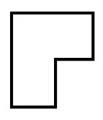

Rectangles

Name |  | Class |  | Date

- Draw a rectangle.

- List (label and explain) everything you can about it using as many of these words as possible:
side | parallel | angle | equal | diagonal | bisect
concave/ convex | regular/ irregular | symmetry | reflection | rotation | centre

- What properties must a quadrilateral have for it to be a rectangle? (Repeat for a square, a parallelogram and a rhombus.)

Guess who cards

Equilateral triangle | Isosceles triangle | Scalene triangle | Right-angled triangle | Obtuse-angled triangle
Acute-angled triangle | Square | Rectangle | Rhombus | Parallelogram
Kite | Arrowhead | Trapezium | Regular pentagon | Regular hexagon
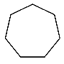  Regular heptagon | Regular octagon | 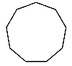  Regular nonagon | 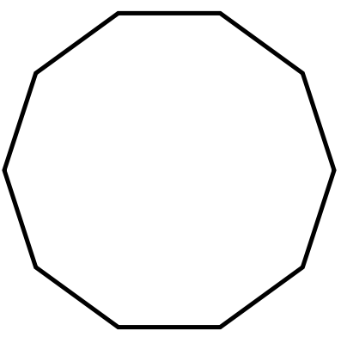  Regular decagon | 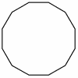  Regular dodecagon
Irregular quadrilateral | Circle | Ellipse | 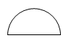  Semicircle | 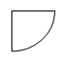  Sector
Irregular pentagon | Irregular octagon | Irregular heptagon | Irregular decagon | Irregular dodecagon

Polygons in their places

Name |  | Class |  | Date

Key words
Side | parallel | angle | equal | diagonal | bisect
concave/ convex | regular/ irregular | symmetry | reflection | rotation | centre

- Here is a floor plan of our classroom:

What type of polygon is it? (Write as much as you can about it using the keywords. Label the diagram to help.)

- These structures are based on regular polygons. In the table, record which polygon each structure is based on.
The Pentagon | is based on:
Honeycomb | is based on:

Choose one of the two structures (either the honeycomb or the Pentagon) and write as much as you can about it using the keywords.

- Design a building that is based on a polygon.

Provide drawings to show:
- floor plan, showing at least 3 rooms
- front
- regular or semi regular tessellating pattern for floor tiles
- symmetric design for wall paper using one polygon
- feature wall design using as many different polygons as possible
- diagonals string art – a series of framed designs to feature in a hallway involving diagonals of different polygons.

Write 20–50 words about each of your diagrams using each of the keywords at least once in the whole assignment.

Assessment rubric

 | Beginner | Learner | Competent | Proficient
Geometric thinking | Little or no attempt to use geometric language. | Can recognise and name polygons. | Can list properties of polygons. | Identifies relationships between properties.
Construction | None or little use of drawing tools. | Uses ruler and or traces templates to construct polygons with straight edges. | Measures angles and sides to construct more accurate polygons. | Uses compass, protractor to construct accurate polygons.
Application | Identifies none or few basic polygons in built structures. | Identifies and uses polygons in built structures. | Identifies and uses polygons and transformations of polygons in a range of structural contexts. | Identifies and uses polygons and transformations of polygons appropriately and/or creatively in a range of structural contexts.
ICT | None or little use of ICT to produce polygons. | Uses ICT to construct polygons. | Uses ICT to construct a range of polygons. | Uses ICT to construct and manipulate accurate polygons.

Polygons test

Name |  | Class |  | Date

- Name these polygons:

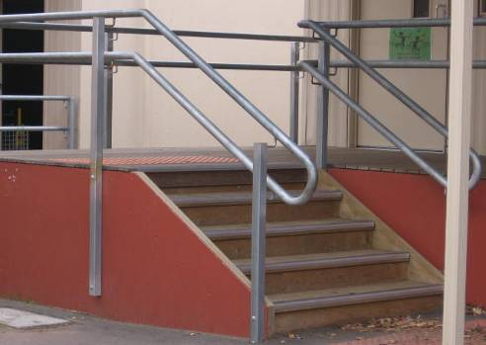
- Find and name two different polygons in this image.
Marryatville Primary School, SA.
1.
2.

- Use a ruler and protractor to draw a regular pentagon.
- How many diagonals does it have?
- How many lines of symmetry?
- How many orders of rotational symmetry are there?

- Sketch an isosceles triangle and show the equal sides and angles.
- How many diagonals would a nonagon have?

- How many lines of symmetry would a regular octagon have?
Where would they go from?
How would this change for a heptagon?

- Write at least 30 words on what you have learnt about how polygons are similar and how they differ.

What helped you develop your understanding?

Glossary

Acute-angled triangle | A triangle that contains angles that are all less than 90 degrees.
Adjacent | Next to. Two adjacent sides share an angle. Two adjacent angles share a side.
Angle | Amount of turning from one arm to another, by turning around the vertex. Measured in degrees. | 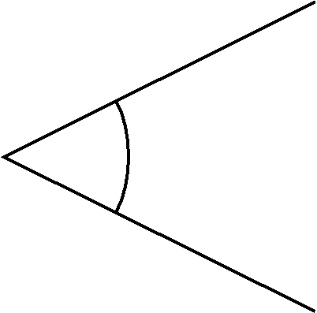
Bisect | Divide an angle or line segment into two equal parts. | 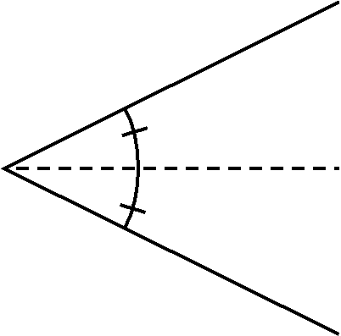
Concave | A shape with a dent in it.
Convex | A shape without a dent in it.
Diagonals | Go from corner to any other corner.
Diagonals of quadrilaterals | May be equal (or not), perpendicular (or not) and may bisect each other (or not).
Ellipse | A squished or partly flattened circle.

Equal angles | Two angles are equal if the angles at the vertex are equal.  This is shown with matching curved lines.
Equal sides | Two sides are equal if they are the same length from vertex to vertex.  This is shown with matching cross marks.
If … then … logic | Eg If a regular polygon has 5 sides then it has 5 lines of symmetry, or if a polygon has an internal reflex angle then it is concave.
Isosceles triangle | A triangle where two sides are the same length (and two angles are the same size). | 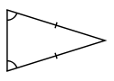
Minimal properties | The minimum number of properties needed to define a polygon (eg quadrilateral with at least 3 right angles has to be a rectangle, or, triangle with at least two 60˚ angles has to be equilateral).
Obtuse-angled triangle | A triangle that contains one angle that is greater than 90 degrees.
Opposite angle and opposite side | In a triangle, the angle opposite a side is the only angle that is not adjacent to it.  In a triangle, the side opposite an angle is the only side not adjacent to it.  In this triangle, angle A is opposite side BC, angle B is opposite side AC, and angle C is opposite side AB. | 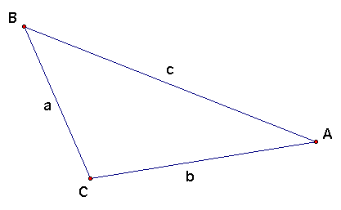
Parallel sides | Two sides are parallel if they are the same distance apart along their entire length. This is shown with matching arrow heads.
Polygon | A 2D shape that  - has no gaps  - has straight sides. | ✓    

Quadrilateral | A four-sided polygon.
Regular polygons | Have equal sides and equal angles. | ❒  ✓  ✓  
Scalene triangle | A triangle where all sides are different lengths (and all angles are therefore also unequal).
Symmetrical | Has either:  - mirror line (also called a line of symmetry)  - centre of rotation (also called point of symmetry).
Vertex | A corner, or where two sides meet.

Polygon fact file
Name |  | Class |  | Date

Name | Sides | Angles | Equal sides | Equal angles | Parallel sides | Right angles | Diagonals | Diagonals bisect? | Lines of symmetry | Orders of symmetry
Triangle
Quadrilateral
Pentagon
Hexagon
Heptagon
Octagon
Nonagon
Decagon
Dodecagon
Icosagon
Patterns?
Triangle fact file
Name |  | Class |  | Date
Name | Sides | Angles | Equal sides | Equal angles | Parallel sides | Right angles | Diagonals | Diagonals bisect? | Lines of symmetry | Orders of symmetry
Equilateral
Isosceles
Scalene
Right-angled
Obtuse-angled
Acute-angled
Patterns?

Quadrilateral fact file
Name |  | Class |  | Date

Name | Sides | Angles | Equal sides | Equal angles | Parallel sides | Right angles | Diagonals | Diagonals bisect? | Lines of symmetry | Orders of symmetry
Square
Rhombus
Rectangle
Parallelogram
Trapezium
Kite
Arrowhead
Pattern?

