Counting on, counting back Year level: 1
Unit of work contributed by Jane McAlpine, Chapman Primary School, ACT
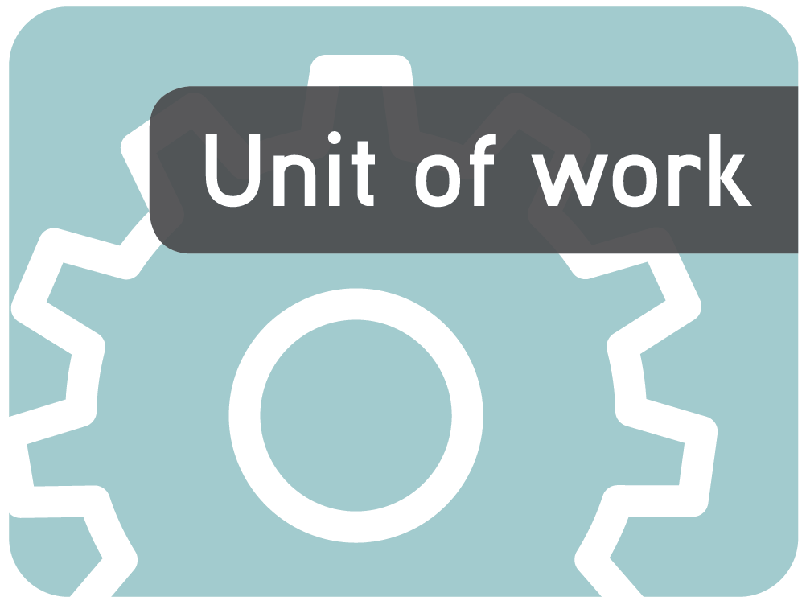
About the unit
Unit description
The beginning of this unit focuses on ensuring that students have basic foundation skills, and an understanding of both what the number line means and the forward and backward number sequence. They then progress to developing conceptual understandings of place value, specifically tens and ones. Once these foundation skills have been mastered, students are introduced to the strategies of counting on and then counting back.
Knowledge, understandings, skills, values
- Students sequence whole numbers up to 20.
- Students recognise place value in two digit numbers.
- Students can solve addition and subtraction problems using counting on and counting back.
Focus questions
- What is the number ‘before’ and ‘after’ a particular number?
- What does each digit represent in a two digit number?
- What is an efficient way to solve addition and subtraction problems?
Resources
Digital curriculum resources
L2319 Number trains: numbers 1–20
Counting beetles series: L8280 Counting beetles, L8284 Counting beetles: making word problems, L8285 Counting beetles: solving word problems
Other resources
- Nylon rope for a washing line, 20 socks numbered from 1–20 and 20 pegs
- A large hundred square
- Unifix blocks
- One set of large number cards (numbers 0–20)
- A white board, whiteboard marker and MAB tens and ones per child
- A small hundreds square
- 1 set of lower number cards (numbers 1–4 shown as dots) and higher number cards (numbers 11–16 shown as numerals)
- Laminated ‘Dice bingo’ boards with numbers from 10–20 – template attached
- Dice (numbers 1–6 represented as dots) and dice (numbers 9–14 represented as numerals)
- Large number line
- ‘Step Back: Song for Teaching Counting Back to Subtract’ song and flash cards by Carl M. Sherrill. Purchase from: http://www.songsforteaching.com/
Attached printable resources

The following teacher-created learning resources referred to in the Unit of work are available for you to modify, print and use in your own teaching and learning context:
- Train carriage set (laminate and hand out one per pair)
- Number card sets (enlarge to A3 then laminate and cut up)
- Forward and backward number sequences assessment
- Number ladder
- Number fact game boards
- Count back game board and instruction cards
- Number line worksheet per child
- Dice bingo boards
- Final assessment guidelines
Teaching the unit
Setting the scene
Resources
- Nylon rope for a washing line, 20 socks numbered from 1–20 and 20 pegs
- One set of large number cards (numbers 0–20)
- Counting beetles – L8280
- Number card sets (numbers 10–20) per pair enlarged to A3 then laminated and cut up (page 11)
- Forward and backward number sequences assessment (page 12)
Teaching and learning activities
Going forwards
Have two students hold up a length of rope. Hand out one sock to each student. The student with the sock numbered ‘1’ pegs their sock on the line and students take it in turns to peg their sock up in order going from smallest to largest.
Collect the socks and re-issue them. Select students at random to peg their sock in the position they think it should go on the washing line. Continue until all socks are hung in a forward sequence.
Ask students to close their eyes and turn around or swap some socks on the washing line then invite students to tell you the numbers that have been turned around or swapped.
~
Students work in pairs to play the Counting beetles (L8280) learning object on the computer.
End the lesson by asking each student, ‘What is the number after...?’ (inserting different numbers).
Going backwards
Play ‘Zero zap’. Students stand in a circle and one person begins by saying ‘10’. Move around the circle, each student saying the next number in the backward sequence. The student who should say ‘zero’ calls out ‘zero, zap!’ and sits down. Repeat process with standing students until one student remains.
~
Place large number cards in order along the floor. Turn numbers 1–19 face down, leaving the numbers 0 and 20 face up. Choose one student at a time to come up and stand on 20 and step backwards to a card of their choice. Students suggest what number the student is standing on.
Divide the class into two equal teams and give each student a number card (numbers 10–20). On ‘Go!’, teams race to order themselves in a backward sequence (ie from 20 to 10).
Students work in pairs racing against other pairs to sequence each set of number cards (numerals, words then counting frames) in a backward sequence.
End the lesson by asking each child, ‘What is the number before...?’ (inserting different numbers).
Assessment
Students complete the attached Forward and backward number sequences assessment sheet (page 12).
Bringing it all together
Resources
- Unifix blocks and 1 container per pair
- Large number cards (numbers 1 to 20)
- Individual number ladders and small toy or counter per child
- 1 set of lower number cards (numbers 1–4 shown as dots) and higher number cards (numbers 11–16 shown as numerals)
- Laminated ‘Dice bingo’ boards with numbers from 10–20, dice (numbers 1–6 represented as dots and numbers 9–14 represented as numerals) and counters
- Train carriage set, laminate, cut out and hand out one set per pair – attached
- L2319 Number trains: numbers 1–20 and interactive whiteboard
- Large number line
- Number fact game boards, dice (numbers 1–6) and different coloured counters
- 1 container, Unifix blocks and 2 individual number ladders per pair
- Count back game board, instruction cards and counters per small group
- ‘Step Back: Song for Teaching Counting Back to Subtract’ By Carl M. Sherrill. Purchase from: http://www.songsforteaching.com/
- Number line worksheet (1 per student)
Teaching and learning activities
Counting on
Have students sit in a circle. Drop a small collection of blocks one by one into a container, asking students to count aloud as each block is added to the container. Show the contents of the container and then hold the container above their eye level. Ask how many blocks would be in the container if one more block was added.
Repeat question, changing the number of blocks to be added to 2 and 3 blocks. Encourage counting on.
~
Place 11 Unifix blocks in the centre of the circle. Ask students to close their eyes and while they are doing this, place a container over 3 blocks. Invite students to count the blocks that are not covered. Ask, ‘How many blocks have I covered?’ Have students suggest ways of finding the solution, for example, counting on from 8 to 11.
Have students work in pairs to complete the above activity using 12 blocks.
Lay out the large number cards from 1–20 like a ladder (1 at the bottom). Choose one student to stand on a number and count on, for example ‘Stand on 4, count on 2.’ Repeat the process.
Encourage students to visualise the number ladder by closing their eyes. Then tell them to imagine standing on 7 and counting on one, and so on.
Give each student a number ladder and a jumping object. Give instructions for students to follow to practise their counting on. For example, ‘Stand on 3 and count on 2. Where are you?’
End by asking each student, ‘Count on 2 from the number...’ inserting different numbers.
More counting on
Play ‘Two hand whiz’. Select 2 students to demonstrate. On the count of 3 they show 1 hand, each holding up a random number of fingers. Students try to be the quickest to add the 2 numbers. Students then play ‘Two hand whiz’ in pairs.
~
Using the 1–10 cards, have 1 student select a lower card and another select a higher card. Ask the 2 students to stand and position themselves so that the larger number goes first. Ask students to add the 2 numbers, encouraging students to count on from the larger number to find the answer. Repeat.
Place students into 2 groups to participate in 2 rotations:
Students play ‘Dice bingo’ in small groups by taking it in turns to roll the two dice and then add the 2 numbers by counting on from the larger number.
They cover the number if it is on their board. The first student to cover 3 numbers in a row, diagonal or column is the winner.
~
Have students work in pairs to make a number train from the laminated train carriage sets where they have to arrange train carriages in a forward sequence from 1 to 20.
Play L2319 Number trains: numbers 1–20 as a whole class on the interactive whiteboard.
End by asking each student, ‘Count on 3 from the number...’ (inserting different numbers).
Even more counting on
Display a large number line and point to a number. Ask, ‘When we count on from a number which way do we move on the number line?’ (ie right). Then ask, ‘Does this mean the number gets larger or smaller?’ (ie larger). As a class, complete a concept map about ‘Counting On’, encouraging students to think of words, symbols and examples related to counting on. These could include: plus, +, add, make bigger, total, more, altogether.
Use the large number line to show how to add 2 numbers together by counting on from the larger number. Show how to jump along the number line like a frog.
Use an enlarged copy of the attached Number line worksheet to show how to represent counting on using a number line, by drawing in the jumps.
Provide each child with their own Number line worksheet and invent and read out different addition stories one at a time that they then go and solve using a new number line for each problem.
~
Have students play the Number fact game in small groups. They choose a game board, either the ‘Add 2’ or ‘Add 3’ board.
Students take it in turns to roll the dice and add 2 (or 3) to the score on the dice. If that number is on the game board, the player places one of their coloured counters on the number. Students continue until a player covers their whole board.
End the lesson by getting each child to answer an addition question where they are encouraged to count on to work out the answer.
Simple subtraction by counting back
Have students sit in a circle. Show students a container that has 13 Unifix blocks in it. Say, ‘I am now going to take out 4 blocks.’ Take out 4 blocks and then hold the container above their eye level. Ask, ‘How many blocks do I have left in my bowl?’ Ask students to share how they would work out the answer. Demonstrate how to count back 4 from 13 to reach 9.
~
Organise students into pairs and provide them with one container and some blocks. Ask them to take it in turns to set up a subtraction problem for their partner to solve.
Give students their number ladders to assist them with counting back.
Set up large number cards like a ladder (number 20 at the top). Ask 1 student to stand on a number and count back from a specified number. For example, ‘Stand on 17, count back 4.’ Repeat.
~
Play the Count back game with some counters and shuffled ‘count back’ cards. Let students play in pairs, starting with their counters on the 20.
Explain that they should take turns turning over a card and following the instructions. So if the first card is ‘count back 2’ the student should move their counter to 18. The first student to reach home wins.
~
Ask students to close their eyes and picture the number ladder in their head. Then ask them to count back from specific numbers. Show them how to check by counting on from their answer back to the original number.
More counting back
Ask students to stand up and play ‘Step Back: Song for Teaching Counting Back to Subtract’. Students can join in, following the instructions of the song.
Using a large number line, point to a number and ask, ‘When we count back from a number, which way do we move on the number line?’ (ie left). Then ask, ‘Does this mean the number gets larger or smaller?’ (ie smaller). As a class, complete a concept map about ‘Counting back’, encouraging students to think of words, symbols and examples related to counting back. These could include: subtract, minus, take away, -, make smaller, less, how many left?
~
Use the large number line to show how to subtract a number from a larger number by counting back from the larger number. Show how to jump along the number line like a frog.
Use an enlarged copy of the Number line worksheet to show how to represent counting back using a number line, by drawing in the jumps.
Provide each child with their own Number line worksheet. Verbally provide them with different subtraction stories, one at a time, that they then go and solve using a new number line for each problem.
End by asking each student to ‘count back 2 from the number...’ (inserting different numbers).
Drawing conclusions
Resources
- 1 bell and counters
- Counting beetles: making word problems (L8284), Counting beetles: solving word problems (L8285)
Teaching and learning activities
Counting on or counting back
Provide students with a supply of counters. Ring a bell a number of times, for example 5 times. Instruct students to place the corresponding number of counters on their desk. Hold up a symbol card for addition or subtraction and then ring the bell again, for example twice. Have students respond by observing the symbol card and adding or subtracting the correct number of counters. Students then state the total number of counters.
~
Students individually play Counting beetles: solving word problems (L8285), then Counting beetles: making word problems (L8284).
Communicating
Resources
- Addition and subtraction symbol cards
- Final assessment guidelines – attached
Teaching and learning activities
Give students some cards that have words associated with addition or subtraction written on each one. Invite students to use the cards to make addition or subtraction sentences. Have them share their sentences with the class and then let students solve them.
Students participate in ‘Think, pair, share’ where they reflect on the things they have enjoyed and/or learnt from doing this mathematics unit.
Assessment
Use the ‘Final assessment guidelines’ to identify what individuals have learned.
Writer: Jane McAlpine, 2009
The material in this Unit of work may contain links to internet sites maintained by entities not connected to Education Services Australia Ltd and which it does not control (‘Sites’).
Education Services Australia Ltd:
- provides the links for ease of reference only and it does not sponsor, sanction or approve of any material contained on the Sites; and
- does not make any warranties or representations as to, and will not be liable for, the accuracy or any other aspect of the material on the Sites or any other matter connected to the use of the Sites.



While the material in this Unit of work is not remunerable under Part VB of the Copyright Act 1968, material on the Sites may be remunerable under Part VB of the Copyright Act 1968. It is your responsibility to read and comply with any copyright information, notices or conditions of use which apply to a Site.

Train carriages

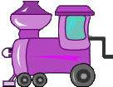 | 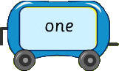 | 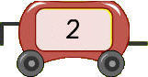
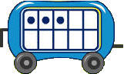 | 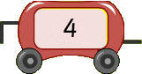 | 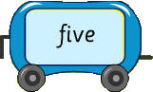
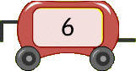 | 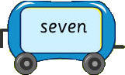 | 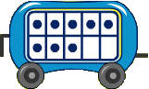
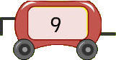 | 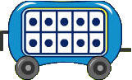 | 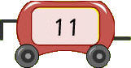
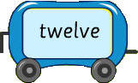 | 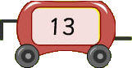 | 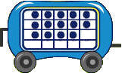
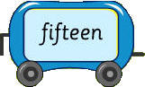 | 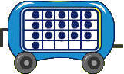 | 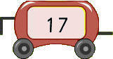
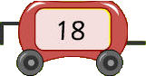 | 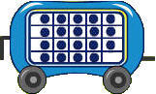 | 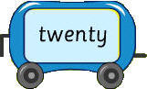

Number card sets
10 |  | 11 |  | 12 |  | 13
14 |  | 15 |  | 16 |  | 17
18 |  | 19 |  | 20 |  | ten
eleven |  | twelve |  | thirteen |  | fourteen
fifteen |  | sixteen |  | seventeen |  | eighteen
nineteen |  | twenty
  ● | ● | ● | ● | ●
  ● | ● | ● | ● | ●
  ● | ● | ● | ● | ●
  ● | ● | ● | ● | ●
  ●
  ● | ● | ● | ● | ●
  ● | ● | ● | ● | ●
  ● | ●
  ● | ● | ● | ● | ●
  ● | ● | ● | ● | ●
  ● | ● | ●
  ● | ● | ● | ● | ●
  ● | ● | ● | ● | ●
  ● | ● | ● | ●
  ● | ● | ● | ● | ●
  ● | ● | ● | ● | ●
  ● | ● | ● | ● | ●
  ● | ● | ● | ● | ●
  ● | ● | ● | ● | ●
  ● | ● | ● | ● | ●
  ●
  ● | ● | ● | ● | ●
  ● | ● | ● | ● | ●
  ● | ● | ● | ● | ●
  ● | ●
  ● | ● | ● | ● | ●
  ● | ● | ● | ● | ●
  ● | ● | ● | ● | ●
  ● | ● | ●
  ● | ● | ● | ● | ●
  ● | ● | ● | ● | ●
  ● | ● | ● | ● | ●
  ● | ● | ● | ●
● | ● | ● | ● | ●
● | ● | ● | ● | ●
● | ● | ● | ● | ●
● | ● | ● | ● | ●

Forward and backward number sequences

Name |  | Class |  | Date

Forward number sequences
Fill in the missing numbers to complete each forward number sequence.
3 |  |  |  | 5 |  |  |  |  |  | 8
7 |  |  |  |  |  | 10 |  |  |  |  |  | 13

9 |  |  |  | 11
15 |  |  |  |  |  | 18
19 |  |  |  |  |  | 22

Teacher to ask: ‘Count aloud from 1 to 30: Yes/No
Backwards number sequences
Fill in the missing numbers to complete each backward number sequence.
10 |  |  |  | 8 |  |  |  |  |  |  |  | 4
14 |  |  |  |  |  | 11 |  |  |  | 9

17 |  |  |  | 15 |  |  |  |  |  | 12
19 |  |  |  |  |  | 16
23 |  |  |  |  |  |  |  | 19

Teacher to individually ask: ‘Count aloud from 23 back to 1’: Yes/No

Number ladder

Twenty |  | 20
Nineteen |  | 19
Eighteen |  | 18
Seventeen |  | 17
Sixteen |  | 16
Fifteen |  | 15
Fourteen |  | 14
Thirteen |  | 13
Twelve |  | 12
Eleven |  | 11
Ten |  | 10
Nine |  | 9
Eight |  | 8
Seven |  | 7
Six |  | 6
Five |  | 5
Four |  | 4
Three |  | 3
Two |  | 2
One |  | 1

Number fact game boards
‘Add 2’ Number fact game board |  |  |  |  | ‘Add 3’ Number fact game board
4 | 3 | 8 | 6 |  | 9 | 8 | 7 | 5
3 | 5 | 6 | 5 |  | 5 | 6 | 5 | 4
8 | 7 | 4 | 7 |  | 6 | 9 | 8 | 7
5 | 3 | 8 | 5 |  | 9 | 7 | 4 | 8

Counting back board game
Take it in turns to pick up a count back card and follow the instructions. The first player to reach the finish is the winner.
START  25 | 24 | 23 | 22 | 21
 |  |  |  | 20
Count back  cards |  | 17 | 18 | 19
 |  | 16
 |  | 15 | 14 | 13
 |  |  |  | 12
7 | 8 | 9 | 10 | 11
6
5 | 4 | 3 | 2 | FINISH  1

Count back cards

Make multiple copies of each card, cut out and glue back and front faces together to use in the Counting back board game.
Front face
Count back 1 space
Count back 2 spaces
Count back
cards
Count back
cards
Count back
cards
Count back 1 space
Count back 2 spaces
Count back
cards
Count back
cards

Back face
Count back 3 spaces

Front face
Count back
cards

Back face
Count back 3 spaces

Dice bingo board

Number lines

Name |  | Class |  | Date

1. __________ = ____
1 | 2 | 3 | 4 | 5 | 6 | 7 | 8 | 9 | 10 | 11 | 12 | 13 | 14 | 15 | 16 | 17 | 18 | 19 | 20
2. __________ = ____
1 | 2 | 3 | 4 | 5 | 6 | 7 | 8 | 9 | 10 | 11 | 12 | 13 | 14 | 15 | 16 | 17 | 18 | 19 | 20

3. __________ = ____
1 |  | 2 |  | 3 |  | 4 |  | 5 |  | 6 |  | 7 |  | 8 |  | 9 |  | 10 |  | 11 |  | 12 |  | 13 |  | 14 |  | 15 |  | 16 |  | 17 |  | 18 |  | 19 |  | 20

4. __________ = ____
1 |  | 2 |  | 3 |  | 4 |  | 5 |  | 6 |  | 7 |  | 8 |  | 9 |  | 10 |  | 11 |  | 12 |  | 13 |  | 14 |  | 15 |  | 16 |  | 17 |  | 18 |  | 19 |  | 20

5. __________ = ____
1 |  | 2 |  | 3 |  | 4 |  | 5 |  | 6 |  | 7 |  | 8 |  | 9 |  | 10 |  | 11 |  | 12 |  | 13 |  | 14 |  | 15 |  | 16 |  | 17 |  | 18 |  | 19 |  | 20

Final assessment guidelines

Conduct individual assessments with students as described below.
Question | Needs further development | Established
Ask, ‘If I have 7 books and I get another 4, how many will I have altogether?’ | - The student attempts to add the two groups by counting on from 7 or 4 but gives an incorrect answer, or:  - The student requires the use of concrete materials to solve the problem, and/or:  - The student counts from one. | - The student correctly adds the two groups counting on from 7 or 4.
Display a set of 9 counters. Say, ‘Here are 9 counters.’ Screen the counters and then display a set of 5 counters. Say, ‘There are 5 counters here.’ Then screen the second group. Ask, ‘How many counters are there altogether?’ | - The student attempts to add the two groups by counting on from 9 or 5 but gives an incorrect answer, or:  - The student counts from one and/or:  - The student has difficulty visualising the screened objects and has to be shown again. | - The student correctly adds the two groups by counting on from 9, or:  - The student correctly adds the two groups by counting on from 9 after being shown the screened objects a second time.
Ask, ‘If I have 8 lollies and I eat 3, how many are left?’ | - The student attempts to solve the subtraction task without concrete materials, but gives an incorrect answer, or:  - The student requires concrete materials to solve the subtraction task. | - The student correctly and efficiently completes the subtraction task without the use of concrete materials.
Display and then screen a collection of 16 counters. Say, ‘I am taking away 5. How many are left?’ Display the 5 removed counters. | - The student attempts to solve the subtraction task by counting on from 5 or counting back from 16.  - The student requires seeing the screened counters to solve the subtraction task. | - The student correctly solves the subtraction task by counting on from 5, or:  - The student correctly solves the subtraction task by counting back from 16.

