Cities taking shape Year level: 4–5
Unit of work contributed by Melanie Bezear, Calwell Primary School, ACT
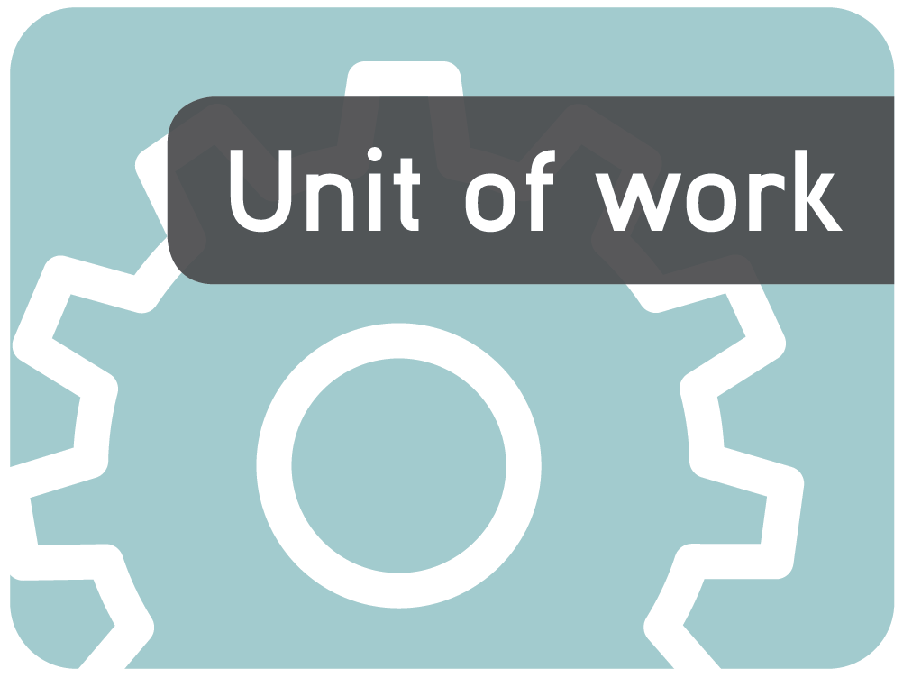
About the unit
Unit description
Students develop their knowledge of 2D and 3D shapes, and the relationships between them. They learn about how a 3D shape can look different when viewed from different positions. Students use knowledge and skills gained through the unit to design and construct a ‘model’ city or town block.
Knowledge, understandings, skills, values
- Recognises, names, sorts and represents 2D and 3D shapes.
- Visualises and sketches objects and sets of objects from different viewpoints.
- Makes simple sketches of 3D shapes.
- Understands and creates nets of 3D shapes.
Focus questions
- How can we identify shapes?
- How are 2D shapes related to 3D shapes?
- Where can we find shapes in our environment?
- How do we make 3D shapes?
- Why do some shapes look different from different angles?
Resources
Digital curriculum resources
Shape maker series: L1058 blocker, L588 stacker, L1061 complex objects 1, L1062 complex objects 2, L1059 replicator
L9931 Shape maker: simple shapes: assessment
Building site series: L849 level1, L1097 level 2, L1098 level 3, L1099 level 4
Viewfinder [Flash player version] series: L6245 Viewfinder, L6262 all angles, L6263 backwards glance, L6264 flip side, L 6265 up front
Internet sites
- Australian Association for Research in Education: http://www.aare.edu.au/ (type 'assessing the effect of an instructional intervention' in search field)
- Picture: http://www.edupics.com/ (type ‘geometric shapes’ in search field)
Software
- Google Earth
- Google SketchUp (available free from: http://sketchup.google.com/)
Other resources
- Pattern blocks
- 3D geometric solids
- Cardboard/poster board
- Cardboard containers of various shapes and sizes
- Lego blocks or Unifix cubes
Attached printable resources

The following teacher-created learning resources referred to in the Unit of work are available for you to modify, print and use in your own teaching and learning context:
- City designer assessment task
- Shapes assessment task
- Which net?
- Match the net
- How to draw a cube
- Sort 3D shapes
- 2D faces on 3D shapes
Teaching the unit
Setting the scene
Resources
- Pattern blocks
- Poster card
- Google Earth (available free from: http://earth.google.com/)
- Shapes assessment task
Teaching and learning activities
Understanding 2D shapes
In groups, students are given a selection of different pattern blocks or other 2D shapes. They then come up with criteria (a rule) for sorting them (this could be number of sides, angles etc). They sort them according to their criteria.
Why did you sort the shapes that way?
Is there another way to sort the shapes?
~
Students then photograph/draw the grouped shapes and write a brief description of their criteria.
Discuss and display in the classroom.
The properties of 2D shapes
Discuss the properties used to identify a range of shapes.
Ask students what properties (or ‘features’) could be used for identification.
Revise or introduce spatial language, such as ‘parallel’, ‘perpendicular’, ‘vertex’ etc.
~
Split the class into groups. Give each group a sheet on which are drawn several distinctly different examples of the named shapes:
- squares (in different orientations)
- rectangles (should include at least one square, as these are also rectangles)
- parallelograms (should include at least one rectangle and one square, as these are also parallelograms)
- rhombuses (should include at least one square, as these are also rhombuses)
- trapezia (should include at least one parallelogram, one rectangle and one square)
- quadrilaterals (should include at least one trapezium, one parallelogram, one rectangle and one square).
Students investigate the properties of all the shapes on their sheet (number of sides, parallel lines, symmetry, etc).
Individually (or in pairs), they create a checklist for identification of their shape. This is displayed on an A4 poster.
This is an open-ended task, designed to give students the opportunity to demonstrate their current understanding of 2D shapes.
2D in context
Refer to students’ checklists. For each shape, discuss the places and objects that might include the shape. Ask students to give examples.
Where might we find this shape?
What does this shape remind you of?
~
Display a picture of a city from the air, sourced from Google Earth. Explain that looking directly down over a scene is called ‘bird’s eye view’. Ask students to identify various 2D shapes that may be visible. Then ask them to draw the 2D shapes over the shapes on the picture. Repeat the activity with pictures of other cities. Discuss.
Which shapes are most common? Why?
Are any shapes missing?
Are there shapes that are used for similar purposes?
Extension activities
Some students may choose less common or irregular shapes, or look for more complicated properties to include in their checklist (such as type/size of angles). Students share their poster with the class.
Assessment
The Shapes assessment task is designed to gauge students’ understanding of 2D and 3D shapes, as well as assess if they can visualise and recreate a group of objects from another angle.
The questions are based on Van Hiele’s first three levels of geometric reasoning. Some online articles explaining this can be found here:
Australian Association for Research in Education: http://www.aare.edu.au (type 'assessing the effect of an instructional intervention' in search field)
It can be used as a pre-test or a post-test.
Investigating
Resources
- 3D solid geometric shapes (or blocks or cardboard packaging)
- Poster paint
- Paper/cardboard
- 2D faces on 3D shapes handout
- 3D solid shapes
- How to draw a cube instructions
- Google ‘SketchUp’ (available free from: http://sketchup.google.com/)
- Shape maker learning object series
- 3D solid shapes
- Rulers
- Pencils
Teaching and learning activities
2D faces on 3D shapes
Discuss:
How are 2D shapes related to 3D shapes?
~
Using 3D shape blocks (or other solid shapes), students dip each of the faces in paint and print them. They then identify the 2D shapes found on the faces of each shape. Students discuss their findings.
When paint has dried, ask students to sort 3D shapes into the types of faces they have. Discuss possible criteria for identifying 3D shapes (eg prisms always have rectangular faces). If necessary, write the criteria to use as a display.
Use the attached handout 2D Faces on 3D shapes to check understanding (page 13).
Discuss how you could work out how many faces a 3D shape has based on this criteria (eg a hexagonal prism would have two hexagons, then six rectangles). Have students test this theory with a range of shapes. Include terms such as ‘edge’, ‘face’ and ‘vertex’ (‘vertices’) in the discussion.
Extruding and spinning
Demonstrate extrusion (extending a 2D shape to create a 3D object) using Google SketchUp. Ask students to predict what 3D shape extruding a variety of 2D shapes will make. Test it using ‘SketchUp’. Students then complete the Shape maker blocker and stacker learning object activities (L1058, L588). These objects also deal with the spinning of 2D shapes to create 3D objects.
Drawing 3D shapes
Ask students to visualise a 3D shape they are familiar with. What shapes are the faces? Once we understand what the faces look like, and to some extent how extruded 2D shapes make 3D shapes, we can draw them more easily. Demonstrate how to draw a cube.
Give students the How to draw a cube instructions. Have students practise drawing a cube following the method explained.
They can then try drawing more difficult shapes. Emphasise the importance of using a ruler!
Extension activities
Students complete the Shape maker complex objects (L1061, L1062) and replicator (L1059) learning objects.
Assessment
When students are confident, they can complete the Shape maker: simple shapes: assessment learning object (L9931).
Bringing it all together
Resources
- Sort 3D shapes activity – attached
- Google Earth (available free from: http://earth.google.com/)
- Google Maps (available at: http://maps.google.com/)
- Cardboard packaging: prisms, cylinders, pyramids (if possible)
- Which net? activity – attached
- Match the net activity – attached
- Thin cardboard
- Viewfinder learning objects (L6245, L6262, L6263, L6264 and L6265)
- 3D solid shapes
- Lego or Unifix cubes
Teaching and learning activities
3D shapes in context
Play ‘Celebrity Head’ with 3D shapes. Three students have the name of a shape written on a label, stuck on their foreheads so that they can’t see it. They ask a series of questions with yes/no answers to try to guess the shape.
~
Discuss 3D shapes in their environment. Where are we likely to find cylinders? What about triangular prisms? Ask students to look around the room and find examples of shapes.
Display the Sort 3D shapes activity on an IWB and have students sort everyday objects into their 3D shape categories (cylinders, rectangular prisms, spheres, triangular prisms and others).
If you don’t have access to an IWB, print and cut out the objects and have students paste them into their categories. Discuss any shapes that don’t fit or that fit into more than one category. Ask:
What 3D shape is going to be most common in a city?
~
Display aerial views of cities from Google Earth. Ask students to look at the shapes of the tops of buildings and identify what 3D shape the building might be (use skyscrapers as well as Canberra’s Academy of Science and the Pyramid of Peace in Kazakhstan).
Go to Google Earth/Google Maps and view the buildings in ‘Street view’ or from a lower angle.
Were the student’s predictions correct?
Which shapes are most common? Why?
Where are you most likely to find a cylinder?
Which shape is most common in cities? Why?
3D nets
Display the packaging. Ask students to sort it by its 3D shapes. Discuss how the shapes still have the same properties (number of faces/edges etc) even when they are different sizes. Choose one of the shapes and ask the students to predict what it might look like when unfolded (they could draw a picture of their prediction). Have a student unfold it. Ask the students if all shapes of that type would look like that when unfolded. Why? Unfold a few more to check. Explain that this is the ‘net’ for the shape.
Show students a different net for the same shape, and ask them to predict what 3D shape it will make when folded. Explain that there is always more than one net that will create each 3D shape.
Choose a simple net (the cube is a good place to start). Discuss how the faces and edges are included in a net.
Have students complete the Which net? handout that has some of the possible nets to make a cube.
Ask students to identify which nets make a cube. An extension question might be to identify other nets that could make a cube, and verify that they aren’t just flipped or rotated versions of nets they already know.
In groups, students explore some of the other shapes and their nets. Use the handout Match the net to check if they can recognise which nets belong to particular 3D shapes.
~
Ask students to choose a shape and try creating a net for it. Get them to ask a partner to make the net into a shape and give them some feedback. (Did they include flaps for gluing it together? Are the faces the right shape/size?) They make any adjustments as needed, then create a new one.
Why are some nets better than others?
Could there be different nets for the same shape?
What do we need to remember when creating our own nets?
Arranging 3D shapes
Introduce the concept of how the same group of objects can be represented in different ways.
Create an arrangement using Unifix cubes or Lego blocks. Give the students the same number of blocks. Take a photo and display it on an interactive whiteboard from one angle (top, front etc). Ask students to recreate the arrangement.
Students work their way through the Viewfinder learning objects (L6245, L6262, L6263, L6264 and L6265).
In pairs, students create an arrangement using Unifix blocks or Lego. They show their partner only one view. Their partner must then recreate the arrangement.
Students draw an arrangement of blocks or objects from either a front or top view. Their partner then draws it from another angle.
Extension activities
These activities are designed to practise visualising, making and drawing arrangements. They can be done one by one in a class group or as small group rotation activities.
- Barrier activity: using blocks, students create an arrangement without showing to their partner. They then describe it to their partner. Their partner must then create an identical arrangement.
- Students work their way through the Building site learning objects (L849, L1097, L1098, L1099).
- Create a small arrangement of blocks in the classroom. Students draw it from at least 2 angles.
- Find a building or playground in the school that can be viewed from several angles. In groups, students sketch the structure from different angles, and then compare their sketches.
Whole class game: create an arrangement using Lego or blocks. Give small teams a selection of blocks, including the ones used to make the arrangement. Give one person from each team 30 seconds to view the main arrangement and then describe it to their team. When each person in the team has viewed the arrangement, the team with the arrangement closest to the original wins.
Drawing conclusions
Resources
- City designer assessment task (page 11)
Assessment
Students complete the attached assessment task: City designer. Students are required to design and build a ‘city block’, containing at least two different 3D shapes.
They will plan and draw the block from two angles, then build it and decorate it. Students will use existing nets or make their own (depending on ability level). The finished product is then displayed with their original sketches.
Communicating
Teaching and learning activities
Students share their models and sketches with the class. They explain their original idea, the shapes they included, any changes they have made, as well as successes and problems they had along the way.
Assessment
Students complete some or all of the following statements:
- Something I have learned about shapes is…
- Something I would still like to find out is…
- My sketches were/were not like my model because…
- The best thing about my model is…
- Something I would do differently next time is…
- One thing I did well was…
- One thing I found difficult was…
Writer: Mel Bezear
The material in this unit of work may contain links to internet sites maintained by entities not connected to Education Services Australia Ltd and which it does not control (‘Sites’).
Education Services Australia Ltd:
- provides the links for ease of reference only and it does not sponsor, sanction or approve of any material contained on the Sites; and
- does not make any warranties or representations as to, and will not be liable for, the accuracy or any other aspect of the material on the Sites or any other matter connected to the use of the Sites.



While the material in this unit of work is not remunerable under Part VB of the Copyright Act 1968, material on the Sites may be remunerable under Part VB of the Copyright Act 1968. It is your responsibility to read and comply with any copyright information, notices or conditions of use which apply to a Site.

City designer

Name |  | Class |  | Date

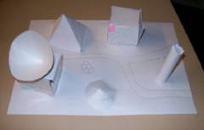
You have been asked to design a futuristic city block. It must include at least 3 buildings and at least two different shapes.
Calwell Primary School, ACT.
You'll need to produce two drawings and a 3D model of your city block.
This is what you need to do:
- Think about what kind of buildings you would include in a city block. Plan and/or sketch it.
- Draw the block from above (a bird’s eye view) and from the front. Try to draw the arrangement as accurately as possible, using a ruler.
- Build a model of your city block. The shapes and arrangement should be the same as your drawings, but you can add colour and other decorations.
Marking criteria
This is what you will be marked on:
To get the best possible mark:
Drawings | - All lines are straight, have been measured and drawn with a ruler.  - The top and front views relate to each other (objects are in the right place, sizes are consistent).  - Drawings are labelled.
2D shapes | - Drawings reflect an understanding of shapes (for example, squares have four equal side lengths at right angles).  - 2D shapes are the correct face shape for the 3D version.
3D shape models | - Shapes have been made from a net (even better if you make the net yourself).  - Net is measured and all sides match.  - Model reflects an understanding of the shape (for example, correct number of faces).
Arrangement | - Arrangement of shapes matches in both drawings and model.  - There are at least three 3D shapes.  - There are at least two different types of 3D shapes.
Presentation | - Drawings are neat and complete.  - Model is neat and complete.  - Model uses colour and is attractive.  - Model has been decorated with care.

Shapes assessment task

Name |  | Class |  | Date

- Write the geometric name of each 2D shape.

- Name one 3D shape that might include these faces.

- Write the geometric name of the 3D shape of each object in the pictures.
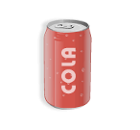
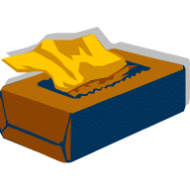
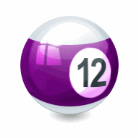
- Which 3D shapes could fit these descriptions?
6 faces, 8 vertices, 12 edges:
5 faces, 9 edges:
3 faces:
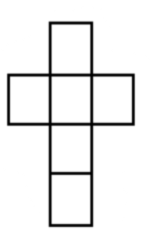
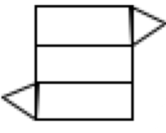
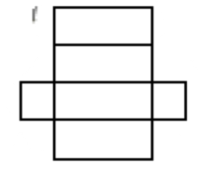
- Name the 3D shapes made by these nets.

2D faces on 3D shapes

Name |  | Class |  | Date

What 3D shapes have these faces?

Sort 3D shapes

Name |  | Class |  | Date

Sort these everyday objects into their approximate 3D shapes.


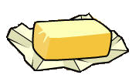

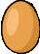
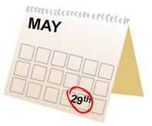
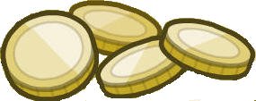






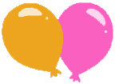

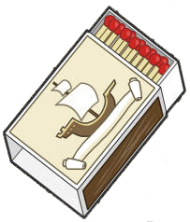

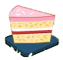

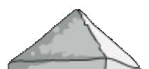
Cylinders
Rectangular prisms
Spheres
Triangular prisms
Others

Which net?

Name |  | Class |  | Date

This is a cube.

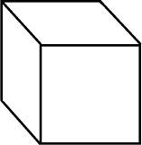

Which of these nets can make a cube?

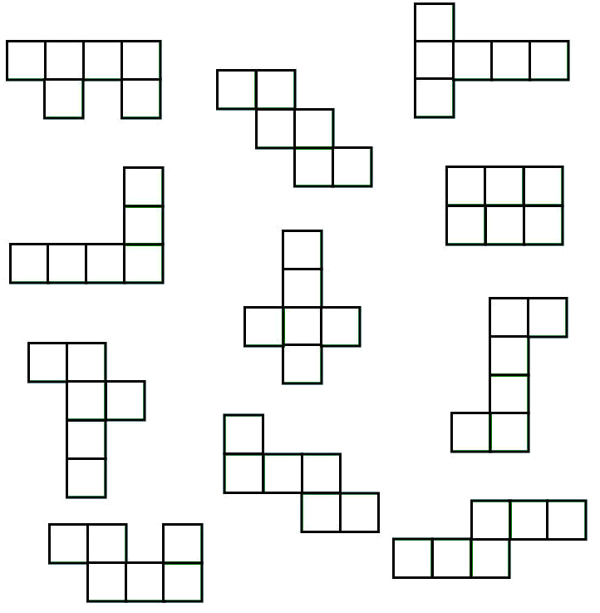

How to draw a cube

Name |  | Class |  | Date

Use a pencil and a ruler to complete this task.
- Draw a square.

- Draw a second square so it overlaps the first one. (You’ll need to rub some lines out later, so don’t press too hard!)

- Join the two squares with diagonal lines.

- Rub out the lines on the inside of the cube.

Match the net

Name |  | Class |  | Date

Draw a line to connect the net to its 3D object.
