Make a people spiral!

You will need a fairly big space, say out on the oval or on the play area.
If you choose to measure your distances rather than use paces (your class might want to discuss the length of a “pace”, how it might vary and what difference it might make to the finished spiral) you will need some metre rules or a tape measure or two.
Depending on what you choose to “fill in” your spiral with, you will also need cones or ropes or bean bags etc.
If students are unsure of turning 90 degrees then you can use instructions relating to the surroundings (e.g. turn to face the art room)

Instructions
Set someone as the centre of the spiral (A).
B stands next to A and takes a pace (you may wish to measure or use a metre rule).
C stands next to B, turns 90⁰ clockwise and takes 2 paces.
D stands next to C, turns 90⁰ clockwise and takes 3 paces.
E stands next to D, turns 90⁰ clockwise and takes 4 paces.

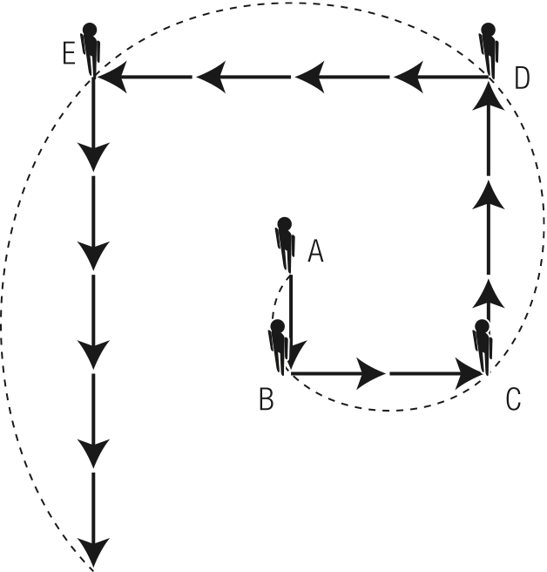

“Fill in” the curves of your spiral with …more people! …or skipping ropes… or chalk (if you are on the asphalt)…or cones…or….

Take a photograph — this may need some planning to get a good overhead shot — and send it to us!

